Name………………………………………………………………………………………...Date………………………………Place…………………………………………………….

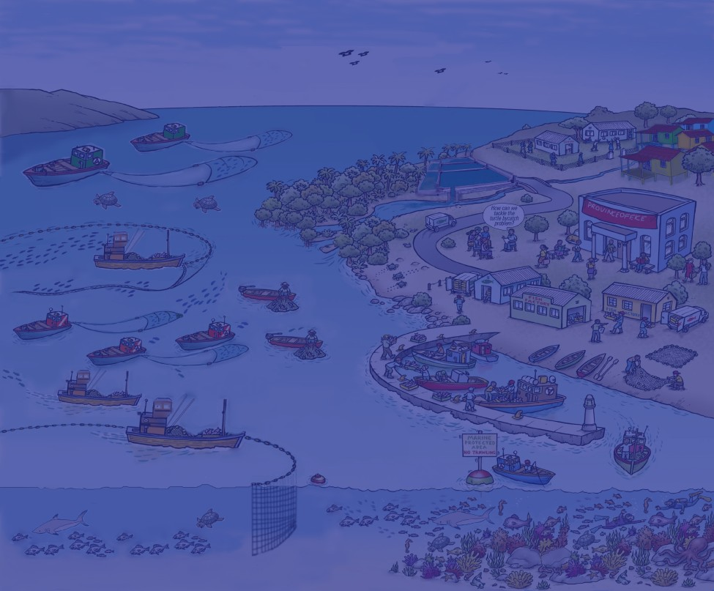
Essential EAFM

(Ecosystem Approach to Fisheries Management)

HANDBOOK

The designations employed and the presentation of material in this publication do not imply the expression of any opinion whatsoever on the part of the Food and Agriculture Organization (FAO) of the United Nations and its collaboration partners concerning the legal and development status of any country, territory, city or area or of its authorities, or concerning the delimitation of its frontiers or boundaries. The mention of specific companies or products of manufacturers, whether or not these have been patented, does not imply that these have been endorsed or recommended by FAO or its partners in preference to others of a similar nature that are not mentioned.

All rights reserved. The Bay of Bengal Large Marine Ecosystem (BOBLME) Project, Food and Agriculture Organization of the United Nations and US-Coral Triangle Initiative, National Oceanic and Atmospheric Administration (NOAA) and their collaboration partners encourage the use, reproduction and dissemination of material in this information product. Except where otherwise indicated, material may be copied, downloaded and printed for private study, research and teaching purposes, or for use in non-commercial products or services, provided that appropriate acknowledgement of the training material development partners as the source and copyright holder is given and that endorsement of users’ views, products or services is not implied in any way.

All Essential EAFM course materials and EAFM LEAD materials are available for use, free of charge, and can be downloaded from eafmlearn.org. Adaptation or translation of the course materials to reflect the local context and characteristics of a fishery or the issues affecting it is advisable, as this will increase participants’ understanding of the relevance and application of the EAFM approach. In many cases translation into national language may also be an important step to increase understanding of trainers and trainees.

Citation:

Staples, D.; Brainard, R.; Capezzuoli, S.; Funge-Smith, S.; Grose, C.; Heenan, A.; Hermes, R.; Maurin, P.; Moews, M.; O’Brien, C.; Pomeroy, R. 2014. Essential EAFM. Ecosystem Approach to Fisheries Management Training Course. Bay of Bengal Large Marine Ecosystem (BOBLME) Project, Food and Agriculture Organization of the United Nations and US-Coral Triangle Initiative, National Oceanic and Atmospheric Administration. 151p.

Cover image adapted from FAO EAF Nansen Project.

Acknowledgements | ii
About this training course | iii
Different EAFM courses | iv
Tailoring capacity development to different audiences | vi
Essential EAFM course in a nutshell | vii
Timetable | viii
Objectives | ix
Acronyms | xii
Glossary | xiii
References | xix

Course modules
- Threats and issues in fisheries | 20
- Fisheries management and the ecosystem approach | 29
- The what and why of EAFM? | 37
- Principles of EAFM | 44
- Moving towards EAFM - case study | 54
- EAFM plans - the link between policy and action | 61
- EAFM process overview | 66
- Startup A - Preparing the ground | 72
- Startup B - Stakeholder engagement | 79
- Steps 1.1, 1.2 & 1.3 Define and scope the FMU | 88
- Steps 2.1, 2.2 & 2.3 Identify and prioritize issues and goals | 95
- Reality Check I | 102
- Steps 3.1 & 3.2 Develop objectives, indicators and benchmarks | 109
- Steps 3.3, 3.4 & 3.5 Management actions, compliance, finance and finalize EAFM plan | 114
- Step 4.1 Formalize, communicate and engage | 123
- Reality Check II | 128
- Steps 5.1 & 5.2 Monitor, evaluate and adapt the plan  Appendix: Recommended reading | 143 149

This Essential-Ecosystem Approach to Fisheries Management (E-EAFM) training course was developed by a consortium with a core team consisting of the Food and Agriculture Organization (FAO) of the United Nations, the National Oceanic and Atmospheric Administration (NOAA) and IMA International. The work was supported financially by the Global Environment Facility (GEF), the Norwegian Agency for International Development (NORAD), the Swedish International Development Cooperation Agency (SIDA) through the Bay of Bengal Large Marine Ecosystem (BOBLME) Project and the “Reduction of Environmental Impact from Tropical Shrimp Trawling through the Introduction of Bycatch Reduction Technologies and Change of Management project (REBYC)” and the United States Agency for International Development (USAID) through the US Coral Triangle Initiative (USCTI) and the Coral Triangle Support Program (CTSP).

The main drafting team for this EAFM training handbook included Rusty Brainard (NOAA), Silvia Capezzuoli (IMA), Simon Funge-Smith (FAO), Chris Grose (IMA), Adel Heenan (NOAA), Rudolf Hermes (BOBLME), Paulo Maurin (NOAA), Megan Moews (NOAA), Chris O’Brien (BOBLME), Robert Pomeroy (USAID-CTSP) and Derek Staples (Fisheries Management Consultant). Nygiel Armada, Robert Pomeroy and Derek Staples drafted the original written modules for this course. Additional input was provided by Janna Shackeroff, Robert Schroeder, Jarad Makaiau and Max Sudnovsky (all NOAA) and Magnus Torell (SEAFDEC). In addition to this handbook, the training package includes linked PowerPoint presentations, a workbook, toolkits and a trainer’s manual. Final editing was undertaken by Silvia Capezzuoli, Adel Heenan and Derek Staples and copy editing was provided by Claire Attwood and Stephen Needham. Figures used and adapted with permission from the United Nations Environment Programme (UNEP) and the International Collective in Support of Fishworkers (ICSF). Amanda Toperoff and Amanda Dillon (NOAA) created new figures.

Major materials used in the design of this training course package
- Agardy, T., Davis, J., Sherwood, K. & Vestergaard, O. 2011. Taking steps toward marine and coastal ecosystem-based management – an introductory guide. UNEP Regional Seas Reports and Studies No. 189. 68 pp
- APFIC. 2009. APFIC/FAO Regional consultative workshop “Practical implementation of the ecosystem approach to fisheries and aquaculture”, 18-22 May 2009, Colombo, Sri Lanka. FAO Regional Office for Asia and the Pacific, Bangkok, Thailand. RAP Publication 2009/10. 96 pp
- Armada, N. 2012. Module 1: Coastal ecosystems and fisheries. Unpublished manuscript
- De Young, C.; Charles, A. & Hjort, A. 2008. Human dimensions of the ecosystem approach to fisheries: an overview of context, concepts, tools and methods. FAO Fisheries Technical Paper No. 489. Rome, FAO. 152 pp
- FAO. 2003. The Ecosystem Approach to Fisheries No. 4 Suppl. 2. Rome, FAO. 112 pp
- FAO. 2005. Putting into practice the ecosystem approach to fisheries. Rome, FAO. 76 pp
- FAO. 2012. EAF Toolbox: the ecosystem approach to fisheries. Rome, FAO. 172 pp
http://www.fao.org/fishery/eaf-net/topic/166272/en
- ICSF. 2013. An ecosystem approach to fisheries (EAF). An illustrated handbook. International Collective in Support of Fishworkers and Bay of Bengal Large Marine Ecosystem Project. http://www.icsf.net/images/EAF_Booklet_27-11-13_AGA%202.pdfICSF
- Pomeroy, R.S. & Rivera-Guieb, R. 2006. Fishery co-management: a practical handbook. International Development Research Centre. 264 pp
- Pomeroy, B. 2012. Module 3: Implementing the plan – governance. Unpublished manuscript
- SPC. 2010. A community-based ecosystem approach to fisheries management: guidelines for Pacific Island Countries. Compiled by the Secretariat of the Pacific Community. 65 pp
- Staples, D. & Funge-Smith, S. 2009. Ecosystem approach to fisheries and aquaculture: implementing the FAO Code of Conduct for Responsible Fisheries. FAO Regional Office for Asia and the Pacific. Bangkok, Thailand. RAP Publication 2009/11. 48 pp
- Staples, D. 2012. Module 2: EAF planning process. Unpublished manuscript
- UNEP. 2011. Taking steps toward marine and coastal Ecosystem-Based Management -
an introductory guide. UNEP Regional Seas Reports and Studies No. 189. 68pp

How the training was developed
The need to apply an ecosystem approach to capture fisheries management is now globally accepted and has been endorsed in several international fora; for example, at the Rio +20 conference in 2012. This approach represents a move away from fisheries management that focuses only on the sustainable harvest of target species, towards management systems and decision-making processes that balance ecological well-being with human and social well-being through improved governance frameworks.
This Ecosystem Approach to Fisheries Management (EAFM) training course is the result of a unique partnership involving the following regional organizations:
- the eight-country UN-FAO Bay of Bengal Large Marine Ecosystem (BOBLME) Project, funded by the Global Environment Facility (GEF), NORAD and SIDA, for improving the regional management of the Bay of Bengal environment and its fisheries;
- the US Coral Triangle Initiative (USCTI) funded by the US Agency for International Development (USAID) and implemented by the US National Oceanic and Atmospheric Administration (NOAA) and the Coral Triangle Support Partnership (CTSP) as part of their efforts to support the six-country Coral Triangle Initiative (CTI) on coral reefs, fisheries and food security; and
- the Asia-Pacific Fishery Commission (APFIC), a Regional Fisheries Body consisting of 21 member countries which covers fisheries, aquaculture and related aquatic resource issues in the Asia-Pacific region.
As early as May 2010, a core group from both the BOBLME Project and USAID-CTSP met with regional partners in Bangkok to discuss the development of an Asia-Pacific region-specific EAFM training course. This process progressed during the following two years, with course modules being drafted by Nygiel Armada, Robert Pomeroy and Derek Staples. For the CTI, these efforts led to the production of an introduction to EAFM course entitled “EAFM 101”spearheaded by NOAA for three one-week EAFM 101 training courses in Indonesia in April/May 2012 and an EAFM training for Leaders, Executives, and Decision-makers (LEAD) collaboratively developed by NOAA and CTSP and piloted in Malaysia in December 2012 and conducted in Timor Leste, Philippines, Indonesia, and Solomon Islands in 2013. At the same time, the BOBLME Project initiated the development of specific Regional Fisheries Management Advisories for shared fish stocks based on the EAF, and commissioned UK-based training course development specialists from IMA International to develop a five-day, modular interactive EAFM training package, based on the original modules.

Both course development initiatives were rooted in and closely followed the EAF guidelines and tools produced by FAO from 2003 onward through the EAF-Nansen Project (tested and applied mainly in Africa and the Caribbean), and were also informed by other processes such as those underway through FAO and the Secretariat of the Pacific Community (SPC). By mid-2012, the commonalities became evident and IMA International was asked by the BOBLME Project to explore and coordinate the potential and opportunity for harmonizing or merging the two regional EAFM capacity development processes.

A first joint EAFM curriculum development “writeshop” was held in November 2012 in Phuket, Thailand, at the BOBLME Project office. This was followed by a second “writeshop” in Manila, Philippines, in January 2013. A joint training package was produced and used as course material for a first “Essential EAFM” pilot-training and training-of-trainers in Kota Kinabalu, Malaysia, in June 2013. Based on the experience gained from this pilot training, the course material was further improved and finalized (Version 2). This material was then presented at another training workshop held at the Southeast Asian Fisheries Development Center (SEAFDEC) in January 2014, with a linked training-of-trainers and the course further refined to produce this Version 3.

EAF or EAFM?
EAF is the ecosystem approach applied to fisheries. The term was formally adopted at the 2001 FAO Reykjavik Conference and was not limited to management, but was intended to cover development, planning, food safety, and governance to better match the breadth of the FAO Code of Conduct for Responsible Fisheries.

EAFM is a subset of EAF, and is the ecosystem approach applied to fisheries management. This Handbook focuses on fisheries management and uses the term EAFM throughout.

A similar, and widely used term is EBFM – ecosystem-based fisheries management. The term did not meet with consensus at the 2001 FAO Reykjavik Conference, possibly because some countries took it as implying that the "ecosystem" would become the new "foundation" of fisheries management. This may have been interpreted as giving to environmental considerations pre-eminence over socio-economic and cultural ones, raising concern about equity, political as well as socio-economic costs and feasibility.

Different EAFM training courses available to date
Over the past ten years or so, a substantial number of guidance and resource materials, guidelines, scholarly articles and books on EAFM have been published and made available to wider audiences. These have been produced by independent scientists, universities, scientific and development cooperation projects, government institutions and non-governmental or international organizations. Some of these are listed under “materials used” or as recommended reading, or are web accessible.
Actual training courses are more limited in number and, by necessity, often intended for a rather defined geographic region, and for more or less clearly identified target groups. There are also training courses which have been held only on a few occasions and those which have become part of an academic institution’s regular course.
 | Course title | Content | Provider
Academic courses | EAF - Monitoring and evaluation of resource use and fisheries impact | EAF theory and analytical tools; forms of fisheries management; catch and effort and socio-economic data | Center for Development Innovation, Wageningen University, Netherlands, in cooperation with FAO  (www.wageningenur.nl/cdi)
 | Fisheries management | Fisheries management principles and processes; including the EAF | Australian National Centre for Ocean Resources & Security (ANCORS), University of Wollongong, Australia (www.ancors.uow.edu.au)
 | Quantitative EAF  (Q-EAF) | Expert training with a special focus on modelling marine ecosystems | Université Paris Marie Curie, France (www.mares-eu.org)
Project courses | EAF in the Mediterranean and Black Seas. Scientific bases | Knowledge needs of EAF; sustainability of target species; ecological aspects; social and economic aspects; new model developments; indicators, targets and reference points; low-impact and fuel-efficient fishing; practical work | International Center for Advanced Mediterranean Agronomic Studies (www.iamz.ciheam.org), Zaragoza, Spain, developed under the EU-CREAM Project (Coordinating research in support of application of the EAF and management advice in the Mediterranean and Black Seas) as part of the 7th EU Framework Programme in cooperation with FAO
 | EAF in the Mediterranean and Black Seas. Management and decision-making | EAF principles and concepts; EAF management process; social and economic dimension of EAF; co-management; science to support EAF; EAF in practice: case studies | International Center for Advanced Mediterranean Agronomic Studies (www.iamz.ciheam.org), Zaragoza, Spain, developed under the EU-CREAM Project (Coordinating research in support of application of the EAF and management advice in the Mediterranean and Black Seas) as part of the 7th EU Framework Programme in cooperation with FAO
 | International training course in EAF (African universities) | Components of the ecosystem; complexity of fisheries systems; EAF concepts, practices and tools | Norway funded EAF-Nansen Project of FAO entitled “Strengthening the knowledge base for and implementing an Ecosystem Approach to marine fisheries in developing countries” (http://www.eaf-nansen.org/nansen/en)
 | Responsible Fisheries Training Programme | Responsible fisheries; ecological health; fisheries management; market influence and enforcement; pragmatic and robust solutions to conservation challenges | Responsible fisheries alliance training working group. World Wildlife Fund South Africa and partners (www.wwf.org.za; www.rfalliance.org.za); accredited by South African Qualifications Authority
Asia-Pacific courses | Regional training for the trainers course on Ecosystem Approach to fisheries and extension methodologies (ASEAN) | Approaches to fisheries ecosystem management; essential skills for extension work; media production; study tours | Training department, SEAFDEC-TD, Thailand
 | EAFM (for Papua New Guinea and Solomon Islands) | Threats to sustainable fishing; fisheries management; EAFM;  ecosystems; fish biology; local coastal fisheries (PNG or Solomon Islands); governance; fisheries assessments; EAFM plan; monitoring and compliance | The Nature Conservancy (TNC) on behalf of the Australian Agency for International Development (AusAid); implemented by the Australian Tropical Marine Alliance and the Coral Triangle Center
 | EAFM for leaders, executives, and decision makers (EAFM LEAD) | What is EAFM and why an EAFM is the preferred approach for management of fisheries to balance diverse societal goals; how to integrate an EAFM into policy and practice; holistic management of fisheries that can be sustainable and mutually beneficial | NOAA funded by USAID CTSP
 | Regional training for the trainers course on Ecosystem Approach for fisheries management | The overall objective of this course is to contribute to the capacity building and strengthening of the competence of national government officers/authority in member countries on the ecosystem approach to fisheries management | SEAFDEC

Capacity development for different audiences
Different audiences require different approaches to capacity development and also different materials. The main target for this Essential EAFM is mid-level managers and fishery and environment staff, as well as related economic development and planning staff, at the provincial/state and district/local levels who are responsible for administering or managing fisheries and the marine environment in which they operate. Essential EAFM is designed in a way which should make local adaptation in different countries easy – there is no need for re-designing the course material for this very broad target group. However, it is suggested that local, context-specific (for the country of training) case studies, possibly sourced from the participants, are included and that there is some level of awareness of a particular country or sub-region’s fisheries and environmental laws and regulations. A major strength of this course is that it allows participants to develop an EAFM plan that can be taken away from the course and, with some further work, be implemented either in the participant’s country or as a transboundary plan.
The closely related EAFM for leaders, executives, and decision makers (LEAD) training aims to provide senior-level leaders with an understanding and forum for discussion of the why, what and how to implement EAFM from national to local levels. A concise overview PowerPoint presentation on the EAFM, supported by a one-pager providing information on “Essential EAFM in a nutshell” and its course content and objectives could also be used to address the top level decision-makers (also available as a companion to Essential EAFM). Local fishing communities could be made aware of EAFM and trained in sessions using the Guidelines for Pacific Island Countries, compiled by the Secretariat of the Pacific Community (SPC, 2010). Some materials for capacity development on community-based ecosystem approach to fisheries management have been developed by NGOs (e.g. WWF Malaysia) and also for South and Southeast Asia by the International Collective in Support of Fishworkers (ICSF), commissioned by the BOBLME Project.

Essential EAFM
The Essential EAFM course provides trainees with the skills that will help them to develop an EAFM plan to more sustainably manage capture fisheries. This course will equip trainees to:
- manage fisheries more holistically;
- better resolve fisheries issues and challenges;
- reduce user group conflicts;
- work cooperatively with other stakeholders;
- and help unlock financial resources and increase political will.

Participants will learn about EAFM concepts and work with an EAFM plan template to develop a draft EAFM plan for their area. They will understand the principles of EAFM and co-management and how to foster cross-sector coordination and will also practice the crucial skills of effective communication, facilitation, and conflict management.
Overall course objectives
Participants will understand the concept and need for an Ecosystem Approach to Fisheries Management (EAFM), and learn skills and knowledge to develop, implement and monitor an “EAFM plan” to more sustainably manage capture fisheries.

Audience
This Essential EAFM course targets mid-level managers and fishery and environment staff, as well as related economic development and planning staff, at the provincial/state and district/local levels who are responsible for administering or managing fisheries and the marine environment in which they operate.

Scope and context
This course can be applied to any fisheries or aquaculture system. In the following handbook and Powerpoint presentations the course focuses on “Coastal marine ecosystems in the countries participating in the “Sustainable Management of Bycatch in Latin America and Caribbean Trawl Fisheries (REBYC-II LAC)”. By changing the focus and examples, the course could equally be applied to inland ecosystems, offshore ecosystems or aquaculture. The principles and the approach to management planning are the same.

Course structure
Initially the course explains why EAFM is the preferred approach to sustainably manage fisheries and what exactly EAFM is. It then explains how EAFM can work: by developing an EAFM plan, implementing the plan and monitoring, evaluating and adapting the plan.
Training methodology
The course is highly participatory. To complement input from the trainers, participants will work in pairs, in groups and individually on specifically designed exercises. The exercises are designed to consolidate learning. The trainers will try, as far as possible, to work with real, local examples and will therefore rely on active participation from trainees.
Learning and feedback
Daily monitoring and reviews ensure that feedback from participants is integrated into course design, where possible. Pre- and post-course assessment, as well as a quiz, will enable the trainers to assess progress.
Course materials
Each step of the EAFM process is explained in dedicated modules in this course Handbook. The Workbook may be used to write notes for each stage. The linked Toolkit provides the “People” and “Technical” tools which can be used at different stages in the EAFM process. After successfully completing the course, participants will receive an electronic version of the Handbook, PowerPoint presentations and the Toolkit, together with any additional resources.
Trainers
The trainers have been trained by internationally experienced participatory facilitators. They are supported by personnel with extensive regional fisheries management knowledge.

 | DAY 1  What & why | DAY 2  How | DAY 3  Plan & check | DAY 4  Do & check | DAY 5  Present
Morning  08.30 –10.10 | Registration  Introductions  Course overview  1. Threats and issues in fisheries | 5. Moving towards EAFM  US case study | 10. Step 1: Define & scope the Fishery Management Unit (FMU)  1.1 Define the FMU  1.2 Agree on the vision  1.3 Scope the FMU | 13. Step 3: Develop the EAFM plan  3.1 Develop management objectives  3.2 Develop indicators and benchmarks | Quiz review  Participant work: refining EAFM plans & preparing presentations
Break
10.30 – 12.30 | 2. Fisheries management and the ecosystem approach  3. The what and why of EAFM? | 6. EAFM plans: the link between policy and action  7. EAFM process overview  8. Startup A  Preparing the ground | 11. Step 2: Identify & prioritize issues & goals  2.1 Identify FMU-specific issues  2.2 Prioritize issues  2.3 Define goals  12. Reality check I  Constraints and opportunities | 14. Step 3: Develop the EAFM plan …cont’d  3.3 Agree management actions  3.4 Include financing mechanisms  3.5 Finalize EAFM plan  15. Step 4: Implement the plan  4.1 Formalize, communicate and engage | Participant presentations on EAFM key elements to illustrate learning  Feedback on presentations
Lunch
Afternoon  13.30 –14.45 | 4. Principles of EAFM | 8. Startup A Preparing the ground cont. | 12. Reality check I  Facilitation skills | 16. Reality check II  Align to EAFM principles  Supporting environment | Course review  Individual action planning
Break
15.05 –16.30.  17.00 wrap up | (4a) How much EAFM are you already doing? | 9. Startup B  Engaging stakeholders | 12. Reality check I  Conflict management | 17. Step 5: Monitor, evaluate and adapt  5.1 Monitor and evaluate performance  5.2 Review and adapt the plan  EAFM QUIZ | Course evaluation  Course closure and certification
 | Homework: EAFM progress |  |  | Homework: Presentation preparation

Overall course objective:
You will understand the concept and the need for an Ecosystem Approach to Fisheries Management (EAFM) and learn skills and knowledge to develop, implement and monitor an EAFM plan to more sustainably manage capture fisheries.
This is a five-day course:
Day 1: To understand what EAFM is and why we should use it.
Day 2: To understand what moving towards EAFM entails.
Day 3: To work through the EAFM planning process.
Day 4: To work through implementing EAFM plans.
Day 5: To present and receive feedback on group EAFM plans.
Day 1 – WHY and WHAT
Participant introductions and course overview
At the end of the session you will have:
- Introduced yourselves and communicated your personal hopes and concerns for the course;
- Stated aims and objectives of the course; and
- Identified threats and issues faced by your fisheries and associated ecosystems.

Fisheries management and the ecosystem approach
At the end of the session you will be able to:
- Realize a new management approach is required to address the many threats and issues facing capture fisheries;
- Recognize how ecosystems benefit human societies;
- Describe the concept of the ecosystem approach (EA); and
- Explain some of the benefits of using an EA.

The what and why EAFM?
At the end of the session you will be able to:
- Describe what EAFM is;
- Describe the benefits of using an EAFM;
- Explain how EAFM complements other approaches; and
- Recognize the complexities of multiple societal objectives.

Principles of EAFM
At the end of the session you will be able to:
- Examine the principles of an EAFM and their link to the FAO Code of Conduct for Responsible Fisheries (CCRF).

What is EAFM and how much are you already doing?
At the end of the session you will be able to:
- Revisit your threats and issues and cluster them according to the three EAFM components;
- Realize that you are already doing some aspects of an EAFM;
- Analyze your current fisheries practices and identify what EAFM you are already doing; and
- Identify gaps in your EAFM practices and possible ways to move forward.
Moving towards EAFM
Day 2 – HOW
At the end of the session you will be able to:
- Recognize how the state of Hawaii, USA adopted the EAFM principles and moved towards EAFM over time;
- Determine where your country is at in moving towards EAFM; and
- Identify challenges your country faces in moving towards EAFM.

EAFM plans: the link between policy and actions
At the end of the session you will be able to:
- Recognize the need for effective planning and plans to translate policies into actions.

EAFM process overview
At the end of the session you will be able to:
- Describe the key steps of the EAFM process and how to plan, implement and monitor EAFM;
- Identify the planning steps in EAFM process; and
- Describe the outline of an EAFM plan.

Startup
A. Preparing the ground
At the end of the session you will be able to:
- Define startup tasks needed to initiate the EAFM process and co-management; and
- Learn how to identify stakeholders.

Startup
B. Stakeholder engagement
At the end of the session you will be able to:
- Apply participatory approaches to stakeholder engagement;
- Organize and hold stakeholder meetings; and
- Describe the basic concepts of co-management.
Step 1 Define and scope the Fisheries Management Unit (FMU)
Day 3 – PLAN AND CHECK
At the end of the session you will be able to:
- Describe FMU defining and scoping; and
- Undertake visioning and be able to agree on a vision.

Step 2: Identify and prioritize issues and goals
Steps 2.1 to 2.3
At the end of the session you will be able to:
- Identify your FMU-specific issues;
- Develop goals for the EAFM plan; and
- Prioritize issues through risk assessment.

Reality Check I
At the end of the session you will be able to:
- Identify the constraints and opportunities in meeting your FMU goals;
- Use facilitation skills with co-management partners in focus group discussions (FGDs); and
- Use conflict management in EAFM and practise a range of techniques.

Step 3a: Develop objectives, indicators and benchmarks
Steps 3.1 & 3.2
At the end of the session you will be able to:
- Develop management objectives; and
- Develop indicators and benchmarks related to the objectives.
Step 3b: Management actions, compliance, finance & finalize EAFM plan
Steps 3.3 to 3.5
At the end of the session you will be able to:
- Identify management actions and how stakeholders will comply with these;
- Include financing mechanisms in the plan; and
- Bring it all together – finalize the EAFM plan.
Step 4: Implement the plan
Day 4 – DO AND CHECK
Step 4.1 Formalize, communicate and engage
At the end of the session you will be able to:
- Develop an implementation work plan;
- Summarize what is meant by formal adoption of the EAFM plan; and
- Develop a communication strategy.

Reality Check II
At the end of the session you will be able to:
- Check on the status of the EAFM plan implementation;
- Consider whether implementation is in line with the principles of EAFM;
- Check on the practicalities – is the supporting environment in place?; and
- Revisit the constraints and opportunities in meeting your FMU goals.

Step 5: Monitor, evaluate and adapt
Steps 5.1 & 5.2
At the end of the session you will be able to:
- Monitor how well management actions are meeting goals and objectives;
- Plan what has to monitored, why, when, how and by whom;
- Evaluate monitoring information and report on performance; and
- Review and adapt the plan.
Participant group work preparing presentations
Day 5 – PRESENT and SHOW LEARNING
At the end of the session you will have:
- Prepared your FMU group EAFM plans presentations.
Participant presentations
At the end of the session you will have:
- Presented your FMU group EAFM plans or tools related to the plan to the wider group;
- Received feedback on your presentations; and
- Given constructive feedback on others’ presentations.

Course review and individual action planning
At the end of the session you will have:
- Discussed key learning from the course; and
- Developed an individual action plan and potential next steps for your agency, to be acted on upon your return to work.
Course evaluation
At the end of the session you will have:
- Completed final course evaluation forms
Course closure and certification:
At the end of the session you will have:
- Received your course certificates.

APFIC Asia Pacific Fishery Commission
ASEAN Association of South East Asian Nations
BOBLME Bay of Bengal Large Marine Ecosystem Project
CBFM Community Based Fisheries Management
CBFMP Community Based Fisheries Management Plan
CCA Climate Change Adaptation
CCRF Code of Conduct for Responsible Fisheries
COASTFISH Sustainable Coastal Fisheries and Poverty Reduction Initiative
CTI Coral Triangle Initiative
CTSP Coral Triangle Support Partnership
EA Ecosystem Approach
EAF Ecosystem Approach to Fisheries
EAFM Ecosystem Approach to Fisheries Management
EAFM LEAD EAFM Leaders, Executives and Decision Makers (training course)
EBM Ecosystem Based Management
EBFM Ecosystem Based Fisheries Management
EEZ Exclusive Economic Zone
FAO Food and Agriculture Organization of the United Nations
FIP Fisheries Improvement Plan
FMP Fisheries Management Plan
FMU Fisheries Management Unit
GEF Global Environment Facility
ICM Integrated Coastal Management
IOTC Indian Ocean Tuna Commission
IMU Integrated Management Unit
IPB Faculty of Fisheries at Bogor University, Indonesia
IPCC Intergovernmental Panel on Climate Change
ITQ Individual Transferable Quota
IUU Illegal Unregulated and Unreported
IWM Integrated Watershed Management
LME Large Marine Ecosystem
LMMA Locally Managed Marine Area
MCS Monitoring, Control and Surveillance
MOU Memorandum of Understanding
MPA Marine Protected Area
MSP Marine Spatial Planning
NOAA National Oceanic and Atmospheric Administration, USA
NORAD Norwegian Agency for International Development
PEMSEA Partnerships in Environmental Management for the Seas of East Asia
PI Program Integrator
PM&E Planning Monitoring & Evaluation
PSC Project Steering Committee
RFMAC Regional Fisheries Management Advisory Committee
RFMO Regional Fisheries Management Organization
SEAFDEC Southeast Asian Fisheries Development Centre
SIDA Swedish International Development Cooperation Agency
SPC Secretariat of the Pacific Community
TAC Total Allowable Catch
TDA Transboundary Diagnostic Analysis
TOT Training of Trainers
TROM Target Resource Oriented Management
TURF Territorial Use Rights in Fisheries
USAID US Agency for International Development
USCTI US Coral Triangle Initiative

Glossary of terms
☺ When you see a smiley face in the Modules, it indicates that a term is explained in the glossary.
Acidification: Ocean acidification refers to the process of lowering the oceans’ pH (that is, increasing the concentration of hydrogen ions) by dissolving additional carbon dioxide in seawater from the atmosphere, or by other chemical additions either caused by natural processes or human activity. The word “acidification” refers to lowering pH from any starting point to any end point on the pH scale. Woods Hole Oceanographic Institution; http://www.whoi.edu/OCB-OA/page.do?pid=112096

Adaptive management: A systematic process for continually improving management policies and practices by learning from the outcomes of previously employed policies and practices. The basic steps of adaptive management are to implement actions, monitor their effectiveness; analyze, use and adapt; and then capture and share learning. Active adaptive management occurs where management options are used as a deliberate experiment for the purpose of learning (Millennium Ecosystem Assessment, 2006).
Artisanal fishery: A small-scale fishery carried out using traditional fishing boats and gears. See small-scale artisanal fishery.
Benchmark: A standard against which something can be measured or judged. It can describe where you want to go (target), where you have come from (baseline) or where you do not want to be (limit).
Benthic: Of, relating to, or occurring at the bottom of a body of water; bottom-dwelling or benthic organisms are important in marine food webs and include many species, such as crabs, lobsters, clams, mussels, scallops, and seaweeds that are harvested for food or other uses by humans.
Biodiversity: The variation of life at all levels, ranging from genes to ecosystems. It is more than a count of species and can be characterized by extinctions, reductions or increases of some species, invasions and hybridizations, degradation of habitats and changes in ecosystem processes.
Biota: The combined flora and fauna of a region. It is one component of an ecosystem.
Capture fisheries: Fishing for naturally occurring fish using a variety of fishing gears and methods (e.g. trawls, gillnets, purse seines, traps and barriers). The term “fishery” refers to harvesting fish that are farmed (aquaculture) or caught in the wild (capture fishery).
Climate: The weather averaged over a long period of time (typically 30 years). Climate is what you expect; as opposed to weather, which is what you get (IPCC, 2001).
Climate change: A change in the state of the climate that can be identified (e.g. using statistical analysis) by changes in the mean and/or the variability of its properties, and that persists for an extended period, typically decades or longer (IPCC, 2007).
Climate Change Adaptation (CCA): Actions taken to help communities and ecosystems moderate, cope with, or take advantage of actual or expected changes in climate conditions. Adaptation can reduce vulnerability, both in the short- and long-term (IPCC, 2007).
Coastal and marine spatial planning: A public process of analyzing and allocating the spatial and temporal distribution of human activities in coastal and marine areas to achieve ecological, economic, and social objectives that are usually specified through a political process. Sometimes used interchangeably with marine spatial planning (MSP), (Ehler and Douvere, 2009).
Co-management: Partnership arrangements between key stakeholders and government to share the responsibility and authority for the management of the fisheries and coastal resources, with various degrees of power sharing.
Code of Conduct for Responsible Fisheries (CCRF): A voluntary guide developed by the Food and Agriculture Organization of the United Nations (FAO) that provides a set of principles on how to develop fisheries and aquaculture sustainably.
Community based management (CBM): Management planning and implementation carried out by the people in a community.

Convention on Biological Diversity (CBD): Signed by 150 government leaders at the 1992 Rio Earth Summit, the Convention on Biological Diversity is dedicated to promoting sustainable development. It recognizes that biological diversity is about more than plants, animals and microorganisms and their ecosystems – it is about people and their need for food security, medicines, fresh air and water, shelter and a clean and healthy environment in which to live.
CBD website http://www.cbd.int/convention/
Demersal: species that live on or close to the sea floor (in contrast to pelagic species which live in the upper waters of the sea.
Demersal fishery: A fishery that targets demersal fishes, in contrast to a pelagic fishery that targets fish that swim near the surface of the sea.
Development: Improving human well-being (see below). Note that in sustainable development, it is the development that needs to be sustained.
Ecological well-being: The state of the ecosystem in terms of health, biodiversity, supportive structures and habitats and food webs.
Ecosystem: A relatively self-contained system that contains plants, animals (including humans), micro-organisms and non-living components of the environment, as well as the interactions between them (SPC, 2010).
Ecosystem Approach (EA): A strategy for the integrated management of land, water and living resources that promotes conservation and sustainable use in an equitable way (CBD, 2000). Often used interchangeably with ecosystem-based management.
Ecosystem approach to fisheries (EAF): The purpose of an ecosystem approach to fisheries is to plan, develop and manage fisheries in a manner that addresses the multiple needs and desires of societies, without jeopardizing the options for future generations to benefit from the full range of goods and services provided by marine ecosystems. An ecosystem approach to fisheries strives to balance diverse societal objectives, by taking account of the knowledge and uncertainties of biotic, abiotic and human components of ecosystems and their interactions and applying an integrated approach to fisheries within ecologically meaningful boundaries (FAO 2003). The term was formally adopted at the 2001 FAO Reykjavik Conference and was not limited narrowly to management, but could cover development, planning, food safety and governance that covers the breadth of the FAO Code of Conduct for Responsible Fisheries.
Ecosystem approach to fisheries management (EAFM): EAFM is a more holistic approach to fisheries management that represents a move away from fisheries management systems that focus only on the sustainable harvest of target species, towards systems and decision-making processes that balance ecological well-being with human and societal well-being, within improved governance frameworks i.e. it is a practical way to achieve sustainable development. It addresses the multiple needs and desires of societies, without jeopardizing the options for future generations to benefit from the full range of goods and services provided by marine ecosystems (Garcia et al., 2003; Food and Agriculture Organization 2003, 2011).
Ecosystem approach to fisheries management plan (EAFM plan): The output of a planning framework that outlines the objectives and integrated set of management arrangements for a fishery to generate more acceptable, sustainable and beneficial community outcomes.
Ecosystem-based management (EBM): A management framework that integrates biological, social and economic factors into a comprehensive strategy aimed at protecting and enhancing sustainability, diversity, and productivity of natural resources. EBM emphasizes the protection of ecosystem structure, functioning and key processes; is place-based in focusing on a specific ecosystem and the range of activities affecting it; explicitly accounts for the interconnectedness among systems, such as between air, land and sea; and integrates ecological, social, economic and institutional perspectives, recognizing their strong interdependences (COMPASS Scientific Consensus Statement). Often used interchangeably with EA.

Ecosystem-based fisheries management (EBFM): The fisheries component of ecosystem-based management, but focused on a single sector. EBFM considers both the impacts of the environment on fisheries health and productivity and the impacts that fishing has on all aspects of the marine ecosystem. Often used interchangeably with an ecosystem approach to fisheries management (EAFM).
Ecosystem goods and services: The benefits people obtain from ecosystems. These include provisioning services such as food and water; regulating services such as flood and disease control; cultural services, such as spiritual and cultural benefits; and supporting services, such as nutrient cycling or waste degradation, that maintain the conditions for life on Earth.
Facilitator: A person who manages the interactions of other people to achieve an acceptable outcome for all.
Fish finders: In commercial fishing, high-frequency sonar device for locating schools of fish. It transmits sound waves downward and receives echoes from the bottom of the sea, or from intervening schools of fish, also indicating distance from ship to fish. Two different types are used, one of which is a simple “echo sounder” that points directly downward from the ship and indicates the depth of the water as well as the presence of fish. (Encyclopedia Britannica;
http://global.britannica.com/EBchecked/topic/208570/fish-finder)
Fisheries management: An integrated process that controls fishing activities to improve the benefits that society receives from harvesting fish. It includes the activities of (i) information gathering, (ii) analysis, (iii) planning, (iv) consultation, (v) decision-making, (vi) allocation of resources and (vii) formulation and implementation, with enforcement, as necessary, of regulations or rules which govern fisheries activities. The main aim is to ensure the continued productivity of the resources and accomplishment of other fisheries objectives.
Fishery management unit (FMU): The area of the ecosystem and fisheries that is the focus for management under an ecosystem approach to fisheries management. The FMU can be a particular type of fishing, e.g. trawl fishery, and/or a particular resource fishery, e.g. shrimp fishery or a geographic area.
Fishery resource: The fish that are harvested, where fish includes molluscs, crustaceans and any aquatic animal.
Fishing right: A right to carry out specified fishing activities. Can be a territorial use right (TURF), a community right that allows access by poor small-scale fishers, a right granted though a limited-entry system (e.g. allocated number of fishing days or an individual transferable quota (ITQ).
Food security: The availability of consistent and sufficient quantities of food, access to appropriate and sufficient foods and consumption or appropriate use of basic nutrition and food preparation.
Food web: A system of interlocking and interdependent food chains.
Goal: A goal is the long term outcome that management is striving to achieve. It often refers to a group of inter-related issues.
Good governance: See below for definition of governance. Good governance is governance that includes (i) consensus, (ii) participation, (iii) accountability, (iv) transparency and (v) follows the rule of law and is (vi) responsive, (vii) equitable and inclusive and (viii) efficient and effective.
Governance: Effective institutions and arrangements for setting and implementing rules and regulations. It includes the planning and implementation mechanisms, processes and institutions through which citizens and governing groups (institutions and arrangements) voice their interests, mediate differences, exercise their legal rights and meet their obligations. Good governance also includes adequate resources and arrangements for compliance and enforcement.
Habitat: The environment in which fish and other living marine resources live, including everything that surrounds and affects their life, e.g. water quality, bottom vegetation, associated species (including food supplies).

Human well-being: The state of the society in terms of health, education, food security, political voice and influence, living environment and economic security and safety.
Indicator: A variable, pointer, or index that measures the current condition of a selected component of the ecosystem. Indicators provide a link between objectives and action when they are compared to benchmarks.
Integrated management: The process of simultaneously and synergistically working towards multiple objectives and goals, rather than undertaking separate activities in parallel or sequentially. Integration is carried out at the scale of priority geographical or management areas. For governance, integration means working across sectors.
Integrated coastal management (ICM): An ecosystem approach to managing a coastal area. It is a continuous mechanism that involves a systematic process for managing competing issues in marine and coastal areas, including diverse and multiple uses of natural resources. ICM puts into practice effective governance, active partnerships, practical coordinating strategies, sustainable financial resources and strengthened technical institutional capacities. Under ICM, decisions are taken for the sustainable use, development and protection of coastal and marine areas and resources.
Integrated watershed management (IWM): A rational framework for the development of management strategies for water resources.
Illegal, Unregulated and Unreported fishing (IUU): Illegal fishing is conducted by vessels of countries that are parties to a regional fisheries management organization (RFMO), but operate in violation of its rules, or operate in a country's waters without permission. Unreported fishing is catch not reported or misreported to relevant national authorities or RFMO. Unregulated fishing is conducted by vessels without nationality or that fly the flag of states that are not party to relevant fisheries organizations and who, therefore, consider themselves not bound by their rules (FAO, 2002).
Large-scale industrial fishery: The sub-sector of a fishery typically operated by larger vessels equipped with large fishing gear and sophisticated technology, and powered by large engines. Vessels can be owner-operated or owned by large companies.
Limited access: A system of fisheries management where the number of fishing vessels and/or fishermen is limited to conserve the resource.
Management goal: A broad statement of a desired outcome, often a specific theme (e.g. the environment or the fishing communities). Goals are usually not quantifiable and may not have established timeframes for achievement (see vision and objectives).
Management actions: Specific actions (controls) applied to achieve the management objective, including gear regulations, areas and time closures (see MPA), and input and output controls on fishing effort, ecosystem manipulations or governance actions.
Mariculture: Cultivation, management and harvesting of marine organisms in their natural habitat or in specially constructed rearing units, e.g. ponds, cages, pens, enclosures or tanks. For the purpose of FAO statistics, mariculture refers to cultivation of the end product in seawater even though earlier stages in the life cycle of the concerned aquatic organisms may be cultured in brackish water or freshwater. FAO Aquaculture Glossary.
Marine protected area (MPA): A clearly defined geographical space, recognized, dedicated and managed, through legal or other effective means, to achieve the long-term conservation of nature, with associated ecosystem services and cultural values (IUCN). MPAs include a wide variety of governance types (including community-based areas), and include, but are not limited to, marine reserves where no extraction is permitted (Dudley, 2008; IUCN-WCPA, 2008).
Marine Protected Area Network: A collection of individual MPAs or reserves operating cooperatively and synergistically, at various spatial scales, and with a range of protection levels that are designed to meet objectives that a single reserve cannot achieve (IUCN-WCPA, 2008).
Marine Spatial Planning (MSP): see coastal and marine spatial planning.

Monitoring and Evaluation (M&E): the process of evaluating the performance of management actions for adaptive management. Participatory M&E is when stakeholders are involved in this process.
Monitoring, control and surveillance (MCS): The overall process used to ensure laws, rules and regulations are complied with.
Management objective: What is intended to be achieved through management actions.
Objective: What is intended to be achieved. An objective should be linked to indicator(s) against which progress can be measured. Positive or negative change resulting from the achievement of an objective is an outcome. See vision and goal.
Open-access: A system open to anybody who wants to fish and there are no restrictions on the number of vessels and/or fishers.
Outcome: The change in status, attitude or behaviour that results from a set of management activities. An outcome should be able to be tracked through measurement and/or observation over time.
Pelagic: species which live in the upper surface of the sea.
Precautionary approach (or principle): An underlying element of the broader framework of sustainable development. Where there are threats of serious or irreversible damage, lack of full scientific certainty shall not be used as a reason for postponing cost-effective measures to prevent environmental degradation (UNCED, 1992).
The United Nations Conference on Straddling Fish Stocks and Highly Migratory Fish Stocks (UN 1995) first articulated the principle for fisheries with the following definition:
“States shall be more cautious when information is uncertain, unreliable or inadequate. The absence of adequate scientific information shall not be used as a reason for postponing or failing to take conservation and management measures (UN, 1995).
The two ramifications of the precautionary approach are:
- Lack of data and information should not be used as an excuse for not taking action.

- Where there is uncertainty, management actions should be more risk averse.

Promoting agency: The agency that takes the lead in promoting a new concept, such as EAFM.
Resilience: The ability of an ecosystem to maintain key functions and processes in the face of (human or natural) stresses or pressures, either by resisting or adapting to change (Nystrom and Folke, 2001).
Risk: A function of probability and consequence. Risk assessment is the process intended to calculate or estimate the risk to an object or system. The process includes identifying the severity of a hazard (its impact) and likelihood of it happening.
Scoping: Determination of the broad background to the fishery management unit (FMU), including a description of the geographic area, stakeholders, fisheries, critical habitats and issues on which a project or resource management plan must focus (SPC, 2010).
Small-scale artisanal fishery: The fishery sub-sector usually operated by fishers with either no fishing vessels or small fishing vessels, using more traditional fishing gear. Vessels are usually owner-operated and, if powered, powered by small inboard or outboard motors.
Stakeholders: Any individual, group or organization who has an interest in (or a “stake”), or who can affect or is affected, positively or negatively, by a process or management decision.
Sustainable development: Development (improvement in human well-being) that meets the needs of the present without compromising the ability of future generations to meet their own needs.

Sustainable fisheries management: Fisheries management that promotes the contribution that fisheries makes to sustainable development.
Sustainable use: The harvesting of natural resources that does not lead to long-term decline of the resource and biodiversity, thereby maintaining its potential to meet the needs of the present without compromising the ability of future generations to meet their own needs.
Sustainability: Short hand for sustainable development.
Trophic: Relating to nutrition; trophic level: one of the hierarchical strata of a food web characterized by organisms which are the same number of steps removed from the primary producers.
Vision: A vision is the top-level aspiration of what the future will look like if management is successful. See goal and objective.
Vulnerability: The degree to which a human or natural system is susceptible to, or unable to cope with, adverse effects of climate change and/or ocean change, including climate variability and extreme events. Vulnerability is a function of the character, magnitude and rate of change and variation to which a system is exposed, its sensitivity and related adaptive capacity (IPCC, 2001).
Well-being: A concept that refers to the state of a system (e.g. ecosystem or social system). See ecological and human well-being.

References
Convention on Biological Diversity (CBD). 2000. Conference of the Parties 5, decision V/6. Nairobi, Kenya, 15-26 May 2000. Available at http://www.cbd.int/decision/cop/?id=7148
Ehler, C. & Douvere, F. 2009. Marine spatial planning: A step-by-step approach toward ecosystem-based management (IOC Manual and Guides No. 53, ICAM Dossier No. 6). Paris, France. UNESCO Intergovernmental Oceanographic Commission and Man and the Biosphere Programme.
IPCC. 2001. UN Intergovernmental Panel on Climate Change (IPCC). Third Assessment Report, Glossary. Available at: http://www.ipcc.ch/pdf/glossary/tar-ipcc-terms-en.pdf
Millennium Ecosystem Assessment. 2006. Millennium Ecosystem Synthesis Reports. Current state and trends assessment Appendix D. Available at: http://maweb.org/en/Synthesis.aspx
Nystrom, M. & Folke, C. 2001. Spatial resilience of coral reefs. Ecosystems 4(5): 12
Secretariat of the Pacific Community (SPC). 2010. A community-based ecosystem approach to fisheries management: guidelines for Pacific Island Countries. Noumea Cedex, New Caledonia. SPC. 54 pp

Threats and issues in fisheries
Module 1

Session objectives:
- Identify the threats and issues faced by your fisheries and associated ecosystems.

Overview
This module outlines the generic threats and issues, and some related opportunities, in many fisheries (not all will be applicable to specific cases). These issues and threats are summarised under three headings: 1) human well-being; 2) governance; and 3) ecological well-being. In some cases, the opportunities that an EAFM presents for dealing with specific issues and threats are highlighted in italics.
1. Threats and issues affecting human well-being

Population and economic growth
- High population growth rates have resulted in an increasing food requirement in many regions and this includes demand for fish. This demand, and the increasing export pull from developed countries, is putting enormous pressure on the region’s fisheries and coastal and marine resources.

- Economic development and improving lifestyles also result in increased demand. It also means that there is an increasing tendency towards using migratory labour in fisheries across the region. This is partly because fishing is becoming an increasingly unattractive livelihood in many areas and also because of reduced returns from degraded fisheries. Therefore, vessel operators try to reduce labour costs by using cheaper, foreign labour. This results in problems with migrants, poor labour conditions and uncertain short-term perspectives on resource use.

Food security
- There is a high level of dependence upon fishery production in coastal communities, often involving large numbers of people.

- Capture fisheries have for the most part reached their limits, and left unmanaged, it is not reasonable to expect more production volume, yet human population and demand continues to rise and increased production targets are set in a number of countries.

- In the drive for increased fish production, against a backdrop of generally weak management, coastal fishing has reached high intensity (especially in the trawl sector), and this has caused significant fishing down of the food web to lower trophic levels and size classes. The consequence is that the quality and acceptability of fish landed is now reduced and a significant proportion of capture fishery production is being redirected into aquaculture feeds (both for fish feed and conversion to fish meal). This has impacts on fish for food in small-scale fisheries, as well as broader ecosystem impacts that affect the quality and resilience of the fishery at large.

Fishing is increasingly unprofitable
- Economic development and declining catches mean that coastal fishers increasingly need to increase fishing effort to sustain fish catches and incomes.

Poor health infrastructure and vulnerability to HIV/AIDS
- Due to their physical and socio-economic isolation, many fishing communities often lack adequate sanitation, clean water and health care. The rates of HIV infection in fishing communities can be five to ten times higher than those in the general population. In Thailand, 20 percent of workers employed on fishing boats are HIV-positive, while the general rate in the population is 1.5 percent. Premature death robs fishing communities of the knowledge gained by experience and reduces incentives for longer-term and inter-generational stewardship of resources.

Gender
- Women play a prominent role in processing and marketing fish and are often highly engaged in reef gleaning and collecting of near-shore and aquatic fishery resources .

- Management actions which are introduced may impact on women’s livelihoods and ability to provide income for their families/households.

- Women’s views are important for achieving support for fisheries management planning and may be a strong force for advocating sustainable fishing and compliance with management actions.

Conflicts
- Ever increasing fishing effort results in conflicts between resource users over the declining harvestable stock and these conflicts are very pronounced between small-scale fishers and large-scale industrial fishing operations.

- Conflict among small-scale fishers is not uncommon. The clashes are not restricted to these groups and conflict between and among various marine resource users (tourism, navigation, mariculture, coastal development, etc.) and jurisdictional authorities is becoming more frequent.

- There are also conflicts between local and migrant fishers, and between national and foreign vessels.

Technological advances
- Technological advances, such as the introduction of more fuel efficient and easy to maintain engines, improved materials such as monofilament nets, cell phones and use of satellite technology, have enabled fishers to exploit inshore and offshore fisheries more intensively than was ever imagined a few decades ago.

- These advances have led to increased conflicts between large and small-scale fishers as larger boats, using more advanced technologies, can overfish near-shore waters.

- The use of fish finders and bright lights enable larger boats to find and attract more fish, to the detriment of small-scale fishing operations.

Climate related threats to resilience and vulnerability to natural disasters
- Coastal communities are vulnerable to natural disasters (storms/cyclones, tsunamis, etc.) and longer-term climate change and variability (e.g. sea level rise, ocean acidification, changes in sea circulation patterns, impacts on coastal infrastructure; changing agricultural production and water supplies) that could have significant long-term destabilizing impacts on socio-economic systems.

- Broader climate variability issues related to this include: destabilization of rural populations, increased migration and access to freshwater.

Open access regimes
2. Governance threats and issues

- Many coastal fisheries in the region are open access fisheries and there are few, if any, limitations on entry to these fisheries. However, most developed countries have moved to limited access to conserve the fishery resources.

Sustainable management conflicts with production promotion and revenue generation
- Local governments generate revenue based on trade and production, so their policies tend to support and drive greater production.

- This often results in decreased desire to limit or constrain fishing effort, which is usually in direct conflict with the longer-term sustainability of fisheries.

Decentralization of management of natural resources
- Many countries in the region have gone through or are going through decentralization processes, but for fisheries management these processes have often been poorly planned or ad hoc, and many important governance linkages have not been established.

- Although local governments are now responsible for fishery and coastal resource management, they often do not have a broader vision and may not have the institutional capacity or be able to address issues that are external to their jurisdictions (e.g. fishing across boundaries, migratory stocks, and climate change impacts).

Political and institutional planning horizons are short-term
- Fishery management plans, stock recovery efforts, legal/institutional changes often take several years before tangible results are achieved. Any failures in commitment or changing priorities can undermine these plans before they have sufficient time to achieve success.

- Opportunity: developing an EAFM plan provides an opportunity to institutionalize longer-term political, financial and institutional commitments beyond the usual shorter-term financial planning cycles (e.g. budgets are usually planned annually and political terms of governors and mayors may be only two to three years).

- Opportunity: developing an EAFM plan and the associated monitoring and evaluation, can enable greater continuity and commitment to longer-term planning.

Unintended negative consequences of subsidies
- Short-term fluctuations in cost of fuel or availability of fish stocks may lead to calls from the fishery for support to cope with the crisis. These “crises” are often a result of the fishery operating very close to a financial breakeven point.

- Since there is considerable employment and infrastructure linked to the larger-scale industrial fishing, governments often provide the support to help the fishery survive a short-term crisis.

- Unfortunately, this support may be sustained well beyond the original problem and thus often contributes directly to supporting overfishing or overcapacity of the fishing fleet or infrastructure. Fuel subsidies are possibly the most prevalent example of this. Other indirect subsidies include welfare schemes or infrastructure development that, once in place, support the argument for sustaining higher levels of fishing capacity or effort than the ecosystem can support.

Weak resource management
- Under decentralization policies, local governments often have responsibility for managing coastal natural resources and fisheries. In many cases, local government fishery offices may not have the technical skills or financial resources needed to plan and manage these fisheries adequately.

- Opportunity: an EAFM provides a practical planning approach that allows prioritization of issues to be undertaken within the practical realities of local conditions and capacities.

- Local fishery management may tend to be reactive, rather than proactive, meaning that problems are often resolved using short-term solutions that do not address the underlying causes.

- Opportunity: an EAFM provides a structured governance framework to proactively address the underlying issues by taking a more thoughtful long-term perspective to planning and management.

Corruption and rent seeking
- Demands for illegal payments for fishing licenses, permits or access rights by authorities are probably the most pervasive form of alleged corruption in the fishery sector.

- Corrupt practices, such as permitting illegal fishing practices to occur and permitting illegally caught fish to be sold in the market, are also common.

- Some forms are more subtle, such as influencing the passing of laws and ordinances or government policies to benefit the vested interests of influential persons with fishing operations or companies.

Stakeholder participation
- Fishery and coastal resource management decision-making may not adequately involve fishers or other stakeholders , which often leads to lack of support for the management actions developed. These actions may be fishery focused (e.g. gear measures, spatial measures, etc.) or focused more generally on other ecological goals (e.g. biodiversity conservation, protection of critical habitats or species, etc.).

- Opportunity: an EAFM relies on adequate identification of, and participation by, stakeholders in the process of developing EAFM plans and thus generates greater support for and ownership of the resulting decisions.

- Opportunity: where stakeholders have differing objectives (e.g. fishing versus conservation), this stakeholder engagement increases opportunities to achieve an agreeable balance that achieves diverse societal and ecological outcomes .

- Opportunity: engagement with higher-level authorities can increase political commitment to the EAFM plan and enable its recognition and institutionalization.

Structure of fishery management arrangements
- The region has a huge workforce in its fisheries/aquaculture agencies and research institutes that could be mobilized to provide better fisheries management.

- Unfortunately, in many areas this workforce and resources are being used mainly to provide welfare and subsidies and to resolve conflicts, rather than for pro-active planning and management.

- Opportunity: EAFM allows the direction of efforts to resolve the most pressing management issues and upon delivering results can motivate and encourage stakeholders to buy-in to the stakeholder driven process.

Alignment of science with fisheries management needs
- A significant amount of research related to fisheries is not directly of use to fishery and coastal resource management stakeholders. Many researchers are not effectively linked to the fishery management systems and academic research may be poorly targeted.

- Lack of scientific integrity or independence in fishery research can result in a lack of trust by fisheries stakeholders.

- Opportunity: an EAFM provides a framework for stakeholder dialogue and greater understanding and trust between science, resource management and the fisheries sectors.

Co-management
- With rapid decentralization taking place in the region, national governments have relinquished authority to “communities” where resource conflicts often exist.

- Opportunity: co-management is an alternative to “top-down” management. As stakeholders participate more actively in fishery projects and programs, decisions about how to manage and use benefits from fishery resources can be made through shared processes. Thus, communities of local resource users and governments at different jurisdictional levels share the responsibility and authority for management.

- Conflict management goes hand in hand with co-management.

Compliance and enforcement
- Lack of enforcement often undermines many initiatives and emphasizes the importance of having local government support to assist in enforcement (both within jurisdictions and between adjacent jurisdictions).

- Community-based and local (e.g. district level) management actions may be recognized under the authority of decentralized natural resource management, but do not have legal authority. This means that there may not be an effective system for enforcement and compliance, or even an ability to punish offenders.

Fishing rights
- A well-defined and appropriate system of access rights in a fishery produces many essential benefits, most importantly ensuring that fishing effort is commensurate with the productivity of the resource and providing the fishers and fishing communities with longer-term security that enables and encourages them to view the fishery resources as an asset to be sustainably managed through responsible stewardship.

- Basing fishing rights only on economic efficiency in resource use is not typically an acceptable approach in developing countries, since it often results in social impacts, particularly to livelihoods in the small-scale fishery sector.

- For small-scale fisheries, the main tool to assure rights and support more effective management may be a system of community rights. These protect the rights of access by poor small-scale fishers and offer a degree of protection from the impacts of larger-scale commercial fishing.

- Equally, larger-scale commercial fishing operators who may have significant capital investments, must have clear rights to operate, providing they are compliant with management actions.

- There are several different types of use rights.
- Territorial use rights (TURFs) assign rights to fish to individuals or groups in certain localities.
- Limited-entry systems allow only a certain number of individuals or vessels to take part in a fishery, with entry being granted by way of a license or other form of permit.
- Alternatively, entry may be regulated through a system of effort rights (input rights – e.g. fishing days) or by setting catch controls (output rights). In the latter case, the total allowable catch (TAC) is split into quotas and the quotas are allocated to authorized users (noting that these can be difficult to implement where there are large numbers of fishers).

- These systems are rare in the region, although some countries are trying to close new entry to segments of the fisheries and most countries have forms of zoning that allocate fishing areas to particular segments of the fishery. For example, a near-shore artisanal fishing zone may exclude larger-scale gears, such as trawls and seine nets. Compliance with these actions remains a significant obstacle to their effectiveness.

- Each type of use right has its own properties, advantages and disadvantages and the ecological, social, economic and political environment varies from place to place and fishery to fishery. Therefore, no single system of use rights will work under all circumstances. It is necessary to devise a system that best suits the general objectives and context for each case and this system may well include two or more types of use rights within an EAFM plan for a geographic area (fishery management unit discussed later). For example, a fishery that includes artisanal and commercial fishers could make use of TURFs (fishing zones), effort controls (fishing days and seasonal closures) and catch quotas to regulate access in the different segments of the fishery. Input and output controls could be combined in a way that suits the nature of each and gives due attention to the productivity of the resources.

- Opportunity: implementing an EAFM will require the allocation of rights in most, if not all, fisheries. It is worth noting that many countries do not have clear legislation that allows the allocation of TURFs to fisheries, although traditional rights systems often allow this and may be recognized as legitimate in some countries.

- Under decentralized government, local authorities may have the authority to legally recognize a fishery management plan, but this may not extend to excluding the right of others to fish in an area, merely that they must comply with the management actions of that area.

The need to manage fisheries and coastal resources in the context of the larger supporting ecosystem, including benthic habitats and environmental conditions, is widely acknowledged by most countries in the region. The dilemma lies in reconciling developing countries’ basic need to increase the harvest from the sea for food security and livelihoods, with the need to maintain the ecological integrity and sustainability of the stocks within their ecological support system.
3. Threats and issues affecting ecological well-being

Impacts on the fishery resources
- There is significant over capacity in the fisheries in many countries of the world and excess fishing effort in many fisheries.

- Overfishing often leads to the reduction, or even disappearance, of economically and culturally valuable target fishery stocks or groups of species.

- The overfishing of larger, long-lived high trophic level species (groupers, snappers, tunas, barracudas, sharks), has the consequence of driving the fishery towards smaller, faster recruiting species (small demersal and pelagic species, such as anchovies, sardines, crustaceans, squid, etc.).

- Declining quality and hence economic or cultural value of catch (typically in trawl fisheries) leads to increasing quantities of low value or undesirable fish being caught. In some areas, bycatch fish are often discarded, but where there is strong demand for their use as aquaculture feed or conversion to fishmeal they are retained. Trawl fisheries, in particular, may rely on this component of the catch to remain profitable.

- Opportunity: an EAFM allows the threats to the long-term sustainability of the fishery to be viewed alongside shorter-term economic needs. Trade-offs and compromise agreements can be reached on actions to reduce impacts or enhance compliance with those actions.
Impacts on the ecosystem
- Issues relating to changes in the structure or composition of fish species in an ecosystem as a result of fishing are described above.

- Bycatch issues that result from the fishery are the capture of non-target species that may be highly vulnerable. Regional examples of these are sea turtles, shark and ray species and marine mammals (e.g. dolphin and dugong entanglement in set gears). In the case of sharks and rays, these may be target species and especially valuable for the fin trade fishery.

- Habitat damage (use of explosives; use of heavy contacting gears, such as pushnets and bottom trawls) also changes the ability to sustain the original diversity of species and may lead to changes in the structure and function of the ecosystem and the ability of the ecosystem to provide services to society. Trawling can physically damage seabed habitats in ways that shift the composition of the bottom dwelling species towards fast growing invertebrates and fast recruiting fish species that can survive in these altered habitats.

- Pushnets are highly contentious because they are typically operated in shallow, more sensitive, near-shore habitats. These gears often create conflict with artisanal fishers because they may use small mesh sizes and often catch juveniles of commercial species. They are contacting gears and their use in shallow waters can impact seagrass bed habitats which are important for some commercial near-shore species (e.g. some shrimp species).

- Marine ecosystems, once significantly impacted, may not have the capacity or resilience to return to their original state. This might be considered if the ecosystems are providing other ecosystem goods and services desired by coastal communities and with the application of actions that seek to reduce impact or ensure a higher degree of sustainability of the altered habitats and fish stocks.

Other impacts that will affect the fishery and the ecosystem
- Climate change and climate variability and ocean acidification are already leading to changes in marine and coastal ecosystems and these changes are projected to increase in the coming years and decades. One of the most obvious examples of climate change impacts is modification of habitats by coral bleaching caused by ocean warming. Other slow onset effects are changing salinity regimes in deltas and estuaries, or the changing of the carbonate chemistry (i.e. ocean acidification) which will also lead to significant ecological changes in marine ecosystems. The various climate change effects will lead to changes in the biodiversity, abundance and distribution of fisheries resources and habitats in the ecosystem with associated changes in socio-economic benefits provided to coastal communities.

- Fish migrations may alter and species can shift their ranges in response to changing temperature (tuna, sardines and squid are excellent examples of this). As a result, fishing areas may shift as fishers follow these stocks; or fishers and/or markets may need to change their fishery targets.

- Habitat loss in coastal areas as a result of agricultural or urban development is common. Less obvious are impacts, such as coastal development that lead to increasing nutrient run-off or impacts on beach habitats (e.g. sea turtle nesting sites).

- There is growing interest in offshore mining. This can affect sediment loads and, in the case of tin and copper dredging, the release of heavy metals, resulting in the disruption of coastal habitats.

- Increasing pollution and organic run-off results from intensification of agriculture and increasing coastal populations.

- Opportunity: while many of these problems require solutions outside the fishery sector, the use of an EAFM allows these externalities to be recognized and potentially opens the way for constructive dialogue and finding solutions for mitigating of the worst impacts, (e.g. hotels dimming beach lighting during the turtle nesting and hatching seasons; improved sewage treatment; zoning of dredging to avoid nursery grounds).

Activity: Discuss issues and threats for fisheries and associated ecosystems, and keep for later activities.

Fisheries management and the ecosystem approach
Module 2

Session objectives:
- Realize that a broader management approach is required to address the many threats and issues facing capture fisheries;
- Recognize how ecosystems benefit human societies;
- Describe the concept of the ecosystem approach (EA);
- Explain some of the benefits of using an EA.

Overview
This module explains the need for an ecosystem approach (EA) to manage natural resources. It firstly sets the context and justification for more effective fisheries management. It then looks at the different elements of fisheries management and characteristics typical to existing fisheries management in the region. Finally, it covers the benefits (goods and services) that ecosystems provide and explains how EA can help address the challenges in current fisheries management.

- Introduction and context
Fisheries provide substantial and important social, economic, and cultural benefits. It has been estimated that 12.5 million people are employed in activities related to fishing and the value of fish traded internationally was estimated at US$60 billion in 2012. The total production from capture fisheries and aquaculture during the same period reached 145 million tonnes – 90 million from capture fisheries and 55 million from aquaculture.
Fisheries of REBYC-II LAC countries
Countries involved in the Sustainable Management of Bycatch in Latin America and Caribbean Trawl Fisheries project (REBYC-II LAC) ( Brazil, Colombia, Costa Rica, Mexico, Suriname and Trinidad and Tobago) accounted for approximately 2 million tonnes of the global marine catch in 2015 (FAO FishStats, 2017). The Sea Around Us Project (Sea Around Us, 2017) consider that this an underestimate, with the real catch about 60 – 70% higher, the difference being made up largely of unrecorded artisanal catches and discarded by-catch. Unlike the typical development trajectory for global fisheries, catches in most countries have apparently fluctuated around an average catch since the 1980s. The exceptions appear to be Colombia that has shown recent declines and Suriname that developed later. Several coastal fishery resources are fully exploited or over-exploited, as a result of excessive fishing effort, generally, but not exclusively, by the large-scale industrial fisheries

Employment figures are not available for all countries, but estimates for the two largest producers – Mexico and Brazil are in the order of 1.1 million. Small-scale fisheries are important in all REBYC- II LAC countries. In Brazil the majority (more than 60 percent) of the total fish landings originate from small-scale fisheries (both inland and marine), which represent more than 90 percent of the employment in the capture sector. In Colombia, of the total marine fisheries production in 2005, with industrial fisheries contributing the most (55%), and the rest coming from artisanal fisheries (25%) and aquaculture (20%). In the same year, small-scale fisheries in Mexico account for about 97% of the marine fleet, while in Costa Rica, between 75% and 80% of the landings came from the artisanal fleet.

The shrimp fisheries are an important sources of foreign exchange for REBYC II-LAC countries. Shrimp trawling and other types of bottom trawling also provide employment, income and livelihoods for a large number of people. However, in addition to targeted species, this form of trawling also catches a large proportion of by-catch and discards. Often a significant part of the bycatch consists of small-sized and low-value fish but it can also include juveniles of commercially important fish species as well as highly vulnerable animals such as sea turtles, sharks or rays. Bottom trawl fishing can be damaging to sea-bed habitats and cause conflicts with coastal small-scale fisheries. In the LAC region, progress has been made in reducing both bycatch and sea-bed damage caused by trawling. Nonetheless, trawl bycatch and discards still constitute a sustainability threat and continue to jeopardize livelihoods and long-term food security.

The mismanagement of marine fisheries and coastal resources has greatly reduced the potential benefits that fishing can provide It also has a greater impact on the coastal poor. The impacts of mismanagement are seen in boats lying idle along the coast and in ports; high unemployment; lower profits; longer fishing trips (with increased safety risks); and migration of fishers to find work either within their own countries or overseas; fishers being forced from their livelihoods by disease; rising costs; and encroachment of other users. The vast majority of the hungry live in developing countries.
Fisheries play an important role in global efforts to eliminate hunger and malnutrition through supplying fish and other aquatic products, which are rich in protein, essential fatty acids, vitamins and minerals. In 2010, fish accounted for 17 percent of the global population’s intake of animal protein and 6.5 percent of all protein consumed. Globally, fish provides about three billion people with almost 20 percent of their average per capita intake of animal protein, and 4.3 billion people with about 15 percent of such protein. In developing countries, fish and fishery products often represent an affordable source of animal protein that may not only be cheaper than other animal protein sources, but also preferred and part of local and traditional recipes. For instance, fish contributes to, or exceeds, 50 percent of total animal protein intake in some small island developing states, as well as in Bangladesh, Cambodia, Ghana, the Gambia, Indonesia, Sierra Leone and Sri Lanka.
Ironically, there are equal percentages of people, especially in middle and higher income families of both developing and developed countries, suffering from an epidemic of excessive calorie intake and obesity and consequently, increased risk of heart disease, diabetes, cancer, etc. Fish as a nutritious food has an important role to play here as well.
However, despite their enormous significance, fisheries in the region face a number of challenges. The coastal waters are among the most productive and biologically diverse in the world, but decades of overfishing have led to changes in many fisheries. The majority of resources found in these overfished waters are fast growing, short-lived species and the majority of these fishery stocks have high turnover rates and short recovery periods for biomass rehabilitation. Effort restrictions, habitat protection, and other management actions have the potential to yield fairly immediate positive results in terms of stock recovery. Longer-lived species that have been seriously overfished will take much longer to recover, if ever, and will require specific additional actions.
This degraded state has come about mainly because governments and stakeholders have been slow to adopt sustainable development principles and sustainable fisheries management practices and instead have focused on increasing production. This largely reflects the fact that many countries in the region are developing rapidly and there are extremely high human population densities in coastal areas. Many of these populations also have a particularly high dependence on fisheries for food security and livelihoods.
If left unmanaged, fisheries usually develop to a point where the fisheries resources become so degraded that the socio-economic returns are much less than those potentially available. These declining returns affect food security, poverty alleviation, employment and national revenue (and rent). Experience in several parts of the world has shown that major ecological damage can be reversible and that the economic waste, already evident in many areas across the region, can be reclaimed.
Fisheries management - a quick overview
What is fisheries management?
Fisheries management can be thought of as an integrated process to control fishing to improve the benefits that society receives from harvesting fish from the ecosystem. It includes the activities of (i) information gathering; (ii) analysis; (iii) planning; (iv) consultation; (v) decision-making; (vi) allocation of resources; and (vii) formulation and implementation, with enforcement of regulations or rules which govern fisheries activities. The main aim is to ensure continued productivity of the resources and accomplishment of other fisheries objectives. These main activities are shown in Figure 2.1.

Figure 2.1: Main activities involved in fisheries management.
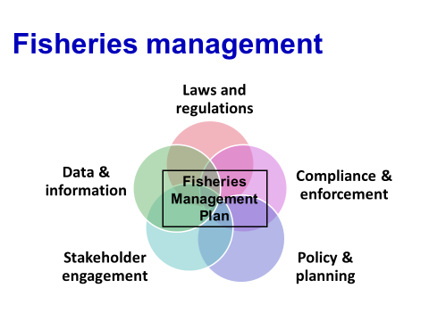
What is a fisheries manager?
A fisheries manager is a person (or persons) who coordinate the different fisheries management activities for a given fishery. In particular they manage the (i) process of informed decision making, formulation and implementation of rules and regulations, (iii) compliance and enforcement, (iv) allocation of resources and (v) negotiation.
Group activity: Discuss what you understand by fishery management in your country based on your experience. Sort the threats and issues identified earlier into those that (i) can be addressed by existing fisheries management and (ii) others.

In the region, fisheries have been managed mainly from a sectoral perspective. There are few examples of well-managed fisheries with an objective of maximizing the benefits (often considered as economic benefits) while trying to ensure that the catch is commensurate with the natural productivity of the harvest stocks. In many other fisheries the main objective of management has been to reduce conflict and it is often aimed at increasing the overall production.
Existing fisheries in the region may have characteristics such as:
- mainly focused on target species;
- single sector specific (fisheries);
- management actions mainly focus on control of fishing (e.g. gear restrictions and zones);
- stock assessment based; and
- mainly biological management objectives (e.g. increasing production).

If we consider the wide scope of threats and issues facing fisheries and their supporting ecosystems, it is obvious that existing fisheries management does not cover them all and a broader, more inclusive approach that includes many more elements of an ecosystem is needed (Figure 2.2).

Figure 2.2: A typical coastal ecosystem (Source: FAO)
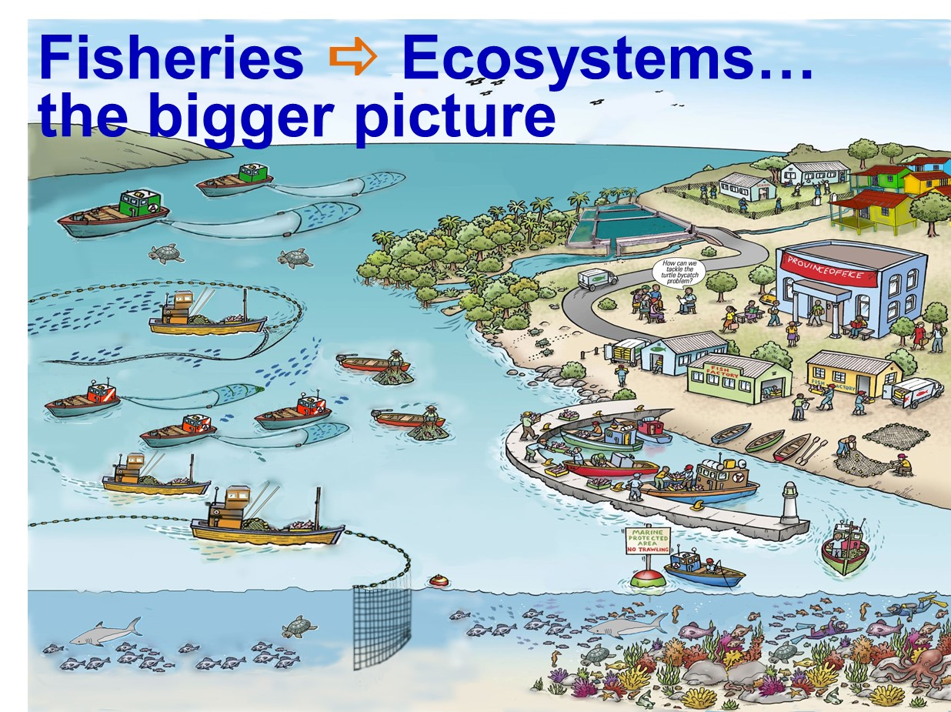

- Benefits of ecosystems
What is an ecosystem?
“An ecosystem can be defined as a relatively self-contained system that contains plants, animals (including humans), micro-organisms and non-living components of the environment, as well as the interactions between them.” SPC, 2010.
It is important to understand that many of the elements in the ecosystem are interconnected and changes in one element can have a flow-on effect to others. For example, overfishing of the top predators can have drastic changes to the whole food web.
Ecosystem services and benefits
It is important to recognise the multiple benefits that coastal marine ecosystems provide to human societies.
These benefits can be called “ecosystem services” and include:
- supply of fish for food;
- livelihoods and incomes of fishers and fishing communities through harvesting, processing and trade;
- cultural and traditional heritage values;
- economic development through tourism, trade and transport; and
- coastal protection and resilience against climate variability and change, as well as natural disasters.
The services are often categorised as:
- supporting – food webs for plants and animals;
- provisioning – supply of fish for food, wood for timber;
- cultural – recreation, cultural and traditional heritage values; and
- regulating - coastal protection and resilience against variability and change, as well as natural disasters.

In a fisheries context, fish species depend upon their surrounding and supporting ecosystems that are affected by fishing activities, other human activities, as well as natural processes. Fishing can impact marine ecosystems by: (1) catching unwanted species (bycatch); (2) causing physical damage to benthic habitats; (3) changing species composition; and (4) disrupting food chains. Other human activities unrelated to fishing, such as agriculture, forestry, coastal development and introduced species and pathogens can also affect marine ecosystems, including the many species they contain. Human and natural impacts on ecosystems are also increasingly being exacerbated by the effects of human-induced climate change and ocean acidification.
- The ecosystem approach and sustainable development
The ecosystem approach is now accepted as the management approach applicable to a range of scales, sectors and multi-sectoral approaches. This term “ecosystem approach” (EA) was first coined in the early 1980s, but found formal acceptance at the Earth Summit in Rio in 1992, where it became an underpinning concept of the Convention on Biological Diversity (CBD) that defined it as:
“A strategy for the integrated management of land, water and living resources that promotes conservation and sustainable use in an equitable way.”

The application of the EA helps to balance the three objectives of the CBD: conservation; sustainable use; and the fair and equitable sharing of the benefits arising from the utilization of genetic resources.
In effect, the EA can be thought of as the way to implement sustainable development, a concept that replaced earlier policies of development based on economic growth only. Sustainable development is defined by Brundtland (1987) as:
Development which meets the needs of the present without compromising the ability of future generations to meet their own needs

Note that “development” in this definition refers to the improvement in human well-being and that it is this development that needs to be sustainable. This means that we need to find a balance between ecological well-being and human well-being, so that development does not degrade the natural resource base on which it is dependent, but avoids overprotection of resources that prevents development. This balance between human and ecological well-being is achieved through good governance (Figure 2.3).
Figure 2.3. Sustainable development –balancing ecological well-being and human well-being through good governance.
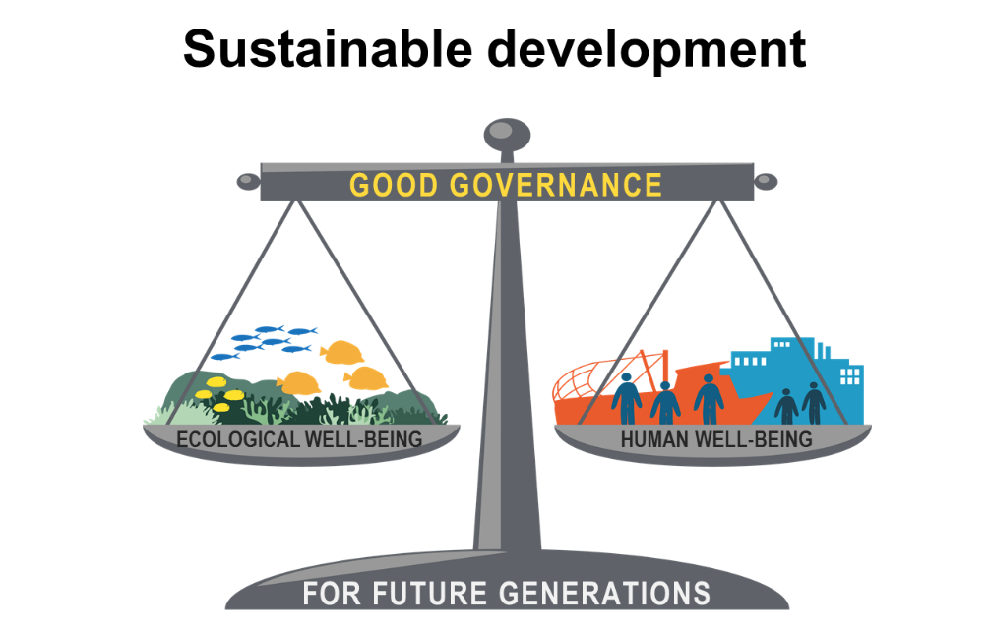
It is widely accepted that “well-being” is a concept that refers to the state of a system (e.g. ecosystem or social system). Specific aspects of the two dimensions of well-being and what is meant by good governance are outlined below.

Ecological well-being, with regard to marine and coastal ecosystems, comprises at least five major aspects:
- healthy ecosystems that maximize ecosystem goods and services;
- biodiversity that leads to ecosystem resilience;
- supportive ecosystem structure and habitats (incl. connected watersheds);
- healthy oceans, coastal areas and watersheds; and
- food webs based on diverse sources of primary production.

Ecosystem health is often expressed using indicators in terms of measurable characteristics that describe:
- key processes that maintain stable and sustainable ecosystems (e.g. there is an absence of blue-green algal blooms);
- zones of human impacts do not expand or deteriorate (e.g. a reduction in the spatial extent of sewage nitrogen); and
- critical habitats remain intact (e.g. seagrass meadows).

Human well-being refers to all human components that are dependent upon, and affecting, the ecosystem. Human well-being reflects the various activities or achievements that constitute a good life. It is also accepted that well-being is a multidimensional concept that embraces all aspects of human life. Income, on its own, although an important component, cannot adequately capture the breadth or complexity of human well-being.
Eight aspects of human well-being are:
- Material living standards (income, food and wealth);
- Health;
- Education;
- Personal activities (recreation and work);
- Political voice and governance;
- Social connections and relationships;
- Living environment (present and future conditions); and
- Economic security and human safety

These aspects are founded on the belief that measuring human well-being goes beyond subjective self-reports and perceptions, and must include an objective measure of the extent of peoples’ "opportunity set" and their capacity (or freedom) to choose from these opportunities in a life they value. Both objective and subjective factors are important in the measurement of the eight aspects listed above.
Good governance refers to the effective institutions and arrangements for setting and implementing rules and regulations. Good governance is considered in much more detail in Module 4 Principles of EAFM. In brief, good governance is related to stewardship where individuals, organizations, communities and societies strive to sustain the qualities of healthy and resilient ecosystems and their associated human populations. Stewardship takes the long-term view and promotes activities that provide for the well-being of both this and future generations.

The term ecosystem based management (EBM) is often used interchangeably with EA, but in some contexts, focuses more on the ecological/environmental dimension of sustainable development.
Note that the EA/EBM does not replace sectoral management, i.e. management of fisheries and agriculture, management of the manufacturing industries, management of mining and petroleum, and management of shipping. If applied correctly it integrates management across (i) different interests within a sector (e.g. harvesting a resource and its environmental impact); (ii) across sectors; and (iii) takes into account externalities such as climate change (see Module 15 Step 4).
Plenary brainstorm: Discuss the benefits of taking an ecosystem approach.

- Benefits of using the EA
There are many benefits of EA. The main ones include:
- Facilitates the trade-offs necessary to balance human and ecological well-being
- enables consideration of diverse stakeholder priorities;
- balances production with conservation of biodiversity and habitat protection; and
- helps resolve conflict.
- Allows adaptive management – leading to more effective coastal planning
- can be applied in data poor situations.
- Increased stakeholder participation and more transparent planning
      - increased equity in the use of coastal resources;
      - recognizes cultural and traditional values; and
      - protects the fishing sector from the impacts of other sectors and vice versa.
- Provides a way to consider large-scale, long-term issues (e.g. climate change)
- Increased political support
    - fosters political and stakeholder participation; and
    - unlocks financial resources.

Once the benefits that ecosystems bring to human societies and the benefits of the EA are recognized, it is possible to understand the need for managing these ecosystems more holistically (i.e. beyond a focus on fish only). The benefits of an EA when applied in a fisheries context are discussed in the next Module.

The what and why of EAFM?
Module 3

Session objectives:
- Describe what EAFM is;
- Describe the benefits of using an EAFM;
- Explain how EAFM fits in with other approaches;
- Recognize the complexities of multiple societal objectives.

Overview
This module explains that an EAFM is the ecosystem approach applied to the fishery sector, and is an approach to improve the contribution of fisheries to sustainable development. As such EAFM has three components – ecological well-being, human well-being and good governance. An EAFM is discussed alongside other fisheries/marine/coastal management approaches; and the key elements that make EAFM different are highlighted.
- Defining EAFM
EAFM is simply EA applied to fisheries. In other words:
“EAFM is a practical way to implement sustainable development principles for the management of fisheries by finding a balance between ecological and human well-being through good governance.” (Adapted from EAFNet: What is EAFM?)
“EAFM represents a move away from management systems that focus only on the sustainable harvest of target species to a system that also considers the major components in an ecosystem, and the social and economic benefits that can be derived from their utilisation”. State of the world’s fisheries, FAO 2012.

EAFM is the ecosystem approach applied to fisheries
i.e. a practical way to implement sustainable development and sustainably maximize ecosystem benefits of a fishery system

The word ecosystem is used to address the fishery system as an integrated socio-ecological system, with humans being an integral part of the ecosystem (see definition in Module 2 Fisheries management and the ecosystem approach). EAFM has at its heart both human well-being and ecological well-being. Thus it strives to balance conservation of biodiversity and ecosystem structure and functioning with harvesting resources for food, income and livelihoods for the benefit of humans. To achieve this balance an EAFM requires an effective governance framework.
- The three components of EAFM
Sustainable development can be summarized as a balance between ecological well-being and human well-being that does not compromise the needs of future generations Module 2 Fisheries management and the ecosystem approach (Figure 3.1)

Figure 3.1: The three EAFM components with fisheries examples

 | EAFM
Ecological well-being |  |  | Human well-being |  |  |  | Good governance
Habitat protection & restoration | Sustainable fishery resource |  |  | Increased & equitable distribution |  | Sustainable livelihoods |  |  | Compliance and enforcement

Because EAFM is a way to achieve sustainable development in fisheries, it also has the three components of:
- Ecological well-being
- Human well-being
- Good governance

- Why an EAFM? – the benefits
The management benefits of an EAFM include:
- broader consideration of links between ecosystems and fisheries;
- contribution to more effective resource use planning;
- facilitation of trade-offs between different stakeholder priorities, balancing human and ecological needs;
- increased stakeholder participation which leads to:
  - better planning of resource uses; and
  - more equitable use of natural resources (both fishery and non-fishery related);
- help with balancing fish production with conservation of biodiversity and habitat protection;
- help with resolving or reducing conflicts between stakeholders;
- greater recognition of cultural and traditional values in decision-making; and
- enabling of larger-scale, longer-term issues to be recognized and incorporated into fisheries and coastal resource management (e.g. long-term implications of climate change and ocean acidification, habitat degradation, population growth, economic development, globalization, etc.).
The table (Table 3.1) below outlines how the features of EAFM enable it to address the many threats and issues in fisheries (see previous module on threats and issues facing fisheries). The left-hand column also refers to the main sections in this Handbook which are relevant to each specific feature.

Table 3.1: How the features of an EAFM can address threats and issues common to many fisheries

Features of EAFM | How this feature helps address threats & issues facing fisheries
- Helps provide financial resources  Module 8 Startup A  Module 14 Steps 3.4 and 3.5 | - Helps coordinate input and services from different groups, such as government institutions, fisheries agencies, and other stakeholders. Improves communication with decision-makers who can release funding.  - The longer-term time horizon of the EAFM plan allows for budgetary planning.  - A more coherent EAFM plan engages with governance and can unlock resources.
- Helps gain political and stakeholder support  Module 4 Principles of EAFM  Module 8 Startup A  Module 9 Startup B  Module 12 Reality Check I | - Support is gained politically through the inclusion of local government and activities outside the fishery that will affect the fishery.  - Greater support from the judiciary.  - Harmonization with environmental departments/ministries.  - EAFM allows the identification of information and research needs by connecting scientists/academics with the planning process, which leads to research relevant to management and improved communication with stakeholders.
- Increases support for better governance  Module 9 Startup B  Modules 11, 13 and 14 Steps 2.1-2.3, 3.1-3.5  Module 12 Reality Check I | - Political support can lead to better enforcement.  - Stakeholders increase compliance with management actions.  - Allows women’s issues to be included in planning.  - Takes into account the needs of fish processors for raw materials.  - Gives a voice to small-scale fishers.
- Helps identify and address conflicts across divergent societal objectives  Module 11 Steps 2.1, 2.2  Module 12 Reality Check I | - Ensures human economic and social well-being are taken into account.  - Balances conflicting policy objectives within and between sectors.  - Opens dialogue between users and can identify solutions through conflict management mechanisms.  - Identifies and redirects effective subsidies.  - Aligns conservation versus fisheries production objectives.  - Helps identify issues between large and small-scale fishers.
- Helps protect the fishing sector from the impacts of other sectors  Module 8 Startup A  Module11 Steps 2.2-2.3 | - Works with other sectors. For example:  - Subsidies in agriculture.  - Urban runoff and habitat damage.  - Tourism development.  - Offshore mining.  - Uncontrolled aquaculture development.  - Conservation actions that do not consider their impact on fisheries and access to fisheries.
- Helps protect other sectors from the impacts of fishing  Module 8 Startup A  Module 11 Steps 2.2-2.3 | - Habitat impacts.  - Allows bycatch issues to be better addressed.  - Allows better integration ☺ of conservation and protection actions.  - Gives attention to biodiversity conservation and ecosystem integrity and support services.
- Protects different sub-sectors of the fisheries sector from negative impacts on each other Module 8 Startup A  Modules 13 and 14  Steps 3.1, 3.2 & 3.3 | - Includes all sub-sectors impacts, including  - Overfishing of juveniles by the trawl sub-sector impacts the value of the fishery.  - Aquaculture development impacts on fisheries (demand for feed and access to areas).
- Provides mechanism to link management across political and jurisdictional scales and boundaries  Module 4 Principles of EAFM  Module 12 Reality Check I  Module 12 Reality Check II | - Decentralization means that national fisheries agencies may not have remit to address user conflicts and issues of user well-being.  - Allows co-management and collaboration between government agencies from municipal, district, provincial, and national agencies, in addition to key stakeholder groups.
- Promotes communication between stakeholders, both within the fishing sector and outside it  Module 9 Startup B  Module 15 Step 4.1 | - Addresses lack of dialogue between fisheries and other departments/ministries, such as environment, agriculture, transportation.
- Can be used in data poor situations  Module 10 Step 1.3  Module 17 Steps 5.1 and 5.2 | - Uses both local/traditional knowledge and scientific knowledge.  - Monitoring and review feedback mechanisms allow new relevant information to be gathered and adaptively incorporated into management cycle.  - New information increases understanding of the socio-ecological system.
- Promotes long-term ecosystem and fisheries sustainability  Module 17 Steps 5.1 and 5.2  Module 12 Reality Check II | - Focuses on longer time horizons that allow incorporation of longer-term environmental and social changes into planning process.  - Incorporates projected social changes (e.g. population growth and development) and the impacts of climate change and ocean acidification.

4. Moving from existing fisheries management approaches to an EAFM
As described above, the main objective of EAFM is the sustainable use of the whole system, not just a single species. However, the application of an EAFM does not mean starting anew as an EAFM builds on existing elements on fisheries management. It also happens incrementally and will take years to move all elements to fully EAFM. For 11 elements of fisheries management, Table 3.2 shows the characteristics typical of existing fisheries management in relation to an EAFM.
Table 3.2: A comparison of 11 elements of management under typical existing fisheries management and under an EAFM
 | Existing approaches | EAFM
Species considered | Mainly target species. | All species in the ecosystem, particularly those impacted by fishing.
Management objectives | Relate mainly to target species and conventionally focused on biological objectives for maximising sustainable yield. | Multiple objectives covering the fisheries, ecosystem goods and services and socio-economic considerations.
Scale | Addresses fisheries management issues at the stock/fishery scale. | Addresses the key issues at the appropriate spatial and temporal scales. These are often nested (local, national, sub-regional, regional, global).
Data and information used | Mainly scientific data focusing on target species. | Broader knowledge base (both scientific and traditional) that emphasizes learning by doing (adaptive management).
Assessment methods | Largely stock assessment for key target species. | Multi-species and ecosystem assessments through indicators.
Management intervention | Mainly control of fishing. | Broad-based incentives (including ecosystem tools such as Marine Protected Areas (MPAs) ). Links with Integrated Coastal Zone Management (ICM) and broad-based incentives.
Planning | Usually in the form of a Fisheries Management Plan that considers target species. | The EAFM plan that considers the fishery, ecosystem and human systems and governance.
Stakeholders | Fishers, fishing industry/communities. | Broader stakeholders: people affected by or who affect EAF management.
Sectors | Sectoral, i.e. focuses mainly on fisheries sector issues. | Deals more explicitly with the interactions of the fishery sector with other sectors, e.g. coastal development, tourism, aquaculture, navigation, petroleum industry.
Policy and decision-making | Largely at the government level. Addresses mainly corporate (fisheries sector) interests. | Participatory with major stakeholders. Addresses the interests and aspirations of a broader stakeholder community.
Participation | Top-down (command and control) approaches typify conventional fisheries management. | Participatory approaches, e.g. various forms of co-management are a key feature of EAFM.
Compliance and enforcement | Operates through regulations and penalties for non-compliance. | Encourages compliance with regulations through incentives.

5. Other approaches
EAFM complements and integrates numerous existing approaches to fisheries, marine and coastal resource management. Co-management that ensures multiple stakeholder decision-making and ownership is at the heart of EAFM (see Startup B and Reality check II). Both Integrated Coastal Zone Management (ICM) and Marine Spatial Planning (MSP) have a lot of overlap with EAFM as management approaches. ICM is EA/EBM across different sectors applied in the coastal areas and depending on one’s entry point to the EA, MSP can be thought of as a management action for achieving EAFM objectives. These approaches are all nested within the EA/EBM concept (Figure 3.2).
All these approaches recognize that management must deal with broad ecosystem management (both natural and human components) and try to optimize the social and economic benefits.

Figure 3.2: EAFM complements other approaches

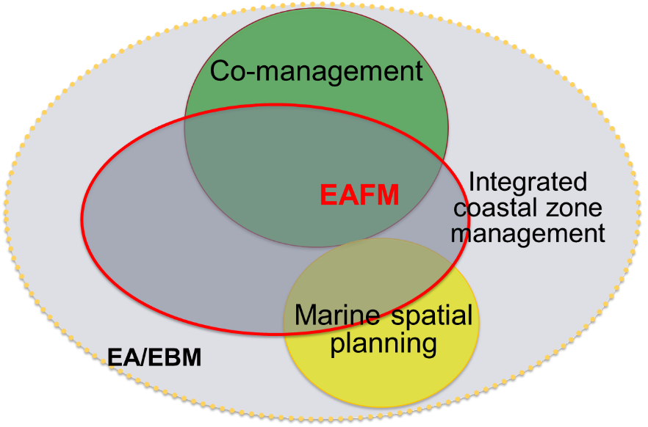

Marine Spatial Planning (MSP) is a public process of analysing and allocating the spatial and temporal distribution of human activities in coastal and marine areas to achieve ecological, economic and social objectives that are usually specified through a political process (UNESCO, 2009). The term covers both (i) a plan for users; and (ii) implementation tools – e.g. zonation that includes MPAs.
Use of MPA networks is often an aspect of MSP. Marine protected areas are really another management tool and should be used in conjunction with other management actions (see Module 14 Step 3.3). As a tool, they can potentially address both fisheries management and conservation considerations, but have often been applied primary to address conservation of biodiversity concerns, not fisheries. Furthermore, it is not uncommon for MPAs to be established without stakeholder consultation, thus decreasing the chance of success. Some key elements of fisheries management which MPAs do not usually address include:
- control of fishing capacity;
- management of an area beyond the boundary of the MPA; and
- impacts of other uses on fisheries.
Conservation measures, such as MPAs can both benefit and impose livelihood costs on local stakeholders, therefore the equitable sharing of costs and benefits is a major challenge when conservation tools are implemented. In developing countries, this difficulty is compounded by the fact that, at the public sector level, there are multiple agencies from the fisheries, environment and other sectors, often working at cross-purposes. Greater cross-sector integration would help achieve more equitable sharing of the costs and benefits of MPAs as a fisheries management tool.
In many cases, the required management action lies outside the scope of the fisheries agency and there is a need for better cooperation between agencies and stakeholders, especially during the planning stages of EAFM. Initiatives such as ICM in both coastal and inland waters can provide a platform for this, but to date fisheries agencies have been reluctant to participate. Once this important step has been achieved, day-to-day management of fisheries can then be left to the fisheries agency to deliver, with regular meetings of other concerned stakeholders to assess progress and resolve any conflicts that may have arisen.
Implementing an EAFM can result in higher management costs, due to the broader data and information requirements, the planning and consultative decision-making process, as well as a wider scope for monitoring, control and surveillance (MCS). However, effective implementation of existing fisheries management should also require these very same efforts. Although the potential cost increases of an EAFM should be outweighed by the longer-term human and ecological benefits, the question of “who pays?” will often be important, especially in a transition phase of implementation. The idea that the beneficiary pays (user pays) is becoming increasingly accepted. Because EAFM also responds to wider societal needs, the costs theoretically should be divided between those people who are benefiting directly, such as fishers, and society at large.

Activity: Balancing different societal objectives. Watch the video and discuss in groups.

Principles of EAFM
Module 4

Session objective:
- Examine the principles of EAFM and their link to the FAO Code of Conduct for Responsible Fisheries (CCRF).

Activity: Develop a time line of key events that have shaped your fisheries.

Overview
This module outlines the principles of EAFM: (i) good governance, (ii) appropriate scale (iii) increased participation, (iv) multiple objectives, (v) cooperation and coordination, (vi) adaptive management, and (vii) precautionary approach .
Introduction
EAFM is a broader and more holistic approach to managing fisheries. As a result, there are a few key differences between existing fisheries management and an EAFM. The following considerations will help identify where these differences lie and how your current approach to fisheries management could be adapted to achieve EAFM.
- Principles of EAFM
The key EAFM principles (Figure 4.1) can be summarised as follows:
- Good governance.
- Appropriate scale that takes into account connections within and across ecosystems and social systems (these connections can be place-based; across different environments: land-air-sea; and across scales, i.e. district/regional/national/international).
- Increased participation of key stakeholders.
- Management for multiple objectives (balancing societal trade-offs entails working across scales and with different stakeholder objectives; the aim is to develop objectives which address multiple challenges/concerns).
- Cooperation and coordination both vertically across different levels of government and society and horizontally across agencies and sectors.
- Adaptive management that embraces change through learning and adapting. The key is to have flexible systems and processes, including feedback loops that allow for learning through doing.
- Use of the precautionary approach when uncertainty exists.
Figure 4.1. Key principles of EAFM
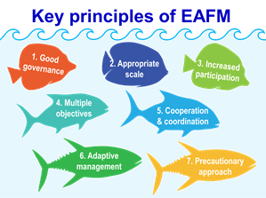
- EAFM principles and the FAO Code of Conduct for Responsible Fisheries
The EAFM principles are based on a set of guiding principles first put forward in the FAO Code of Conduct for Responsible Fisheries (CCRF) . The CCRF is voluntary, although parts are based on international law, including those of the 1982 United Nations Convention on the Law of the Sea (UNCLOS). The CCRF covers all aspects of management and development of fisheries, including capturing, processing and trade in fish products, fishing operations, aquaculture, fisheries research and the integration of fisheries into integrated coastal management (ICM) .

The CCRF sets out some important principles for responsible fisheries (see Box 4.1 for those relating to fisheries resources and the ecosystem and Box 4.2 for those relating to the social and economic dimensions of sustainable development). These principles were developed before the concept of EA and EAFM were fully articulated, but because they were based on the concept of sustainable development at that time, they form the basis of the seven EAFM principles we use in this course.

Box 4.1: Main principles of the CCRF relating to fisheries resources and the ecosystem (ecological well-being)
- Maintain fishery resources for present and future generations.
- Prevent overfishing and excess capacity to ensure that fishing effort is commensurate with the productive capacity of the resource.
- Apply the precautionary approach, do not wait for perfect knowledge
- Manage not only the target species but also species belonging to the same ecosystem.
- Protect and rehabilitate critical habitats.
- Ensure fishery interests are taken into account in the multiple use of the coastal zones and are integrated into coastal area management.
- Undertake appropriate environmental assessments and monitoring with the aim of minimizing adverse ecological changes and related economic and social consequences.

Box 4.2: Main principles of the CCRF relating to social and economic considerations (human well-being)
- Base conservation and management actions on the best scientific advice (environmental, social, and economic) available, taking into account traditional knowledge.
- Protect the rights of fishers and fish workers, particularly those involved in artisanal small-scale fisheries, to a just livelihood as well as preferential access, where appropriate.
- Promote the contribution of fisheries to food security and food quality, giving priority to the needs of local communities.

- EAFM principles in detail

1. Good governance
Governance is the way rules are set and implemented. It includes the mechanisms, processes and institutions through which citizens and governing groups (institutions and arrangements) voice their interests, mediate differences, exercise their legal rights and meet their obligations (AusAID, 2000). Governance is often a complex mixture of formal and informal processes that might involve a geo-political entity (e.g. nation-state government), a socio-political entity (e.g. chiefdom, tribe, family, etc.), or any number of different kinds of institutions and arrangements.
Governance comprises:
- key political support;
- legal authority to manage;
- effective institutions;
- coordination arrangements with government, external agents, resource user groups and community members;
- community support through participatory processes;
- enforcement and compliance;
- a collaborative decision-making process;
- information and data to support monitoring and learning-by-doing;
- adequate and dedicated resources (personnel, funding, equipment) for management;
- staff skills and commitment; and
- consideration of external factors affecting governance – market forces, climate change, natural disasters, level of socio-economic or human development, etc.
While the concept of “governance” is descriptive, the idea of “good governance” is standard-setting, i.e. normative in nature. The exact meaning of “good governance” varies according to the policy area in question, but there are eight general characteristics of good governance (Figure 4.2).

Figure 4.2: Characteristics of good governance

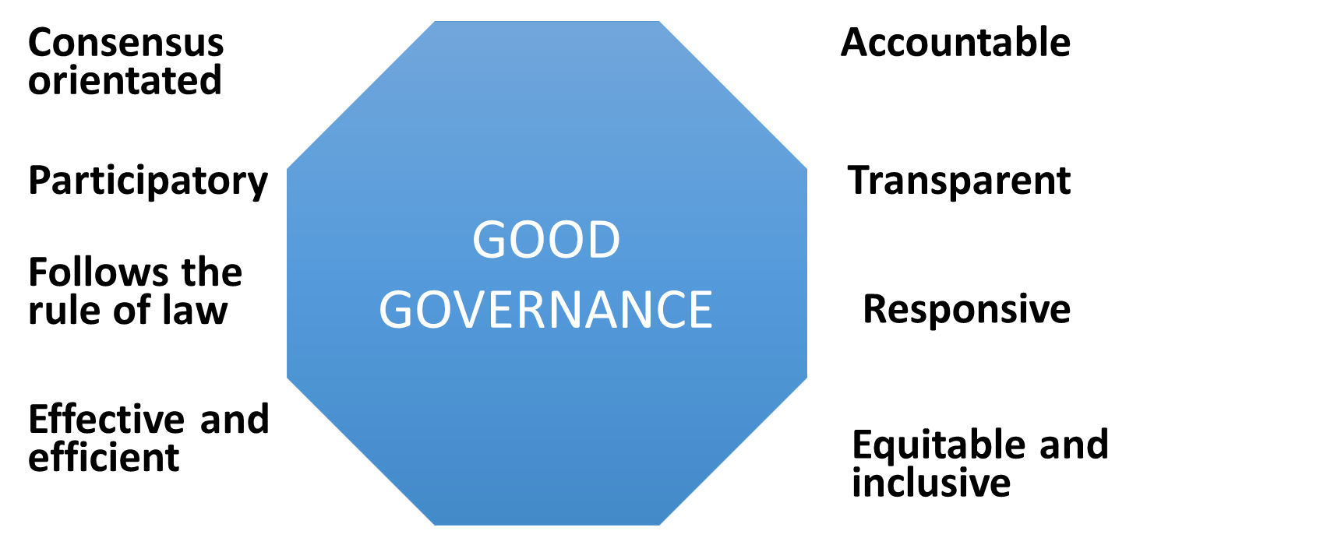
Source: http://www.unescap.org/pdd/prs/ProjectActivities/Ongoing/gg/governance.asp

Accountable: the governing body should be able and willing to show the extent to which its actions and decisions are consistent with clearly-defined and agreed upon objectives. It is also responsive to the present and future needs of society.

Transparent: the governing body’s actions, decisions and decision-making processes should be open to an appropriate level of scrutiny by other parts of government, civil society and, in some instances, outside institutions and governments. This ensures corruption is minimized.

Responsive: the governing body should have the capacity and flexibility to respond rapidly to societal changes and take into account the expectations of civil society in identifying the public interest. It should be willing to critically re-examine its own role.

Equitable and inclusive: the governing body should ensure that the views of minorities are taken into account and that the voices of the most vulnerable in society are heard in decision-making.
Effective and efficient: the governing body should strive to produce quality public outputs, including services delivered to citizens, at the best cost, and ensure that outputs meet the original intentions of policymakers.

Rule of law: the governing body should enforce equally transparent laws, regulations and codes.

Participatory: by actively involving stakeholders (both men and women) in consultation and decision-making, the governing body hopes to foster ownership and support of policy.
Consensus oriented: the governing body strives to achieve a broad consensus on policy to foster policy acceptance.

Good governance for EAFM should ensure both human and ecological well-being, including equitable allocation of benefits. In fisheries, where management and exploitation occur largely out of public view (even though the fishery is often managed by the public sector), accountability is of great importance. As a means of ensuring accountability, access to information and transparency in policy are critical. This access is also a precondition for meaningful public participation in decision-making.
Policy effectiveness can be improved by decentralized management, as measures can be tailored to local needs and increased opportunities can be given to local stakeholders through participation in decision-making.
As a path towards good governance, there are several aspects of organizational behaviour that may be useful:
- establish simpler, non-competing mandates for agencies;
- provide information to many governmental and non-governmental actors;
- restructure intra-governmental arrangements to reduce the opportunities for interagency jurisdictional conflicts;
- restructure organizational incentives to create longer time horizons for agency leaders and personnel; and
- manage conflicts of interests that promote corruption.
2. Appropriate scale
EAFM aims to secure sustainable fisheries by using ecologically relevant boundaries rather than political or administrative ones. This is a big change from traditional fisheries management which works within political or administrative boundaries. The reality is that the scale at which fishery management occurs will be primarily determined by jurisdictional and political boundaries, but there are some general socio-economic and ecological issues which, if considered, would help broaden the mandate of fisheries management. Bear in mind that there is no consensus on how best to factor in these considerations and this is because the scale of the fisheries management unit (FMU) will depend on the aims and goals of that specific fishery (see also Module 10 Step 1.3 and Module 16 Reality CheckII.

Scaling can be considered in four dimensions, three of which align to the three components of EAFM:
- Ecological scales
- Socio-economic scales
- Political/governance scales
- Temporal scales
Ecological scaling
The following aspects of ecological scaling should be considered:

- The distribution and behaviour of the target species
For example, spawning may happen in one place, but the fishery is located elsewhere; nursery areas versus fishing grounds; migratory stocks.
- Large scale processes
For example, the Indian Ocean Dipole, location and paths of boundary currents, upwelling zones. These will operate on decadal time scales and up to thousands of kilometres in distance.
- Smaller-scale features
For example, the distribution of habitats, estuarine plumes and deltas, areas of upwelling, bathymetry.
- Food web processes
Food web ecology looks at the structure and dynamics of species feeding relationships and abundance. It focuses on the underlying processes of feeding behaviour, consumer-resource interactions, community assemblages, diversity, complexity, productivity and predator-prey relationships. The food web scale needs to be considered in EAFM as it helps to understand the link between species (target and/or non-target) and wider ecosystem functions, including the impact of fisheries on the environment and the impact of the environment on fisheries, such as El Niño-Southern Oscillation events.
Socio-economic scaling
A fishery can comprise a single community or be spread along a coastline. It may also be made up of various large- and small-scale operators working from different ports and landing sites.
This affects the way that stakeholders are identified and how the different groups are engaged during an EAFM planning process.
Furthermore, these characteristics are dynamic, not static and as such they may change over time, whether seasonally or over longer time frames. This is because the areas where fisherfolk want and need to fish is influenced by a variety of issues, such as:
- cultural norms (“we have always fished here”);
- changing preferences (driven by market demand);
- price of fuel; and
- migrant fishers, illegal fishers.
Governance scaling
The legal and jurisdictional scale of the FMU will be nested within a wider framework that spans all levels, from local community to provincial, to national, to sub-regional, to regional and to global. The paradox of scale dictates that even if EAFM is done at the smallest, most local scale, a number of institutions across the different governance scales will be involved in decision-making processes that might influence what will happen inside the FMU.
A longer-term goal for EAFM in a country might be to have a harmonized governance arrangement that allows for the FMU goals and policies to be realized within the context of a broader, national framework. The reality is that the starting point will be the pre-existing governance arrangements, and mechanisms need to be put in place over time which allow for the management decisions made in the FMU to harmonize across different governance scales.
Temporal scaling
EAFM requires a change in focus from obtaining short-term to long-term ecosystem benefits. As we have learnt, sustainable development is based on generating equity via “development that meets the needs of the present without compromising the ability of future generations to meet their own needs”. Trade-offs will need to be made so that long-term benefits can be realized. At times, this may result in “winners” and “losers” in which the “losers” may need to be compensated (an action avoided by most governments). Ecosystems also change over time and EAFM will require a shift in time considerations, e.g. expand from short-term issues like annual catch limits to longer time frames/objectives that include environmental variability and climate change.
Is there a “correct” scale to expand fisheries to a broader ecosystem context?
There is probably no “correct” scale to expand fisheries to a broader ecosystem context. However, scaling issues do require careful consideration because incorrect decisions on scale could lead to sub-optimal social, economic or ecological outcomes for the fishery. As a baseline, all major fishing gears for the main species being managed must be included e.g. small-scale and large-scale industrial fishing gear and vessels. In reality, the scale for EAFM will be a compromise. Many definitions of EAFM suggest “meaningful ecological boundaries” but the ecosystem boundaries for a sedentary species such as a cockle or sea cucumber are considerably different from those of a highly migratory species such as tuna. There will always be activities and impacts outside the EAFM unit that affect what goes on inside it. These externalities should not be ignored but considered and dealt in some way, often through governance scaling and increased cooperation and coordination.
It is important to remember that moving to EAFM will be incremental, so rather than worrying about identifying the correct scale, a better approach is to take ecosystem considerations into account at a scale that is appropriate to the fishery in question, in terms of the stock of a particular fishery (harvest and bycatch) and the economy and culture of the communities where the particular fishery is based.
For the highest likelihood of success, an EAFM plan should be developed pragmatically, and should be based on practical scales and boundaries, taking into account existing jurisdictional boundaries. This means that the stock or fishery under consideration should also be framed within meaningful jurisdictional boundaries (e.g. state or provincial jurisdictions).
Crossing between jurisdictional boundaries can be a challenge, but EAFM does provide a framework within which cooperation or harmonization can occur (see Module 8 Startup A task v. and Module 16 Reality Check II).

Activity: In many countries, fisheries management has been devolved to the district/municipality level. In your groups, answer the question: “Is the district/municipality the correct scale to manage all fisheries?”

3. Increased participation
In EAFM both the communities of local resource users and the government (whether local, provincial, national or regional) share the responsibility and authority for managing and determining the sustainability goals of the fishery. EAFM is participatory and this means stakeholders are a central part of the management process. For more details on participation see Module 9 Startup B and the People Toolkit.
Stakeholders and resource users include people, households and communities who interact with and care about the fishery and the associated ecosystem. This will include a diverse number of users, for instance fishers, tour operators, coastal developers, shipping industry, conservationists, etc.
Does including more people in the fishery management process increase conflict?
In some cases stakeholders are competitors and their inclusion can be challenging, especially if there is a pre-existing conflict (this can be between resource users or between institutions, e.g. the environment and fisheries departments).
In the long run, having diverse user perspectives represented and involved in the management planning process serves to increase the understanding of issues and can help to reconcile differences (rather than the alternative which is to become entrenched in one’s own opinion). EAFM actually includes decision-making protocols that can pre-empt and deal with conflict and there are a number of tools to do so (see Module 12 Reality Check I and the People Toolkit).
Stakeholders are identified in Module 8 Startup A phase of the EAFM planning process and a Key Stakeholder Group is established to represent these different voices. Stakeholder representatives in the key group communicate the needs of those whom they represent into the EAFM plan. These needs will shape the goals and objectives of the EAFM plan and will no doubt involve a trade-off between the social, economic and ecological objectives (see Module 3 Fisheries management and the ecosystem approach).
Potential stakeholders include: fishers and fisher associations, governments (district – national), fishery related (e.g. boat owners, money lenders), compliance and enforcement, other users (e.g. tourism, ports) and external agents (e.g. NGOs, researchers) (Figure 4.3).

A co-management approach is more likely to foster participation. Co-management is a partnership arrangement between stakeholders and governments to share the responsibility and authority for the management of a fishery, with various degrees of power sharing. More details on co-management can be found in Module 9 Startup B and Module 16 Reality Check II.

4. Multiple objectives
The success of EAFM depends on reaching a balance between conservation and sustainable use of fishery resources within the limits of ecosystem functioning (see Gulf of Mannar example) and between ecological, economic and social objectives within specific geographical areas. EAFM requires commitment to overcome difficulties (both conceptual and practical) in making choices that require trade-offs and compromises between different sectors of society. This requires long-term political will (backed by sufficient resources) and also short-term economic and social support, particularly for the local stakeholders. However, as noted previously, if successful the benefits could be very significant.
5. Cooperation and coordination
With EAFM there is a need to ensure harmony between scales of governance and management; and linkages between and among the various scales, particularly governance scales that likely range from individual communities to districts, provinces and national governments.
The scaling of governance (i.e. legal and jurisdictional considerations) ties in closely with the need for institutional cooperation and coordination (see Module 8 Startup A task v. and Module 16 Reality Check II). This is because, to be able to move beyond what fisheries agencies typically do (which is to manage fisheries in lots of places) and towards what EAFM does (manage different fishing and non-fishing activities, and sectors affecting fisheries and associated ecosystems in one place), other non-fishery sectors need to be engaged and involved in the management process.
EAFM requires institutional cooperation and coordination because it more explicitly deals with the interactions of the fishery sector with other sectors (Figure 4.3). But before connections are made with other sectors, it is important to first make sure that internal institutional cooperation is in good order. For instance, are fisheries science and research activities supporting fisheries management information requirements? The next step is to ensure effective institutional cooperation and coordination between sectors that are directly related and sometimes even mandated with fishery-associated activities. For example, do monitoring and research activities within academic institutions reflect fisheries related management requirements? Or, is the fishery agency coordinating with the navy and coastguard over control and enforcement issues?

Figure 4.3: Potential EAFM stakeholders and the linkages in cooperation and coordination

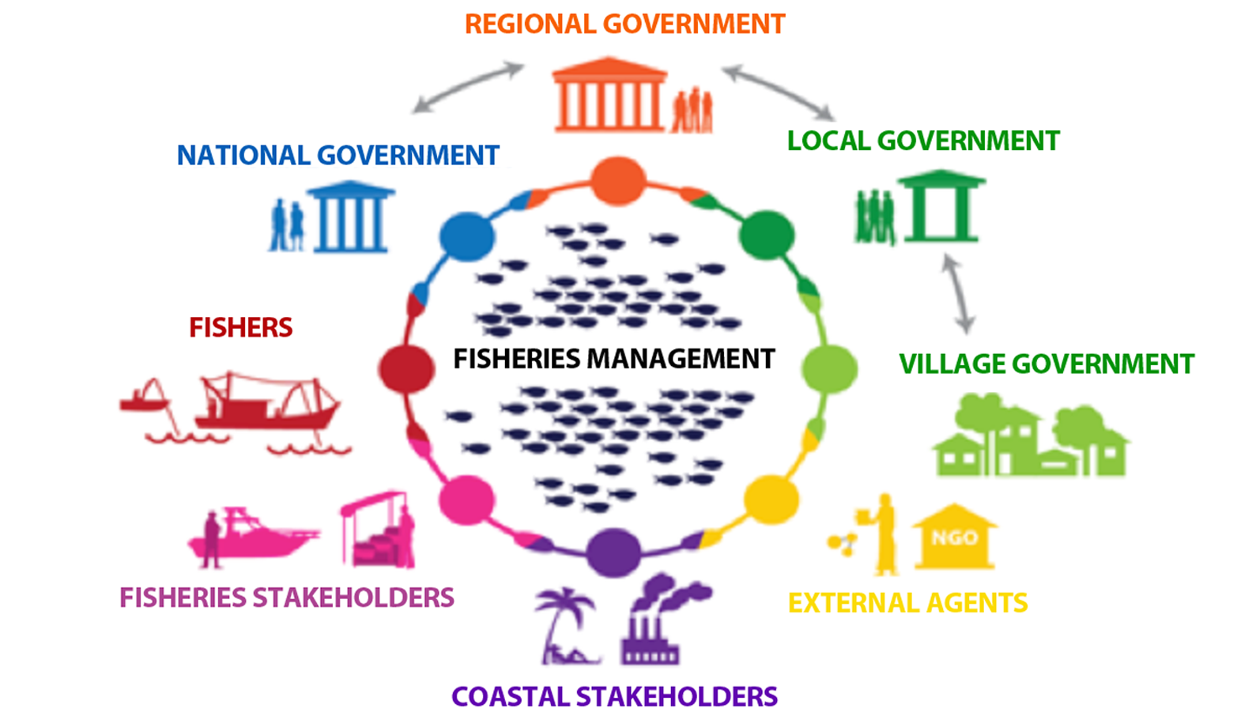

Once there is better cooperation within fisheries agencies and sectors more directly related to fishing activities, then fisheries agencies will be better positioned to coordinate with less obviously related sectors. This will involve working with sectors not traditionally associated with fisheries, for example, ministries of agriculture, energy, tourism, housing and development, women’s affairs, fisheries and marine resources, the environment and rural water sanitation. Through better cooperation, the different actors actively contribute and work together on fisheries management and share the costs, benefits, successes and failures. Cooperation is needed for action regarding rule making, conflict management, power sharing, social learning, dialogue and communication as well as development among the partners.

Examples of cooperative or coordinating activities or mechanisms include:
- talking to others;
- data sharing and information;
- support for local/provincial implementation;
- harmonized or complementary work plans, budgets (across sectors/agencies) and goals;
- linking in with other coordination arrangements e.g. ICM; and
- developing interagency arrangements.
In developing interagency arrangements, formalized memorandums of understanding (MOUs) or other binding agreements can help to establish cross-sector collaboration.

6. Adaptive management
Adaptive management provides a framework for managing change over time (see temporal scaling issues above) by learning from doing. Adaptive management involves managing and learning from what has been done by evaluating the outcome of the management action. It is closely linked to the precautionary approach (see section below) (Figure 4.4). It is not necessary to wait until all the data and information are available and analysed before taking action. Management actions can be put in place and providing they are monitored and evaluated, they can be modified based on the lessons learnt from their implementation.
Figure 4.4. Adaptive management aims to reduce uncertainty through time by evaluating the efficacy of what has been done in order to retain management interventions that do work and discard or improve those that do not.
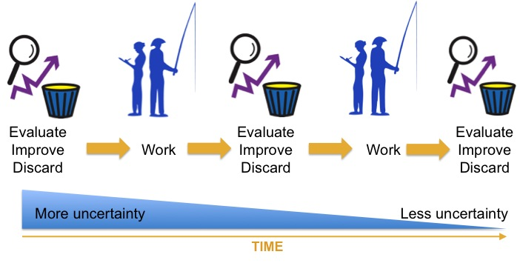
7. Precautionary approach
The precautionary approach can be considered the backbone of EAFM. It was originally defined by UNCED in 1992 as:
“… where there are threats of serious or irreversible damage, lack of full scientific certainty shall not be used as a reason for postponing cost-effective measures to prevent environmental degradation”
The United Nations Conference on Straddling Fish Stocks and Highly Migratory Fish Stocks (UN 1995) first articulated the principle for fisheries with the following definition:
“States shall be more cautious when information is uncertain, unreliable or inadequate. The absence of adequate scientific information shall not be used as a reason for postponing or failing to take conservation and management measures (UN, 1995).
The two ramifications of the precautionary approach, therefore, are:
- Lack of data and information should not be used as an excuse for not taking action.
A claim of insufficient information is often used as a delaying tactic. Instead of dealing with an obvious environmental problem, the catch cry of “need more research” is used to focus the issue back on the scientific community, rather than starting to deal with it using an adaptive management approach. A common myth is that the scientific information available is insufficient to apply EAFM to any ecosystem, let alone ecosystems that are poorly studied. However, EAFM is NOT about managing the whole ecosystem; it is about integrating management – at a minimum it means managing direct human impacts of fisheries (and other human activities). In fact, there is always enough information to begin action, otherwise the issue would not have been recognized in the first place.
- Where there is uncertainty, management actions should be less risky.
The greater the information gap and the amount of uncertainty, the more risk averse management should be. If, through adaptive management, the learning is that the situation is much worse than originally described, risk-averse management allows room for later correction.

Activity: In groups, revisit threats and issues and cluster them into three EAFM components.

Activity: Working individually, identify EAFM elements you are already doing; identify the gaps, suggest ways to improve. Share your thoughts in small groups.

Moving towards EAFM
Module 5

Session objectives:
- Recognize how the USA adopted the EAFM principles and moved towards EAFM (case study);
- Determine where your respective country stands in terms of moving towards EAFM;
- Identify challenges your country faces in moving towards EAFM.

Overview
This module demonstrates how one national government, the United States of America (USA) has evolved from conventional fisheries management toward an EAFM through a progression of small steps over the past several decades. It discusses how fisheries management laws and policies have evolved toward an EAFM and uses case studies to show how the EAFM principles are increasingly being adopted into fisheries management (highlighted below).
Introduction- the supporting Fisheries Act
In 1976, following the collapse of fisheries around the globe and in the United States, the USA Congress declared that a national program for the conservation and management of the fishery resources of the USA was necessary to prevent overfishing, rebuild overfished stocks, ensure conservation and realize the full potential of the nation’s fishery resources. This declaration resulted in the passage of the Magnuson-Stevens Fishery Conservation and Management Act of 1976, the primary law governing marine fisheries management in the USA from three to 200 nautical miles from shore. While fisheries management under the Magnuson-Stevens Fisheries Act of 1976 was transformational and represented a significant shift toward an EAFM, it was still much more aligned with single species or sectoral fisheries management approaches.
The Act recognized the authority of the coastal state (e.g. Hawaii, California, Oregon, etc.) to manage fisheries from the shoreline to three nautical miles from shore. For the sake of national uniformity, the Act established 10 National Standards for fishery conservation and management. All fishery management plans (FMP), FMP amendments, and fishery regulations must be consistent with these 10 National Standards which include a number of specific conservation and management measures.
The Act created eight regional fishery management councils to advise the responsible agency within the USA government (NOAA’s National Marine Fisheries Service (NMFS)) on management of the nation’s fisheries, and to develop regional FMPs for the various fisheries across the eight regions of the United States. At that time, the primary function of the regional fishery management councils was to develop FMPs that conserve marine resources and habitats and maintain opportunities for fishing at sustainable levels of effort and yield.
Each regional fishery management council is composed of representatives of Federal Agencies of the USA national government (e.g. NMFS; the USA Fish and Wildlife Service); Coastal State Agencies (e.g. state fisheries departments); commercial and recreational fishers, and other individuals with knowledge of conservation and management of fisheries resources. Fishers and other non-governmental representatives are nominated by the governors of the coastal states.
In the development of FMPs, consultation takes place between council staff, the public and/or the fishing industry, contractors, advisory bodies, the regional fishery council and NOAA. The councils may also establish FMP Development Teams; Fishing Industry Advisory Committees or Panels; other ad hoc advisory groups and a Science and Statistical Committee. Together these teams provide specialist information for the development of a FMP. In this manner, the councils serve to assist cooperation and coordination among key stakeholders (EAFM Principle #5 Cooperation and coordination).
Public participation
- Each regional fishery management council and each of its advisory bodies is required to conduct open public meetings in the geographical area concerned, so as to allow all interested parties an opportunity to be heard in the development of FMPs and amendments (EAFM Principle #3 increased participation).
- The development of an FMP or FMP amendment may take many years to complete, with several dozen meetings conducted before management measures are finally translated into law (EAFM Principle #6 Adaptive management).
Case studies
The case studies presented in this section focus on the Western Pacific Regional Fishery Management Council, whose jurisdiction includes the EEZ around the following coastal states:
- Commonwealth of the Northern Mariana Islands (CNMI)
- Territory of Guam
- Territory of American Samoa
- State of Hawaii
- Seven unincorporated possessions of the USA, including the islands of Howland, Baker, Jarvis and Wake, Johnston Atoll, Palmyra Atoll and Kingman Reef (known collectively as the Pacific Remote Island Areas)
Case Study 1
Conventional management of a lobster fishery in the remote Northwestern Hawaiian Islands
The Northwestern Hawaiian Islands (NWHI) are remote uninhabited islands, atolls, and submerged banks spanning about 2,000 km and located to the northwest of the populated Main Hawaiian Islands. In the mid-1970s, many of the fishery resources in the populated Main Hawaiian Islands were experiencing high levels of exploitation and there were many signs of declining abundance and potential overfishing. To relieve pressure on the fishery resources of the Main Hawaiian Islands, exploratory fishery assessment surveys were initiated to locate alternative resources. Those early exploratory surveys discovered a high abundance of spiny and slipper lobsters located across the NWHI. In 1977, a lobster fishery and lobster research survey program was initiated. In 1983 the Western Pacific Regional Fishery Management Council finalized a Crustacean Fishery Management Plan to manage this new lobster fishery. This FMP was established under the precautionary approach requirements of the Magnuson-Stevens Act 1976 (EAFM Principle #7 Precautionary approach). It included a minimum size limit (based on carapace length) and prohibited the taking of lobsters in depths less than 10 fathoms (~20 m) throughout the NWHI.
Figure 5.1: Time line of total landings and significant events for the Northwestern Hawaii islands
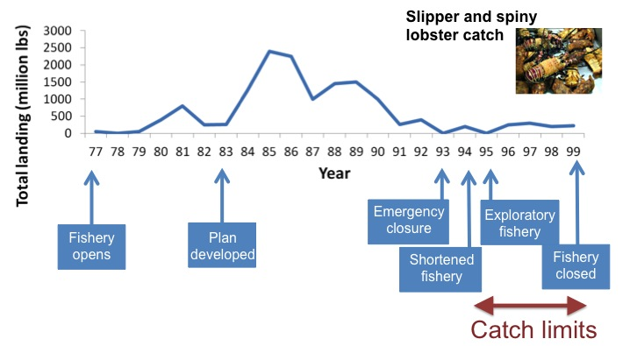
The fishery grew very rapidly from 1983 to 1985/86, when total landings increased from ~68,000 metric tons to ~1,043,262 metric tons (Figure 5.1). Over the next six to seven years, total landings steadily fell back to ~68,000 metric tons), representing an 80 percent decline in catch by 1991. In 1992, limited entry (maximum of 15 vessels) and catch limits were established. With little sign of recovery, a limited experimental fishery with significant catch restrictions was allowed, starting in 1995 (EAFM Principle #6 Adaptive management). In 1996, the catch limits were set to 13 percent of the assessed exploitable population based on an assumed 10 percent risk (EAFM Principle #7 precautionary approach). Based on those precautionary restrictions, it was anticipated that lobster populations would rebound. However, the fishery did not recover and was closed in 1999 due to stock assessment model uncertainty. Though it was anticipated that the fishery would eventually re-open once science-based improvements could be made to the stock assessment models, competing concerns led to the permanent closure of the lobster fishery. These included the protection of critically endangered Hawaiian monk seals and the establishment of the entire NWHI as a Coral Reef Ecosystem Reserve in 2001 and as the Papahānaumokuākea Marine National Monument in 2006.

Lessons learned from the NWHI lobster fishery
- The stock assessment models were based on measures of catch per unit effort (CPUE) that combined the two species (spiny and the slipper lobster).
- The stock assessment models did not account for variability in ecosystem productivity. While productivity declined, lobster exploitation continued to increase, further reducing standing stock biomass.
- Stock assessment models assumed a single stock population; however, new information suggests that the lobster populations are spatially-structured. Furthermore, the data used to assess stock status was derived from fishery operations from the most highly productive banks, leading to inaccurate estimates of maximum sustainable yield (MSY).
- Lobsters are a prey species of the critically endangered Hawaiian monk seal. Lawsuits were filed to close the lobster fishery under the USA Endangered Species Act.
- The rapid development and subsequent crash of the fishery provides a classic example of the potential pitfalls of a conventional approach to fisheries management which focuses on managing the stock for MSY in isolation from its population structure and wider environment.
- Management of the area in which the fishery was based was an evolving process that began by focusing management actions on the target species (e.g. managing for MSY using effort restrictions). The precautionary approach was applied when, due to uncertainty in stock status, the lobster fishery was closed. Over time, management of the area addressed other habitat impacts (the Northwestern Hawaiian Islands became a large marine protected area closed to all extractive activity). Despite these interventions, experimental fishing has shown that depleted populations did not recover immediately.
An EAFM builds upon conventional fisheries management by broadening the scope of management, increasing stakeholder engagement in management, increasing breadth and use of information inputs, applying the precautionary principle, and managing based on more than just MSY.
Amendment to Magnuson-Stevens Act (Sustainable Fisheries Act of 1996)
In 1996, the Magnuson-Stevens Act of 1976 was significantly amended with the passage of the Sustainable Fisheries Act of 1996 (SFA). There were two major changes to the purpose of the law:
- The promotion of catch-and-release programs was added to conservation and management principles.
- The protection of essential fish habitats (EFH) was added, where EFH was defined as those waters and substrate necessary to fish for spawning, breeding, feeding, or growth to maturity.
The inclusion of requirements to protect essential fish habitat in all waters of the United States provided the legal and policy support needed to more effectively implement an EAFM.
Case Study 2
Development of the Coral Reef Ecosystem Fishery Management Plan of the Western Pacific region

Development of a Coral Reef Ecosystem FMP
Responding to the Sustainable Fisheries Act of 1996, the Western Pacific Regional Fishery Management Council developed and NOAA adopted a Coral Reef Ecosystem FMP in 2004 as a proactive step to more effectively manage extraction of coral reef resources if fisheries expanded beyond three miles from shore (Figure 5.2).

Goals of the Coral Reef Ecosystem FMP
The overall goal of the Coral Reef Ecosystem FMP was to establish a management regime for the entire Western Pacific Region that would maintain sustainable coral reef fisheries while preventing adverse impacts on stocks, habitat, protected species, or the ecosystems. Hence, the goals of this first ecosystem-based FMP were a noteworthy shift toward an EAFM (EAFM Principle # 4 Multiple objectives).

Figure 5.2: The Coral reef ecosystem in the Western Pacific region

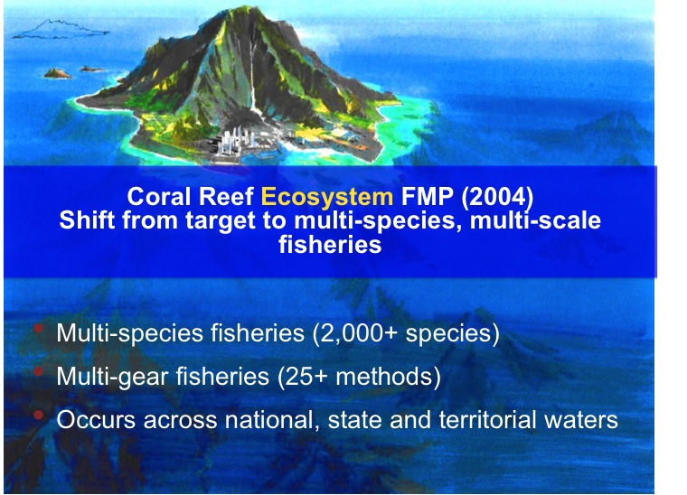

Management objectives of the Coral Reef Ecosystem FMP
- To foster sustainable use of multi-species resources in an ecologically and culturally sensitive manner, through the use of the precautionary approach and ecosystem-based resource management.
- To provide a flexible and responsive management system for coral reef resources that can rapidly adapt to changes in resource abundance, new scientific information, and changes in fishing patterns among user groups, or by area (EAFM Principle # 6 Adaptive management).
- To establish integrated resource data collection and permitting systems, establish a research and monitoring program to collect fishery and other ecological information, and to collect scientific data necessary to make informed management decisions about coral reef ecosystems in the EEZ.
- To minimize adverse human impacts on coral reef resources by establishing new – and improving existing – marine protected areas, managing fishing pressure, controlling wasteful harvest practices, reducing other anthropogenic stressors directly affecting coral reef resources, and allowing the recovery of naturally-balanced reef systems. This objective includes the conservation and protection of essential fish habitats (EAFM Principle # 4 Multiple objectives).
- To improve public and government awareness and understanding of coral reef ecosystems and their vulnerability and resource potential in order to reduce adverse human impacts and foster support for management (EAFM Principle # 3 Increased participation).
- To collaborate with other agencies and organizations concerned with the conservation of coral reefs in order to share in decision-making and to obtain and share data and resources needed to effectively monitor this vast and complex ecosystem (EAFM Principle # 5 Cooperation and coordination).
- To encourage and promote improved surveillance and enforcement to support the plan’s management measures (EAFM Principle #1 Good governance).
- To provide for sustainable participation by fishing communities in coral reef fisheries and, to the extent practicable, minimize the adverse economic impacts on such communities (EAFM Principle # 3 Increased participation).
Species managed by the Coral Reef Ecosystem FMP
All coral reef ecosystem associated species which spend the majority of their non-pelagic (post-settlement) life stages within waters less than or equal to 50 fathoms (91.4 m).

General management measures of the Coral Reef Ecosystem FMP
- established a network of MPAs;
- established permit and reporting requirements for fishing in MPAs and harvesting certain CRE-MUS (Coral Reef Ecosystem Management Unit Species);
- permits only selective and non-destructive fishing gears and methods;
- prohibits harvest of corals and live rock (limited harvest may be allowed under special permit for science); and
- mechanisms for specifying annual catch limits (ACL) for all fisheries (all extracted species) are currently being incorporated into the fishery management plans.

Supporting policy
Magnuson-Stevens Fishery Conservation and Management Reauthorization Act of 2006
On January 12, 2007, the President signed the Magnuson-Stevens Fishery Conservation and Management Reauthorization Act of 2006. The new law was ground breaking in several respects: it mandated the use of annual catch limits (ACL) and accountability measures to end overfishing; provided for widespread market-based fishery management through limited access privilege programs; and called for increased international cooperation.

Transition from species-based FMPs to-ecosystem-based FMPs
In addition to the Coral Reef Ecosystem FMP developed between 2001 and 2004 and implemented in 2004, the following FMPs were in place across the Pacific Islands region:
- Precious Corals FMP
- Crustaceans FMP (Lobster Case Study)
- Bottomfish FMP
- Pelagics FMP
- Coral Reef Ecosystem FMP
Transition to geographically-based (archipelagic) Fishery Ecosystem Plans FEPs
In 2009, the Western Pacific Regional Fishery Management Council re-organized the management programs from the above five species/taxa-based Fishery Management Plans to five Fishery Ecosystem Plans (FEP) to provide a place-based framework that better integrates taxa across ecosystem components. Hence, this was another step towards an EAFM for each geographic/archipelagic area under the Council’s jurisdiction (EAFM Principle # 2: Appropriate scale):
  - Mariana Archipelago FEP;
  - Pacific Remote Islands FEP;
  - American Samoa Archipelago FEP;
  - Hawaiian Archipelago FEP; and
  - Pacific Pelagics FEP.

Applying principles of EAFM in the Coral Reef Ecosystem FMP and FMP process
Through the process of developing and implementing fisheries management plans that are multi-species and ecosystem orientated in scale, all of the EAFM principles were adopted at some stage and to some extent.
- During the development and amendment of the fishery ecosystem plans, there is a public consultation process (EAFM Principle # 3: Increased participation).
- For each fishery in the fishery ecosystem plan, the assessments and specifications e.g. the optimum yield, the annual domestic harvesting limit and the total allowable level of foreign fishing, is continually reviewed and revised (EAFM Principle # 6: adaptive management).
- Annual catch limits (ACLs) and accountability measures for each coral reef ecosystem stock are being specified using the best available scientific evidence available. When setting the ACL, the acceptable biological catch (ABC) is set at or below the overfishing limit (OFL). For data poor stocks, there is a 5 tiered control rule process to calculate the ABC. The system accounts for the varying levels of scientific data that exists for given fisheries by allowing for ABCs to be calculated using, for example, alternate sources of information, informed judgement and expert opinion (via consensus building techniques) (EAFM Principle # 7: precautionary approach).
For more information on the Western Pacific Regional Fisheries Management Council see the standard operating procedures (http://wpcouncil.org/wp-content/uploads/2013/05/SOPP.pdf).
For more information on the Annual Catch Limit and Accountability Measures specification process see: http://www.wpcouncil.org/wp-content/uploads/2014/01/NEPA-EA-Coral-Reef-ACLs-2012-13-RIN-0648-XA674_2011-12-13-FINAL.pdf.
In response to the passage of the Magnuson-Stevens Fishery Conservation and Management Reauthorization Act of 2006, the eight regional fishery management councils of the USA started requiring annual catch limits (ACLs) and associated accountability measures to be implemented for all federally managed fisheries in fishing year 2011. Through the continued commitment and tireless efforts of USA fishers, fishery management councils, scientists and managers, the USA achieved a historic milestone in natural resource management by ending active overfishing of all monitored USA fisheries in 2012. While many fishery stocks continue to be rebuilt after being overfished, overfishing is no longer occurring. Full implementation of ACLs established a robust process of science-based management that monitors and responds to the needs of the resource to sustain its long-term use, and the economies that rely on fisheries. With the investment in stock assessments, cooperative research and innovation and science-based management, the USA model of fisheries management has become an international hallmark for addressing the ecological and economic sustainability challenges facing global fisheries (another example of the shift toward an EAFM).

Activity: Review EAFM continuum for an individual fishery and plot for local or country fishery.

Activity: Identify challenges and opportunities for your country in moving towards EAFM.

EAFM plans – the link between policy and action
Module 6

Session objective:
- Recognize the need for effective planning;
- Explain how to translate policies into actions.

Overview
This module explains how effective plans are the link between policy and implementation. It outlines the adaptive EAFM cycle of planning, doing, checking and improving, and clarifies what good planning entails for EAFM.
Introduction
Many countries have national policies or frameworks that support EAFM principles, but there are few operational plans that actually enable fishery agencies to manage through EAFM. To have operational plans, there needs to be an increase in the planning capacity of fisheries. This involves creating awareness about the NEED for planning, and then having the skills to CARRY OUT the planning in a participatory way (refer to Module 9 Startup B and Module 12 Reality Check I).
- Why plan?
Good management needs good planning. Plans are needed to implement policies – policies on their own seldom result in action and plans are needed to link policies and to action.
Planning encourages participatory input from key stakeholders who will gain ownership of the plan and will facilitate better implementation. Planning should always be participatory as it provides an opportunity to consider the future and what outcomes are desirable by the people who can affect or will be affected by the plan, as well as producing a plan that can be used to chart progress. In many cases, the process of participating is as important as the final product, especially for those impacted socially and economically by the process. It is helpful to start the planning process by developing a planning work plan (who does what and by when in the planning process). This is presented in more detail in Module 8 Startup A task ii.

Planning can facilitate resource mobilization that allows judicious allocation of scarce resources within an organization, such that they have the greatest likelihood of achieving the goals. A good plan can attract funding either through budgetary processes or from outside donors.
It can also promote resource use efficiency as planning provides more certainty for the roles and responsibilities of the different players. This is especially important in an ecosystem approach involving players that come from different sectors, disciplines and backgrounds.
- The management cycle
The management of any activity involves three important stages (i) planning; (ii) doing; and (iii) checking and improving (Figure 6.1).
Figure 6.1: The EAFM cycle is based on the three phases of adaptive management.

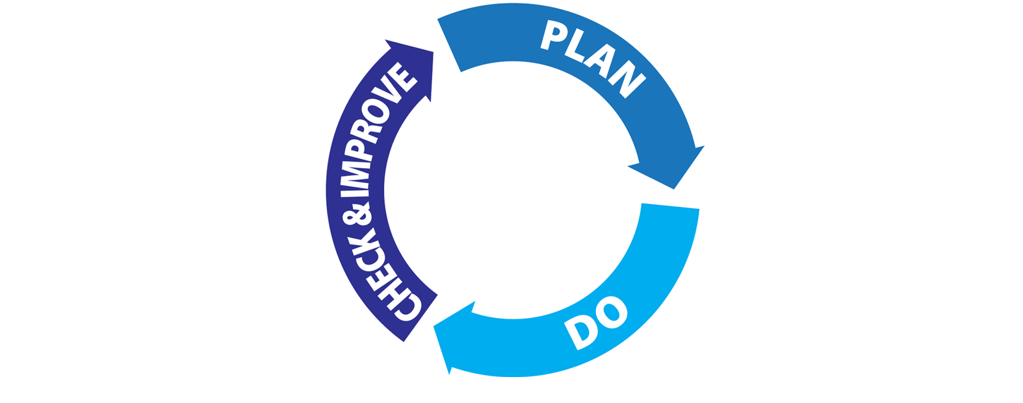

During the planning stage, stakeholder consultations are used to determine what is to be achieved by management and how success will be measured. In the jargon of management plans this involves agreeing objectives, management actions and performance measures, as well as indicators and benchmarks for monitoring progress, and for identifying whether adjustments are required (see Modules 13 and 14).
In the doing or implementing stage, management facilitates the implementation of the action plan(s).
In the checking and improving stage, management reviews performance information to determine if the actions are achieving the desired result and makes adjustments to reflect learning from experience (adaptive management) – see Module 17 Steps 5.1-5.2). The planning stage should set up how this is going to be achieved.
- From principles to implementation
The key to EAFM is to “translate” the high level guiding principles, such as those in the FAO Code of Conduct for Responsible Fisheries (or their related international instruments) into objectives and actions that can be implemented in a given fishery. As the policies are all founded on the concept of sustainable development, any actions instigated through planning, by definition assist in implementing sustainable development through EAFM. See Figure 6.2 below.
Figure 6.2: Steps in moving from principles to action
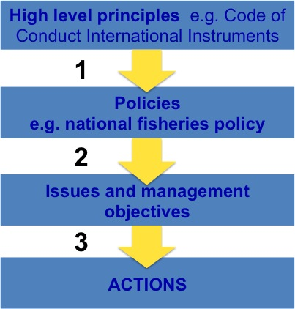

- From principles to policy goals
The translation starts with converting the high level guiding principles into policy goals. Many of the valuable principles underpinning EAFM are so generic that they cannot really be achieved in a practical sense. Furthermore, many of the characteristics of ecosystems, such as ecosystem health, integrity, resilience are difficult to quantify concepts that are not fully understood and difficult to apply in practice. These principles are often incorporated in the higher-level policy goals, such as conserving biodiversity, maintaining fishery habitats, protecting important food chain functions and so on, which usually form the basis of national policies and plans.

- From policy goals to issues and management objectives
These higher-level policy goals then need to be broken down into more specific management objectives. This is achieved by identifying and prioritizing issues and then developing a management objective for each issue. (Module 7 EAFM Process Overview and Module 13 Step 3.1). At this operational level, priorities can be set through a risk assessment process and trade-offs and balances reached by consensus. These objectives need to be specific enough that one or other management action can address them and the success (or otherwise) of this intervention can be monitored and assessed.
- From objectives to management actions
Each management objective can be achieved by the implementation of a management action (e.g. introducing a limit on the number of fishing vessels, increasing the mesh size of nets, planting mangroves, introducing MPAs, etc.). Often, one management action can address several objectives.
Provided there is a good linkage between the high level policy goals and the management objectives, management actions in the EAFM plans implement policy.
- Good planning
- Make general principles and higher level goals operational: for effective EAFM the general principles and the higher level policy goals need to be translated into management objectives ☺. An operational objective is an objective that management can address. For example, “Promote sustainable development of the fishery” cannot be addressed directly by management, but an operational objective of “Reduce the number of fishing boats” can be addressed by a management measure.
- Provide direction: planning provides a clear sense of direction for the activities of management. It strengthens the confidence of the stakeholders and encourages them to move along a chosen path, while also clarifying the actions they should take to achieve the goals.
- Consider alternative courses of action: planning permits managers to examine and analyse alternative courses of action with a better understanding of their likely consequences.
- Reduce uncertainties: planning forces managers and stakeholders to look beyond immediate concerns. It encourages them to analyse the complexities and uncertainties of the environment and attempt to gain control.
- Minimize impulsive and arbitrary decisions: planning tends to minimize the incidence of impulsive and arbitrary decisions and ad hoc actions. It reduces the probability of major errors and failures in managerial actions. It injects a measure of discipline into thinking and action.
- Provide a basis for better management: it provides the basis for the other managerial functions. Thus, planning is the central function around which other functions (e.g. monitoring, control and surveillance (MCS)) are designed.
- Include adaptive responses: planning tends to improve the ability of management to adapt effectively and adjust its activities and directions in response to the changes taking place in the external environment.
- Enable proactive action: while adaptation is undertaken in reaction and response to some changes in the outside world, it is not sufficient in some situations. In recognition of this fact, planning stimulates management to decide in advance on what action to take when things do not go according to plan (control rules).
- Promotes transparency: makes decision making transparent and available to all stakeholders.

- Outputs from planning
Planning can be done at many different levels and geographic scales, but it is important that plans align with each other and can comfortably be nested under each other (Figure 6.3).

In EAFM a typical set of nested plans and reports would be:

- national 5-year plan;
- an agency strategic plan: a plan that includes the higher policy goals derived from the principles of responsible fisheries;
- an EAFM plan: the outcome of the planning process that contains objectives, management actions and performance measures (indicators and benchmarks); and
- work plans: these are an outline of all tasks that need to be completed (including timelines and responsibilities) in order to implement the EAFM plan.

Figure 6.3: Nested plans

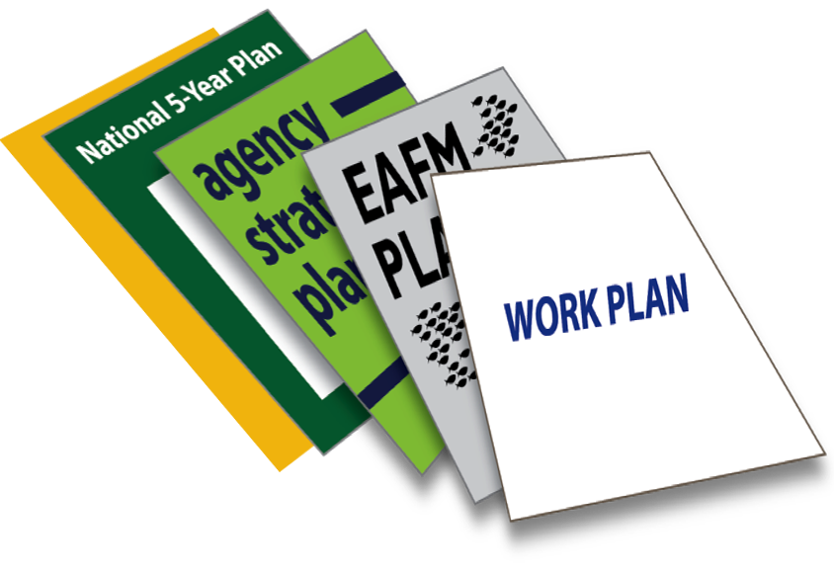

EAFM process overview
Module 7

Session objectives:
- Describe the key steps of the EAFM process and how to plan, implement and monitor EAFM;
- Identify the planning steps in the EAFM process;
- Describe the outline of an EAFM plan.

Overview
This module outlines the EAFM process. It describes the initial tasks and the five EAFM steps and sub-steps, highlighting those that specifically involve planning.
As explained earlier, the EAFM cycle consists of three main stages: planning, doing, checking and improving. These three stages translate into five major steps for EAFM, as outlined in Figure 7.1 and the Table 7.1 below. In the table, the planning steps are shaded in grey.
Figure 7.1: The 5 steps of EAFM

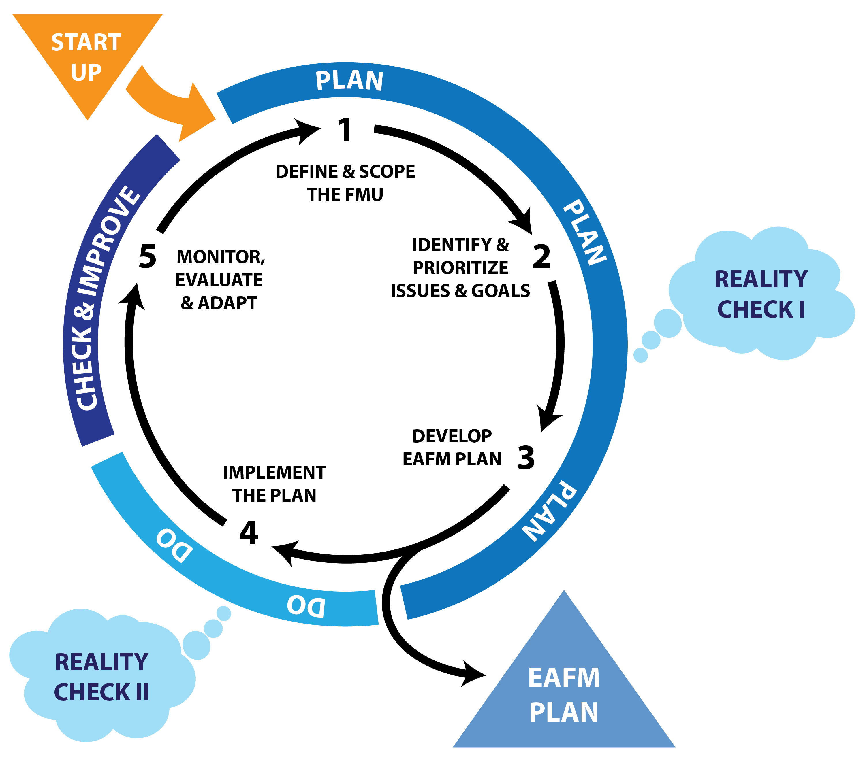

Table 7.1: Summary of the five EAFM steps

Startup | A: Prepare the ground | B: Engage stakeholders
STEP 1 | Define and scope the Fisheries Management Unit (FMU) | - Define the FMU  - Agree the FMU vision  1.3 Scope and profile the FMU
STEP 2 | Identify and prioritize issues and goals | 2.1 Identify threats and issues  2.2 Prioritize threats and issues  2.3 Define goals for EAFM plan  Reality Check I
STEP 3 | Develop the EAFM plan | 3.1 Develop management objectives  3.2 Develop indicators and benchmarks  3.3 Agree on management actions and compliance  3.4 Identify finance  3.5 Finalize EAFM plan
STEP 4 | Implement the plan | 4.1 Formalize, communicate and engage  Reality Check II
STEP 5 | Monitor, evaluate and adapt | 5.1 Monitor and evaluate performance of management actions  5.2 Review and adapt the plan

Startup A and B
Before starting Step 1 of the process, a number of startup tasks are required. These consist of one-off tasks in Module 8 Startup A - Preparing the ground; and a series of on-going processes initiated in Module 9 Startup B - Engaging stakeholders.
Tasks in Startup A - Preparing the ground consists of:
- Identify the EAFM team and facilitators
- Identify the broad FMU area
- Develop startup work plan
- EAFM introduction
- Coordinate with other agencies and government levels
- Identify stakeholders and organizations
- Establish key stakeholder group
- Determine legal basis for EAFM
Startup B - Engaging stakeholders is a critical stage that involves identifying the various potential stakeholders, raising awareness about the EAFM process and starting the on-going process of involving them in the various EAFM process stages (initially planning, and then implementation and monitoring). Preliminary stakeholder engagement is important for identifying the expectations, roles and responsibilities of stakeholders.
Outline of the five steps
Step 1 – Define and scope the Fishery Management Unit
Define the Fisheries Management Unit (FMU): The identified FMU will most likely be based on a geographical area and ideally will coincide with a clearly and precisely defined ecosystem. However, ecosystems are not usually clearly defined entities with unambiguous boundaries and they may cross or be contained within existing fishery management areas. The final choice of FMU and geographic area for a management plan will depend on a number of factors, but at the very least it should cover all harvesting sub-sectors, both small-scale artisanal and large-scale industrial.

Agree the FMU vision: At the outset, it is very useful for stakeholders to agree on a vision for the EAFM plan. A vision is a long-term statement of the aspirations of the stakeholders.

Scope the FMU: This means the background information (fish, gears, people, etc.) that characterizes the FMU. Ensure you have information relating to economic, social, environmental and governance factors. You may need to collect quantitative and qualitative data (remember some of this data may already exist, not necessarily in your agency but may be available in partner agencies or departments).

Step 2 – Identify and prioritize issues and goals
2.1 Identify threats and issues: The next step is for stakeholders to undertake an initial evaluation of the threats and issues associated with the fishery. These must include issues for each of the three components (ecological well-being; human well-being/socio-economic; and governance). Broad issues are further divided into more specific issues that can be tackled through a management intervention of some kind.

2.2 Prioritize these issues: The large number of issues that will be raised will need to be prioritized so that a manageable number of issues are addressed in the EAFM plan. Risk assessment tools are available to help prioritize the identified issues, so as to define which issues are of high priority and therefore need to be managed directly.

2.3 Define goals for the EAFM plan: While considering the issues it is useful to group them into separate themes (e.g. those to do with fishing, those to do with communities etc). Then develop a goal for each theme. These are also long-term goals that relate to the overall vision.

Reality Check I ity check I

Consider constraints to and opportunities for achieving goals: This is a reality check to decide whether the goals are really achievable.

Step 3 – Develop the EAFM plan
3.1 Develop management objectives: Clear and appropriate management objectives are required for all high priority issues requiring management. The objectives need to state what will be achieved. Management objectives are by definition objectives that can be addressed by management actions.

3.2 Indictors and benchmarks: Develop indicators and benchmarks for the above objectives. These will enable stakeholders to assess whether the objectives are being achieved.

3.3 Agree on management actions and compliance: Discuss the management actions needed to meet each specific objective. Often the same action can meet several objectives. Management actions should be accompanied with a description of how the actions will be complied with, by including actions to enforce and generate compliance. Collectively, the objectives, indicators, benchmarks and management actions, provide a means to communicate with decision-makers on how well management is performing and will influence future changes in management.

If possible, specific management actions should also be accompanied by decision rules on how they are to be applied and what to do if they are not working. The key is to try and agree about what might happen and how to counteract this before it happens.

3.4 Identify sustainable financing to support implementation of the plan.

3.5 Finalise the EAFM plan: This is achieved by systematically collating the key data from the above steps (see template below plus a few more considerations). This plan will guide you during the EAFM process. It is not set in stone and should be adapted as new information emerges and lessons are learned.

Step 4 – Implement the plan
4.1 Formalize, communicate and engage. A simple work plan is developed that outlines who does what tasks during implementation, and by when. The EAFM plan needs to be formalized so that it has authority and backing. A communication strategy needs to be developed to communicate different types of information to different stakeholders. The initial stakeholder engagement develops into a process of continuous engagement with stakeholders to ensure that the EAFM plan can be carried out.
Reality
Check II

The appropriate governance arrangements will need to be clearly defined. The implementation of EAFM can utilize co-management arrangements, whereby stakeholders (or partners in the power sharing arrangement) actively contribute and work together to implement fisheries management. A supporting policy environment will need to be established for co-management arrangements to work. This will take time and probably require strengthening institutions and developing human capacity.

Step 5 – Monitor, evaluate and adapt
5.1 Monitor and evaluate performance of management actions: A set of indicators and benchmarks were identified in the EAFM plan. Monitoring these and any other generic indicators allows management to see if the plan is on track and to take remedial action if necessary, i.e. adaptive management. The indicator information is collated and reviewed periodically to assess whether the management actions are actually attaining the objectives as planned
5.2 Review and adapt the plan. . Monitoring data can be collated yearly for a quick check on progress and the plan can be adapted if there is sufficient evidence to indicate that a change is necessary. Every three to five years a longer-term review should take place to assess how the EAFM plan is performing. The actual time of the review should reflect the nested nature of the EAFM plan, such that the outputs and reports can feed into the broader strategic plans. In the light of longer-term data and reviews, the plan may need to be adapted considerably to allow for unforeseen elements and to incorporate lessons learned.
Activity: Human circle to embed the EAFM steps.

Activity: Form meaningful (FMU) groups.

EAFM template. This is the suggested template for the EAFM plan. The outputs from Steps 1-3 are essential components of the plan, and elements from Steps 4-5 also need to be included. The template consists of 10 headings and sub-headings.
EAFM plan for FMU XXXX
- VISION
The broad goal of management.
- BACKGROUND
Description of the area and resources to be managed, including maps at different scales.
The fisheries management area
Area of operation of the fishery, jurisdictions and ecosystem "boundaries" (including national/province/district jurisdictions). Map of FMU.
History of fishing and management
Brief description of the past development of the fishery in terms of fleets, gear, people involved, etc.
Current status of the fishery
Description of the fishery resources and fleet/gears used;
Resource status;
Map of resource use patterns.
Current management (co-management) arrangements
Existing management arrangements
Socio-economic benefits, including postharvest
Description of stakeholders and their interests (including socio-economic status);
Description of other uses/users of the ecosystem, especially activities that could have major impacts and arrangements for coordination and consultation processes;
Social and economic benefits, both now and in the future.
Special environmental considerations
Details of critical environments, particularly sensitive areas and endangered species.
Institutional aspects
Legislative background;
Existing co-management arrangements – roles and responsibilities;
MCS arrangements;
Consultation process leading to the plan and ongoing activities;
Details of decision-making process, including recognized participants;
Nature of rights granted in the fishery and details of those holding the rights;
Maps of management interventions/user rights/jurisdiction boundaries.
- MAJOR THREATS AND ISSUES
Ecological issues
Fisheries resources and general environmental issues, including both the impact of the fishery on the environment and vice versa.
Social and economic issues
Issues relating to the people involved in fishing, the general public and at the national level, including gender issues.
Governance issues
Issues affecting the ability to achieve the management objectives.
- GOALS OF MANAGEMENT
Higher level goals, i.e. the ultimate goal of management.
- OBJECTIVES, INDICATORS AND BENCHMARKS
Priority issues, objectives, benchmarks for the fishery, covering:
- fishery resources;
- environment (including bycatch, habitats, prey protection, biodiversity, etc.);
- social;
- economic;
- governance (ability to achieve the plan).
- MANAGEMENT ACTIONS
Agreed actions for the plan to meet all objectives within an agreed time frame, including bycatch, habitat protection, socio-economic benefits, good governance, etc.
- COMPLIANCE
For actions that require rules/regulations – arrangements for ensuring that the management actions are effective.
- DATA AND INFORMATION NEEDS
Data and information needs to monitor implementation of the plan. Clarify where the data are to be found and who collects, analyses and uses the information.
- FINANCING
Major sources of funding.
- REVIEW OF THE PLAN
Date and nature of next review(s) and audit of performance of management.

Startup A: Preparing for EAFM
Module 8

Session objectives:
Define startup tasks needed to initiate the EAFM process and co-management, including:
- Define Startup tasks needed to initiate the EAFM process and co-management;
- Learn how to identify and prioritize stakeholders.

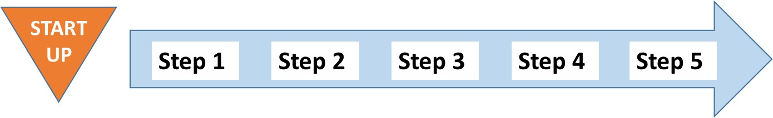
Overview
This module details the eight Startup tasks that need to be carried out to initiate the EAFM process.
Introduction
There are eight Startup tasks to get the EAFM process moving; each of these can be revisited or undertaken in more depth later in the EAFM planning process. These Startup tasks are undertaken initially by the promoting agency ☺, but later they may be directed by the EAFM team and facilitators. Engaging stakeholders is highlighted in Startup B and is used throughout the process of EAFM.
For many of these tasks and later steps, it is necessary to hold participatory workshops or meetings. The next module, Module 9 Startup B explains how to do this.
EAFM planning should not proceed until there is sufficient support from stakeholders and the scope of the exercise is understood. However, a perceived lack of information should not be used as an excuse to delay initiation, because EAFM deals with such situations by adopting the precautionary approach.
A: Startup tasks
Task i. Identify the EAFM team and facilitators
The promoting agency for EAFM should typically be the fisheries agency (at the appropriate level). This agency needs to establish a team to guide the EAFM planning process. Good facilitation and the skills of community mobilization and conflict management will be key for this team as they consult with stakeholders during the EAFM process. They will need to be sure that they facilitate fair representation of all stakeholder groups, creating a transparent and fair decision-making environment and clear two-way communication of information.
Task ii. Identify the broad area to be managed
Taking into account the scaling issues identified earlier (Module 4 Principles of EAFM) the EAFM team should agree on what it is they are managing. This will be defined more formally later on in the process but at this Startup stage all should agree roughly on the area, taking into account existing jurisdictional boundaries. This area defines, to some extent, who the relevant stakeholders will be (see task vi. later).
Task iii. Develop Startup work plan
The EAFM team initially needs to identify the broad goals of the planning exercise, strategies and next steps to help clarify and identify the EAFM partners and stakeholders and their initial roles and responsibilities in the planning process. At this early stage it is also important to consider the size of the budget available. This task differs from actually developing an EAFM plan that contains specific management goals, objectives and actions to be undertaken in EAFM Step 3.
In many countries, the process will involve working with, or through, traditional community leaders or institutions, while still allowing ample opportunities for other community groups to participate. Cultural and social context will be important considerations in working with stakeholders in all places and at all scales; at the national scale, for example, the primary facilitators may wish to consider how to engage and facilitate, given the particular cultural and institutional context of the various sectors that will be engaged in the planning process.
A Startup work plan outlines a set of activities to be undertaken during the preparation phases of EAFM (e.g. stakeholder meetings), the sequence of activities, and the individual responsibilities for each activity. The work plan should set forth as precisely as possible the Startup activities that will be undertaken, by whom, by what date, and under what budget.
Part of the Startup work plan will be identifying short-term sources of funding to initiate the planning process. Is there sufficient funding to carry out the Startup work plan and subsequent planning? Ideally, this should come from existing budgets, but because these activities may not have been specifically identified, changes to the budget may be needed. All options for extra funding, including consideration of the team putting in their time “in kind” as part of the existing job/occupation need to be included. In some cases, starting EAFM will be part of a donor-supported project and every opportunity should be taken to direct sufficient funds to the planned activities. Many aid projects will have budgets for these types of activities if it is within their mandate.
Task iv. EAFM introduction
The EAFM team should begin making courtesy calls, holding meetings and raising public awareness to establish the initial working relationship between the community, the prospective agency partners, and the facilitator or agency. This entails a number of activities, including:
- formally introducing EAFM to prospective partners;
- answering questions about EAFM;
- establishing rapport with prospective partners;
- identifying roles of partners;
- organizing and attending meetings, training and awareness-raising sessions;
- collection of baseline data and information on the management unit;
- meeting with local leaders, government officials, etc. and obtaining approvals; and
- initiating the EAFM process with the community, government agency partners, and other stakeholders.
Task v. Coordinate with other agencies and levels of government
EAFM requires coordination, consultation, cooperation and joint decision-making, not only between different fisheries operating in the same ecosystem or geographical area, but also between the fisheries management agency and the other sectors that have an impact on fisheries or are affected by fisheries (Figure 8.1).
It is important to ensure that coastal and fisheries institutions at each level of government (from local, municipal, district, provincial, regional to national) are informed and engaged early in the EAFM planning process. This helps to harmonize policies and objectives across different levels of governance, as well as in situations of overlapping or mismatched jurisdiction (e.g. where several agencies have management authority over different parts of a fish species’ lifecycle). It may require bringing agencies together that may traditionally have had very little interaction, but are actually working towards complementary goals or addressing overlapping issues. Advantages of working in collaboration can include pooling or sharing of limited resources and expertise, and a unified approach that can help avoid community confusion and disenchantment when separate groups interact with communities in different ways.
Figure 8.1: An ideal inter-agency cooperation and consultation EAFM framework (adapted from FAO, 2005)
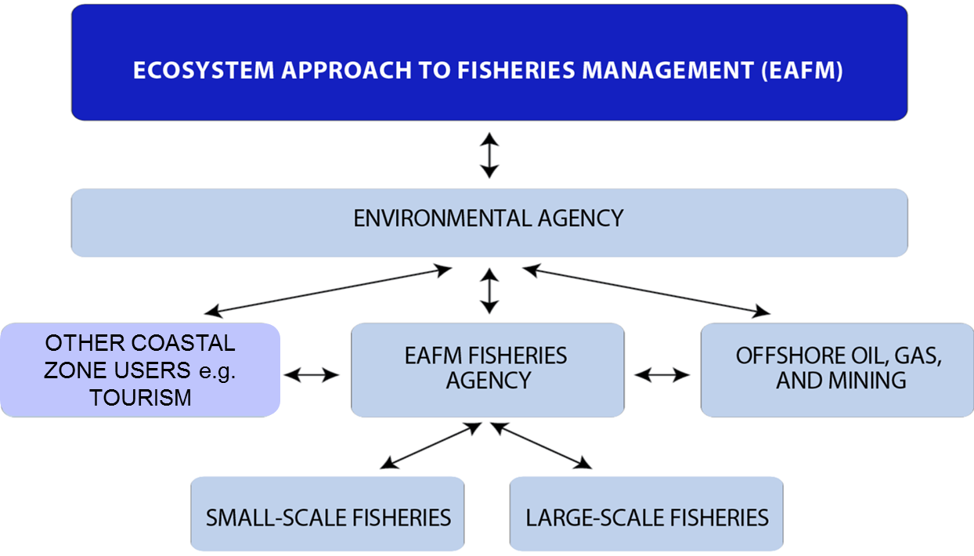
Task vi. Identify and prioritize stakeholders and organisations
The network of stakeholders that needs to be involved in EAFM is complex (see Figure 8.2), both in terms of vertical linkages (national to local), horizontal linkages (between different users of the natural resources) and in terms of geographic coverage. Many potential stakeholders are needed to implement an EAFM effectively, especially in surveillance or compliance.
Who are your stakeholders?
A stakeholder is any individual, group or organization which has an interest in or which can affect or is affected, positively or negatively, by the EAFM process.

Figure 8.2: Examples of stakeholder groups. Source: Adapted from FAO
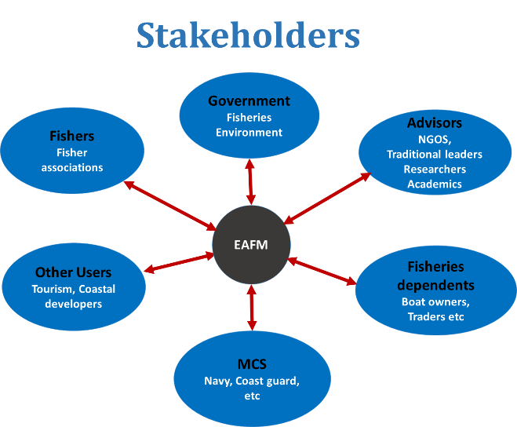
Stakeholders are individuals, groups or organizations of men and women, old and young, who are in one way or another interested, involved or affected (positively or negatively) by a particular process. They may be motivated to take action based on their interest or values. Stakeholders may include groups affected by the management decisions; concerned about the management decisions; dependent upon the resources to be managed, with claims over the area or resources; with activities that impact on the area or resources; and with, for example, special seasonal, geographic or cultural interests.
All relevant stakeholders need to be invited to the initial EAFM stakeholder meetings or workshops. A checklist of which stakeholders should be approached can be based on Figure 8.2. Finding the right balance between being inclusive so to engage as many stakeholders as possible versus having an unruly mob is difficult, but it should be borne in mind that consultations and fine-tuning of a plan can take place subsequently. In the first instance, it is important to include the people likely to be most affected by the planning process. This is most likely to include (i) the fishers (often selected though fishers’ associations including both small-scale artisanal ☺ fishers and large-scale commercial fishers; (ii) the government officers both at the national level (to set overall policy) and in the area of the fishery (to ensure implementation); (iii) NGOs; (iv) researchers; and (v) surveillance.
Support or lack of support by stakeholders can lead to the success or failure of an EAFM. Stakeholder analysis (see People Toolkit) is conducted to identify potential partners for an EAFM, to explore possible approaches in relating to a particular person or group who can be supportive or potentially hostile to an EAFM, and to provide insights into the dynamics and relationships of individuals and groups with various interests in a particular resource or project.
One form of stakeholder analysis is 2x2 matrix where stakeholders are plotted according to (i) how important the stakeholder is to the EAFM process on one axis (Y axis) and how much influence (power) they have over the EAFM process on the other axis (X axis) (Figure 8.3).

Figure 8.3: A 2x2 matrix importance and influence stakeholder analysis
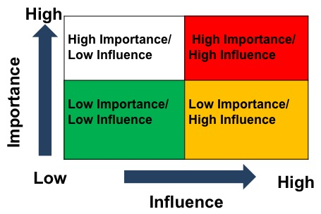
According to where stakeholders fall on the matrix a different strategy is adopted for four groups (Figure 8.4). There will be those that were (i) high importance and high influence (ii) those that were high importance and low influence, (iii) those that were low importance but high influence and (iv) those that were low importance and low influence.
Figure 8.4: Different strategies needed for the different groupings of the stakeholder analysis
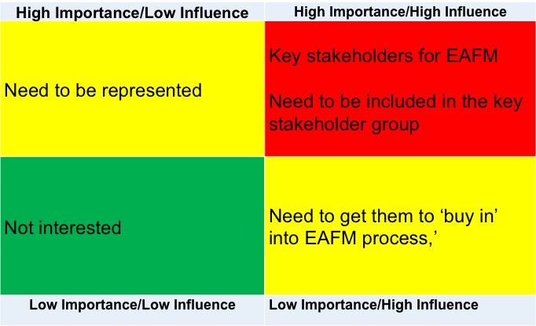
Those in the red box are key stakeholders for EAFM success; they need to be kept motivated and on board as they are ‘allies’. Keep communicating results to them. They do not need convincing about the importance of EAFM- they already know. Those in green box are not interested and have little influence; they need to be kept informed and involved, with minimal effort and monitoring. Those in yellow boxes require active strategies. High influence + low importance: these need to be moved along to the red box, they need to ‘buy in’ into the EAFM process, as they could be potential supporters and could use their influence to support the process. However, some of these influential stakeholders could also hinder/ block the EAFM process (for political or other gains) so they need to be actively monitored. Those with high importance + low influence are often the most affected (i.e. have a high stake in the EAFM process) but do not have the power or a voice. They need to be represented and supported in having more of a say and influence over the EAFM process.
Activity: (i) List stakeholders, and (ii) conduct a stakeholder analysis,

Another way of visualising stakeholders is to plot them on a Venn diagram that describes their relationships as part of institutional analysis. In the diagram, the size of circle indicates importance and the proximity of circle indicates the frequency of contact. Separate circles = no contact; touching circles = information passes between institutions, small overlap = some cooperation in decision-making and large overlap = considerable cooperation in decision-making. An example Venn diagram is shown in Figure 8.5.

Figure 8.5: An example Venn diagram showing the relationships among stakeholders
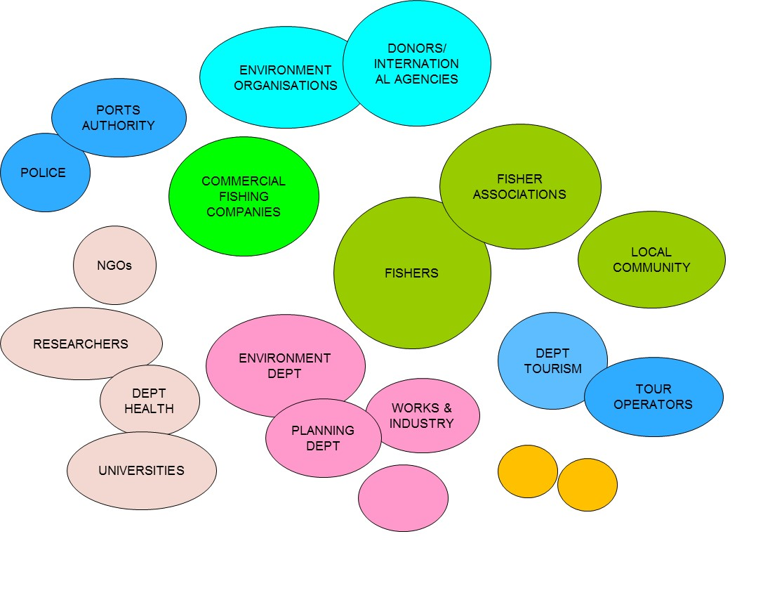
Activity: Plot the stakeholders on a Venn diagram.

Task vii. Establish a group of key stakeholders
The key stakeholder group is a small number of stakeholders (perhaps four or five depending on the prioritization process) representing different sectors of the community and management agencies who will work with the facilitators to guide the EAFM process after Startup. This group may include members of the initial EAFM team established in Task i. or be new people. The key group is crucial as it gives responsibility and power to the community members, and others not typically engaged in fisheries management. The key group can serve to:
- develop dialogue and stimulate EAFM discussion;
- facilitate community organization;
- help stakeholders understand EAFM;
- identify problems, issues, and opportunities in engaging stakeholders;
- assist in decision-making within an EAFM process;
- identify other stakeholders and stakeholder groups; and
- gather and spread information among community members.
Task viii. Determine the legal basis for EAFM
It is desirable to have a legislative or policy mandate to undertake an EAFM. This is especially true when using co-management, because it is better to provide local communities with legal authority to manage. For example, in many Pacific Island countries, the traditional ownership of lagoons and reefs is claimed by adjacent coastal communities. The development of fisheries legislation should therefore provide this authority. In some countries, the development of community fisheries by-laws or fisheries management ordinances includes provisions to allocate this authority. Although establishing a legal basis for an EAFM is desirable, the lack of appropriate existing legislation should not be used as a reason to delay starting the process. Nevertheless, reviewing the legal basis for EAFM is essential in order to understand the existing supporting or non-supportive policy.
Summary
The eight Startup tasks in Startup A do not need to be carried out sequentially; in fact tasks are likely to be parallel or overlapping. The minimum requirements to complete Startup A are depicted in Figure 8.6 and include: forming the EAFM team with a facilitator; making a Startup work plan; identifying stakeholders and forming a key stakeholder group; engaging with other agencies and institutions; carrying out a legal review and identifying the broad area of the FMU.
Figure 8.6: Summary of startup A tasks
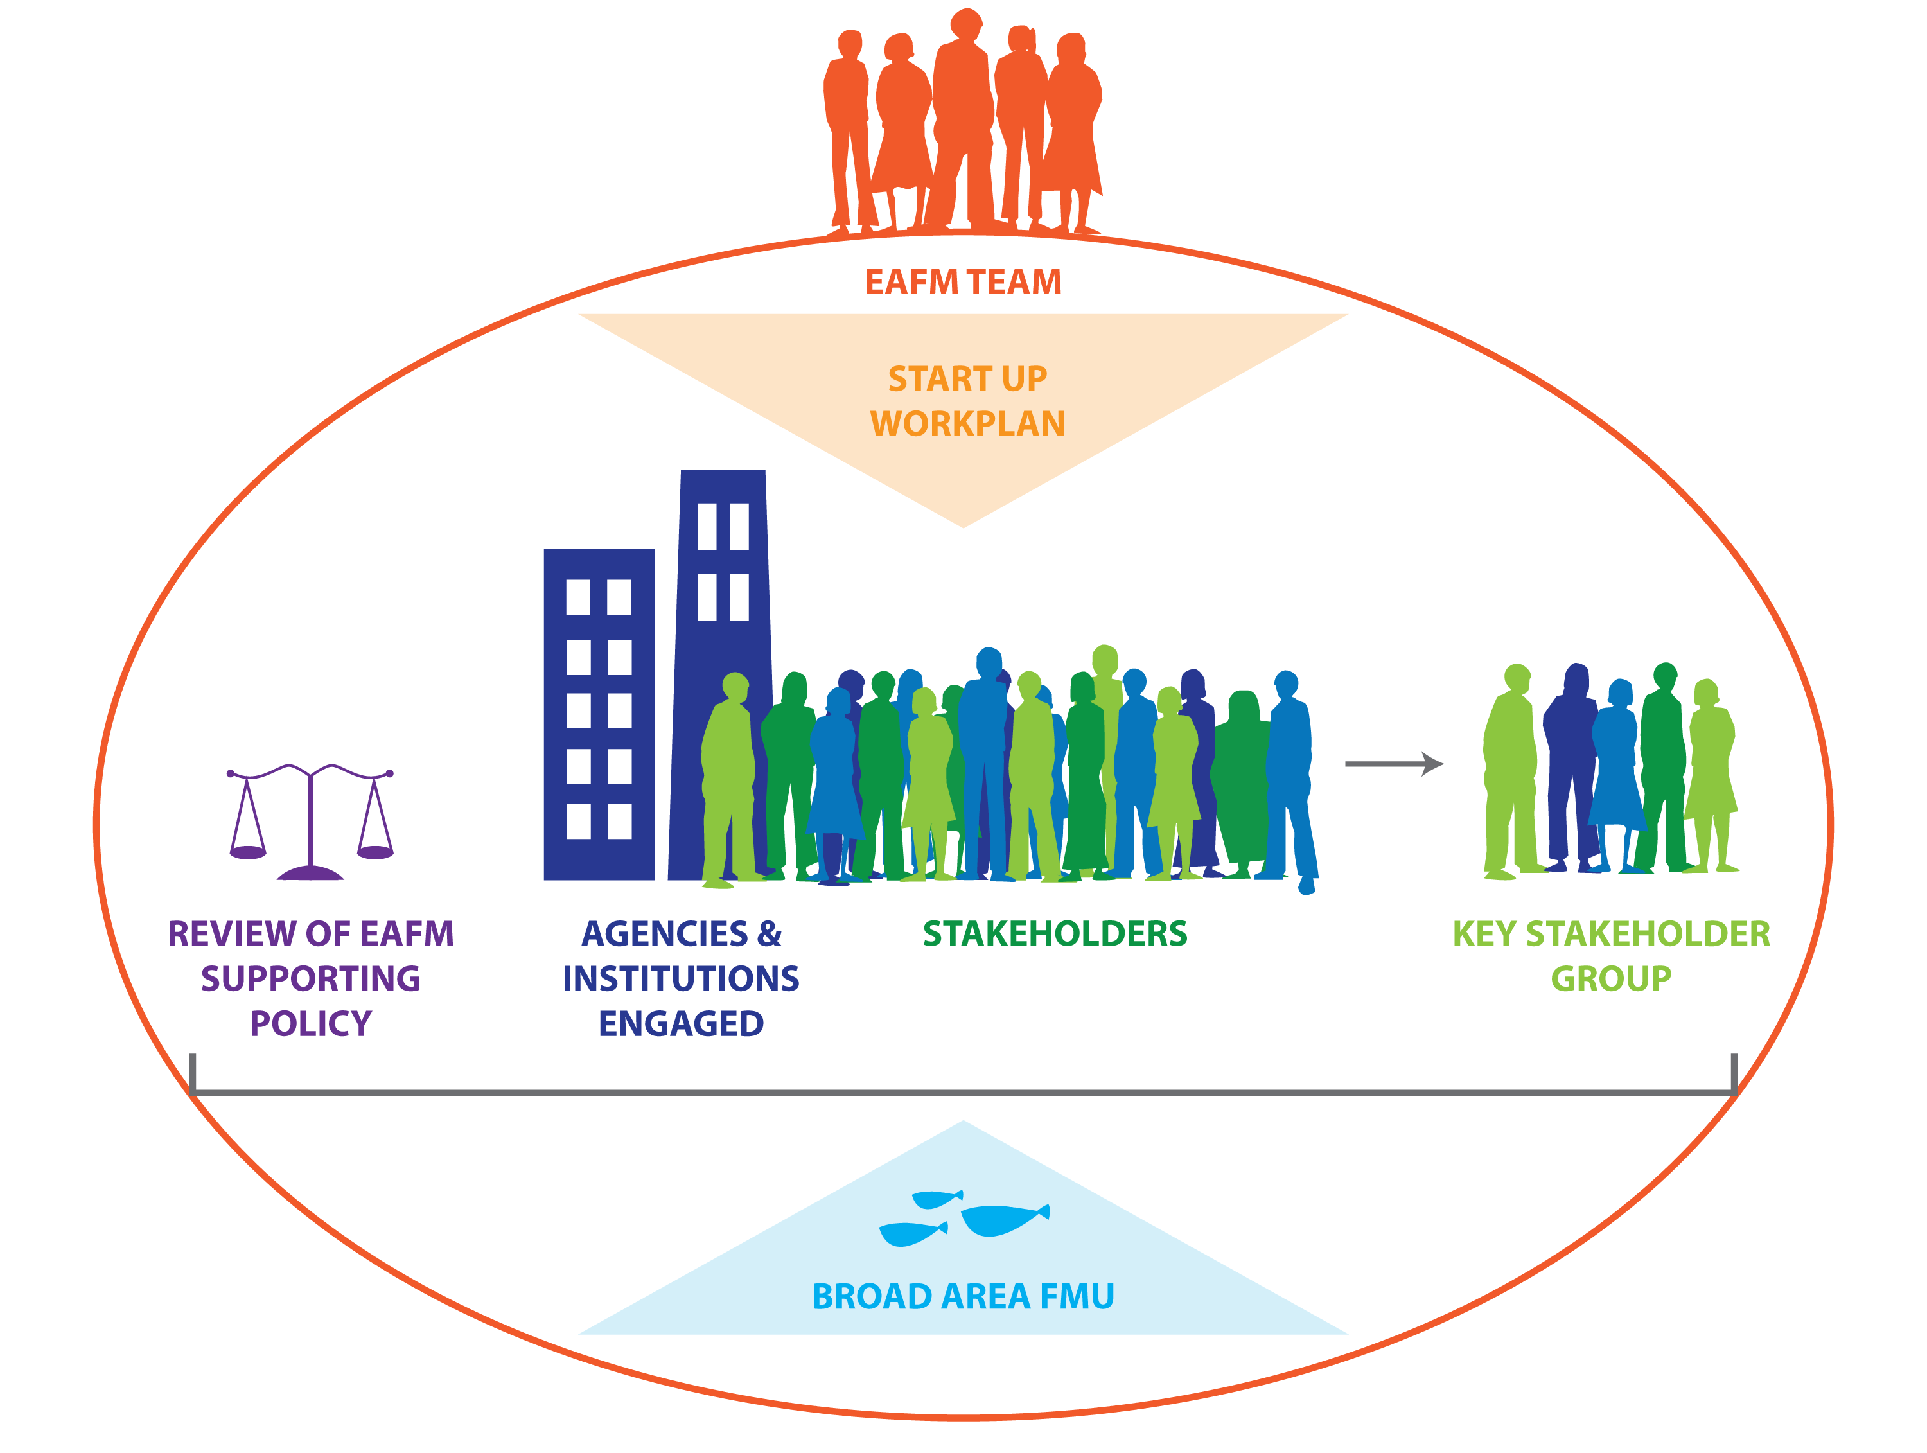

Use the Startup A checklist below to help you assess the Startup tasks and help write a Startup work plan.
Startup A tasks | Completed or not | Notes
- Formed EAFM team with a facilitator
- Identified the broad area of the FMU
- Developed a Startup work plan
- Carried out EAFM introductions
- Coordinated with agencies & government levels
- Identified stakeholders
- Established group of key stakeholders
- Carried out a legal review

Startup B: Stakeholder engagement
Module 9

Session objectives:
- Apply a participatory approaches for stakeholder engagement;
- Organize and hold stakeholder meetings;
- Describe the basic concepts of co-management.

Overview
This module outlines what Startup B entails. It explains participation and facilitation; how to hold and facilitate participatory workshops/meetings which underpin the EAFM process. It also introduces co-management as a key approach for EAFM.
Introduction
Stakeholder engagement is not a step: it is an ongoing activity that is initiated in Startup B and continues throughout the EAFM process and is likely to evolve. The stakeholder engagement activities build institutional knowledge of the EAFM team, key stakeholders and participating partners, agencies and institutions. Also refer to community mobilization methods outlined in Module 16 Reality Check II and many of the related tools in the People Toolkit.
- Participation
The benefits of broad participation include:
- a range of stakeholder perspectives are included;
- promoting action (of what? From who? Stakeholders?);
- enables an empowering process which
  - encourages independence and self confidence
  - can be a catalyst for change;
- quick and cost effective results;
- enhancing a greater sense of ownership among stakeholders;
- literacy is not prescribed;
- subjective insights are given value; and
- building relationships and partnerships.
It is also very important to identify champions or leaders who will provide the drive to follow through with the process and motivate others.
The three pillars of participatory approaches are:
- Attitude and behaviour: the facilitator’s attitude and behaviour is critical to the success of participatory workshops. He or she has to remain neutral, manage discussions fairly and involve all those present.
- Tools: there are various tools that can be used to elicit participation from all members of the population (see People Toolkit). However, the tools are only effective if used with the correct attitude and behaviour as explained above (i.e. non dominant).
- Sharing: sharing information, knowledge, opinions and feelings is a key element of participatory processes. Through this sharing, people are empowered and issues can be discussed and resolved, or at least brought into the open, where they can then be managed through conflict resolution (see Module 12 Reality Check I).
An important aim of the participatory approach is to empower people and groups who are most vulnerable and less able to ensure their needs and expertise are represented in decision-making. For the EAFM process to succeed, men and women resource users, local organizations and communities, as well as local government officials and other stakeholders need to be enabled to take control and make decisions. To do this they will need to increase their awareness and understanding of fisheries resources and their management in an ecosystem context.

The benefits of such empowerment include:
- increased awareness, knowledge, skills, institutional capacity;
- ownership of decisions and outcomes;
- responsibility;
- power to act and make decisions;
- motivation; and
- sustainability.

2. Good facilitation
A facilitator is usually a neutral, independent person whose role it is to support individuals, groups and organizations during participatory processes (this can extend to practical administrative tasks, but here we focus on content and process). Facilitators need to be keenly aware of how power relations and dynamics permeate all group processes. For this reason, they need to pay particular attention to gender dynamics (primarily, though not always, women not speaking up at meetings where men are present); social hierarchies (e.g. elders’ views or presence can limit what younger members/others can say, whether in a village or in a government department) and socio/cultural differences (for example, ethnic minorities not having a voice).
Good facilitation involves:
- trust in other people and their capabilities;
- patience and good listening skills;
- self-awareness and openness to learning new skills;
- confidence without arrogance;
- good life experience and good common sense;
- respect for the opinion of others, not imposing ideas;
- ability to create an atmosphere of confidence among participants;
- flexibility in changing methods and sequences; and
- knowledge of group development including the ability to sense a group mood.
A key element in any communication is building rapport, i.e. the feeling between two people that they can relate to each other. In many of the situations, establishing a rapport of trust is crucial for ensuring a message is received and understood as intended. A good facilitator knows how to build rapport.
Facilitators enable groups to work out issues effectively by:
- Encouraging full participation, overcoming self-censorship
Often people don’t say what they really think. In most groups the norm is that if an individual wants to speak, they do so simply and clearly and say something familiar enough or interesting enough so the group will listen. Without realising it, most people constantly edit their thinking before they speak. Facilitators have the skills to draw people out and allow everyone to be heard. They know how to make room for quiet members, how to reduce the incidence of premature criticism and how to keep everyone thinking instead of shutting down.
- Promoting mutual understanding and overcoming fixed positions
A group cannot do its best thinking if the members don’t understand each other. Most people find it difficult to free themselves from their fixed viewpoints. A facilitator helps the group to realise that productive groups are built on a foundation of mutual understanding. The facilitator also recognises that misunderstandings are inevitable and are stressful for everyone involved. People in distress need support and to be treated respectfully. Therefore, a facilitator knows not to take sides, to honour all points of view and to keep listening, so that each and every person feels confident that someone understands them.
- Fostering inclusive solutions and changing the win-lose mentality
Most people are stuck in a conventional mind set for resolving problems and conflicts, believing it is either one way or the other - they rarely imagine that they might reach an agreement that benefits all parties. An experienced facilitator knows how to help a group search for innovative ideas that incorporate everyone’s point of view. It is a challenging task, but once the group understand the values and methods that foster inclusive solutions, the impact is profound. As they discover the strength of this new way of thinking, they often become more hopeful about their group’s effectiveness.

- Teaching new thinking skills and improving the management of meetings
It is easy to blame poor meetings on the leader, or on others. A facilitator has both the opportunity and a responsibility to teach group members how to design and manage effective sharing, problem-solving and/or decision-making processes.
- Designing explicit and clear procedures for running meetings/workshops
Clear, explicit procedures are among the most important thinking skills a group can learn. Having an explicit and agreed objective and a clear agenda to achieve it can make a huge difference to the running of the meeting and the behaviour of members. A facilitator can train the group in a range of procedures for running successful meetings/workshops.
- Structuring thinking activities
Sometimes a group needs help to focus on the same thing at the same time. At times like this, a structured thinking activity, like brainstorming, can be very helpful. An experienced facilitator will have a range of thinking activities to offer to groups at the appropriate time.
- Using clear language to describe group dynamics
When a facilitator enables a group to reflect on its own group dynamics, and links this to a model of group dynamics, he or she provides group members with shared points of reference and a shared language. This enables the group to step back from the content of their discussion and talk about the process, so that they can improve the dynamics of the meeting.
Activity: Draw a good and a bad facilitator.
3. Facilitating participatory EAFM stakeholder workshops
The aim of these initial EAFM workshops or meetings is to agree on:
- the selected FMU (Module 10 Step 1.1);
- who the major stakeholders are that need to be involved (Module 8 Startup A task vi); and
- the scope of the FMU by defining the broad management goal (vision) and eliciting more background information (Module 10 Steps 1.2 and 1.3).

An EAFM stakeholder workshop involves a meeting of multiple stakeholders to:
- involve stakeholders in improving fisheries-related situations that affect them;
- form a useful social interaction that enables different individuals and groups who are affected by an issue or initiative, to enter into dialogue, negotiate, learn and make decisions for collective action; and
- persuade government staff, policy makers, community representatives, scientists, business people and NGO representatives to think and work better together for improved EAFM.
Workshops can combine training, development, team-building, communication, motivation and planning and usually have a clear purpose or output that is to be generated through the workshop process, rather than just being an awareness raising exercise. In these initial meetings, the purpose is to agree to the EAFM Steps 1.1 to 1.3. Participation and involvement in workshops increases the sense of ownership and empowerment and facilitates the development of the organisations and individuals involved. Workshops are effective in helping to manage or facilitate change, achieving improvement and particularly the creation of initiatives, plans, process and actions to achieve aims. They are also good for breaking down barriers, improving communications inside and outside agencies, groups and communities.

One very simple possible scenario for initial stakeholder consultations:
Very basically, as an introduction, the facilitator would outline the objectives and the mode of working for the workshop. Next, he or she would present the five EAFM steps (as described in Module 7 EAFM Process Overview) and explain that preparatory work had been done for step 1.
Next, the facilitator presents information on the potential FMU (one slide suggested), and on who the potential stakeholders are based on the preparatory work done earlier (see Module 8 Startup A). An activity is then facilitated to seek agreement on the FMU and the major stakeholders.
The facilitator then presents (in two to three slides) the broad FMU management goal and the background to the fishery. More activities are facilitated to a) discuss the goal and adjust if necessary; and b) discuss the background information, asking stakeholders to identify mistakes and gaps. To help define the FMU, scope and background activities could include:
- brainstorm sources of information for the background information, statistics, relevant research, policies, legislation, etc;
- visit a port or landing site and through observation and interviews or facilitated discussions understand the scope of the FMU.
The facilitator then summarizes all that has been agreed, lists next steps and discusses how this information will be communicated back to stakeholders in a format they find suitable. This is the first of many meetings/workshops that will take place as the EAFM process evolves and as stakeholders participate more actively. Similar meetings/ workshops will be needed for Module 11 Step 2 and Module 13 and 14 Step 3.
See Module 10 Step 1.3 for a detailed description of how to scope and profile the FMU.

- Assessing stakeholder interest and commitment
Once stakeholders are identified, it is necessary to understand their attitudes and positions in relation to the EAFM. Use the stakeholder engagement matrix (Tool n.18) to work out where stakeholders are positioned, and depending on this, identify what type of action is needed. For example, it may be necessary to work on community mobilization and carry on with awareness raising (see next section 6.1, Module 16 Reality Check I and People Toolkit). A community needs to be organised to engage in the EAFM process. They need to be aware, self-reliant, empowered, and able to promote new values, build relationships and foster leadership – all this can lead to action.
Alternatively, it may be necessary to work on lobbying/advocacy with local government officials, ministers, donors or funding agencies. This involves a personal skill set, including the ability to write policy briefs, and knowledge of the political environment (see Tool n.37). Networking with other stakeholder groups is also important (e.g. with NGOs, research bodies, etc.) to gather information, seek strategic alliances and gain momentum. Another approach is to work through local and national or international media. Traditional and social media can be used, not only to raise awareness but also to actually lobby and gather public support for the EAFM.
Measures must be put in place to ensure the participation of all key stakeholders. This is a challenge in the region, where fishers may not be part of large organizations or federations and their numbers mean that the process of stakeholder dialogue requires significant financial resources and time. The matter of representation of stakeholders may also be a flawed process, where political leaders are charged with the levering of benefits from government and to act as an interface between the electorate and the government. This means that there may be filters in the process of dialogue and representation whereby measures or processes that require politically unfavourable outcomes may be distorted or filtered through representatives. This requires a process to ensure that representation is valid and that the small-scale fishers and farmers are adequately represented in a manner that corresponds with their priorities and interests.
Broadening stakeholder involvement in the management process is a central principle of EAFM. Through consultations and negotiations, the partners develop a formal agreement on their respective roles, responsibilities and rights in management. Those involved in EAFM have both rights and responsibilities, with the rights in this case being management rights – the right to be involved in design and implementation of management actions.

- Co-management
There is a strong linkage (interdependence) between the ecosystem approach and co-management as they are largely complementary. The rights, and degree of empowerment of stakeholders, have an important impact on their ability to engage in the decision-making and implementation processes.
Management approaches can be “top-down”, i.e. fully implemented by, and the responsibility of, governments (usually central government); or “bottom-up”, where community-based management entails full devolution of responsibilities to communities/fishers. In the real world, power sharing is usually somewhere in between these two extremes (Figure 9.1).

Figure 9.1: The relationship between co-management, community-based management and government management (adapted from Pomeroy and Berkes, 1997)
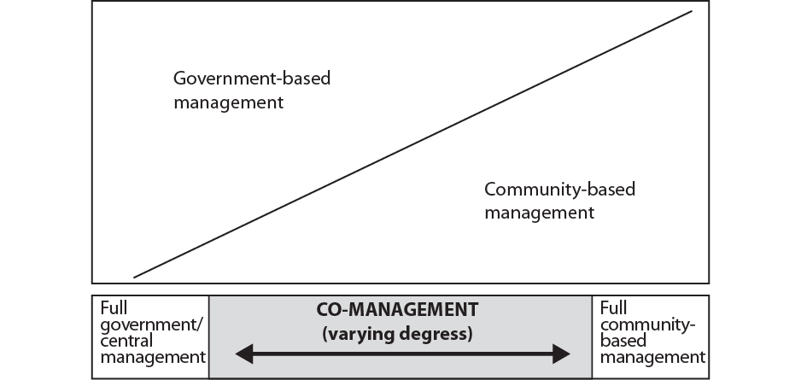

The extreme situations represented by the terms “community-based management” and “central government management” rarely exist in reality and typically there is some form of mixed arrangement. The term co-management therefore represents the varying degrees of involvement/interaction between government and fishers (Figure 9.1).
Co-management can therefore be defined as:
Partnership arrangements in which a community of local resource users, government, other stakeholders and external agents share responsibility and authority for the management of the fishery, with various degrees of power sharing
i.e. a practical way to implement sustainable development and sustainably maximize ecosystem benefits of a fishery system

Degrees of power sharing can be defined as follows:
- Community control: power delegated to the community to make decisions and inform government of these decisions;
- Partnership: partnership of equals with joint decision-making;
- Advisory: users advise government of decisions to be taken and government endorses these decisions;
- Communicative: two-way information exchange, local concerns are represented in management plans;
- Cooperative: community has input into management;
- Consultative: mechanisms exist for government to consult with fishers, government makes all decisions;
- Informative: community is informed about decisions that government has already made.

Through consultations and negotiations, the partners develop a formal agreement on their respective roles, responsibilities and rights in management.

The advantages of co-management include:
- more open, transparent, accountable and autonomous management process;
- a more democratic and participatory society;
- more economical than centralized systems, requiring less to be spent on administration and enforcement in the long run;
- fishers and key stakeholders take responsibility for a number of managerial functions;
- communities and resource users develop a flexible and creative management strategy, which meets particular needs and conditions (seen as legitimate);
- local solutions to local problems; and
- improved stewardship and public awareness of aquatic and coastal resources management.
Co-management initiatives can foster these benefits given their multiple potential. They can help to reduce conflict between stakeholders and government, as well as between stakeholders themselves, by i) clearly defining rights and responsibilities; ii) providing an institutional forum for discussion among decision-makers, and iii) encouraging support for the management process. They also have the potential to build a conservation ethic, by bringing fishers and others into the decision making process, so they share responsibility for sustainability in the fishery.
The challenges include:
- it may not be suitable for all stakeholders. Many will not be willing or able to take on the responsibility of co-management;
- a long history of dependency on government may take years to reverse. Leadership and appropriate local institutions, such as fisher organizations, may not exist within the community to initiate or sustain co-management efforts;
- in the short-term, high initial investment in time, financial resources and human resources are required to establish co-management;
- for many individuals and communities, the incentive(s) – economic, social, and/or political – to engage in co-management may not be present; and
- the risks involved in changing fisheries management strategies may be too high for some communities and fishers.
The co-management approach can be applied at any scale, from that of a single component (fleet sector, gear type, geographical area) of a single fishery, through to multi-stakeholder, multi-resource, multi-use situations, which will arise within the context of integrated management. Although the principles of co-management are essentially the same within large-scale industrial fisheries and in small-scale artisanal fisheries, the policies and modalities for implementing them may differ. Co-management is not just a concept that involves the rural poor, local communities and government, but must incorporate all types of fishing and impacts on the resources. For example, having good stewardship of coastal resources by local communities that are then exploited by larger vessels from other localities is counter-productive and will inevitably lead to the breakdown of the system.
Activity: Practice active listening.
For more details on tools and techniques that can be used for co-management see People Toolkit, as well as Module 16 Reality Check II.

Consultation Tools: http://www.fao.org/fishery/eaf-net/topic/166247/en

- Awareness raising
Awareness raising is a critical ingredient in the transformation of stakeholders into active partners in co-management. Awareness raising empowers people and improves their environmental awareness through knowledge. As part of the EAFM stakeholder engagement process, an awareness raising campaign should include activities that are relevant to stakeholders and their goals for sustainability, and which emphasize the link between local resource-use activities and the quality of the environment. Too often, awareness raising is not targeted at those who are most important in resource use and management. See Tool n.9 on how to carry out an awareness raising campaign.
Refer to the People Toolkit and EAF-net for more about participation and awareness raising methods, and to pick up tips and suggestions for improving your facilitation skills.

7. Community mobilization
In this section we focus on how to mobilize communities for better EAFM. The active participation of people in a community is at the heart of the co-management process. The success of co-management is directly related to well-organized communities that have been empowered to take action to manage and conserve their fisheries resources and associated habitats. Community mobilization for EAFM is much more than just establishing organizations; it is a process of empowerment, building awareness, promoting new values and behaviours, establishing self-reliance, building relationships, developing organizations and leadership, and enabling communities to take action. They can thus be ready to take part and contribute to the EAFM process through co-management.
It is useful to note that the term “community” can have several meanings. Community can be defined geographically by political or resource boundaries, or socially as a community of individuals with common interests. For example, the geographical community is usually a village political unit (the lowest governmental administrative unit); a social community may be a group of fishers using the same fishing gear, or a fisher organization.
Care should also be taken not to assume that a community is a homogeneous unit, as there will often be different interests in a community, based on gender, class, ethnic and economic variations. Recently, the term “virtual community” or “community of interest” has been applied to non-geographically based communities of fishers. Similar to the “social community”, this is a group of fishers who, while they do not live in a single geographical community, use similar gear or target the same fish species or have a common interest in a particular fishery.
To participate in co-management, the stakeholders will need to organize themselves and arrive at an internal consensus on the interests and concerns that they want brought forward (Modules 10 and 11 Steps 1-2). Meetings and discussions are held among the individual stakeholders to identify and clarify their interests and concerns and for those individuals with common interests and concerns to organize themselves into groups. The key stakeholder group established in Module 8 Startup A Task vii, plays a liaison role between wider stakeholders and the EAFM team. Effective community participation in co-management requires a strong community organization(s) to represent its members. In some cases, community organizations capable of representing their members in co-management already exist. In other cases, organizations will either need to be strengthened or newly established. One or more community organizations may be needed in the community depending upon its size, diversity and needs. An appropriate person(s) from the organization must be selected to represent them in the larger co-management organization.
Fishing and fisher associations exist in many communities. However, these organizations will not automatically be suitable as representative organizations in co-management. It is likely that they were established with objectives that relate more to improving marketing, or as a conduit to distribute government subsidies and to increase the incomes of members. Changes in outlook will be necessary for these organizations to play major roles in resource management. These changes may be difficult and lengthy, especially if the organization is still struggling with its original mandate, and so putting more focus on management may strain its internal cohesion. The EAFM team and facilitators need to be aware of all these possibilities.

These organizations can be strengthened through:
- environmental education;
- social communication;
- building alliances and networks;
- organizational sustainability to keep members and funding; and
- human capacity development.
The first four points above are explored in more detail in community mobilization in Tool n.10.

Steps 1.1, 1.2 & 1.3
Define and scope the FMU
Module 10

Session objective:
- Describe FMU defining and scoping means;
- Undertake visioning and be able to agree on a vision.

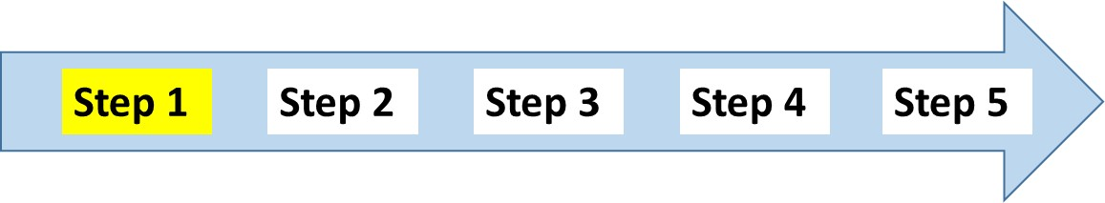
Overview
This module outlines how to define the fisheries management unit FMU, how to agree a vision for it and the various elements to consider for scoping the FMU.

Introduction
A successful EAFM plan requires a clear statement of the area to be managed – the FMU. In Module 8 Startup A Task ii, the broad area was identified. Now you need to define the FMU more precisely so as to inform team staffing, stakeholder engagement and general information gathering.
  - Define the FMU
Fisheries management can be applied at a number of geographic scales, ranging from a large marine ecosystem (LME) to a fishing community (cluster of villages). However, EAFM works best at the level of a “fishery” and it is important to clearly define the area to be managed, i.e. the FMU.

For EAFM, the FMU should be:
- multi-species;
- multi-gear, if catching the same species;
- multi-gear, if conflicts between them occur; and
- multi-jurisdictional, if different jurisdictions involved.
Ideally, the chosen FMU should:
- relate to some known ecological boundaries, although this is often difficult to achieve in a practical sense as ecological boundaries seldom coincide with political boundaries and are often nested (Module 4 Principles of EAFM);
- cover the whole of the geographical range of the main stocks; and
- cover all the gears that are fishing that stock, including both small-scale artisanal fishers and large-scale commercial fishers.
Ecosystems are often nested and on different geographical scales. To re-iterate a previous example, considering a fishery adjacent to a community may be adequate for sedentary species such as a cockle stock that is fished almost exclusively by that community, but totally inadequate for a more mobile fish such as a coastal tuna that are fished by different stakeholders and different gears along the coast, as well as by the community.
When the ideal (matching the FMU with known ecological boundaries) cannot be achieved, the lack of complete coverage must be acknowledged and considered in the planning. Where too much of a species’ range falls outside the FMU – for example, a fishery where the stock is shared by two countries (as is the case with some coastal tuna species) – then every effort must be made to engage the other parties in the planning (Figure 10.1).

Figure 10.1: The ideal versus the practical FMU

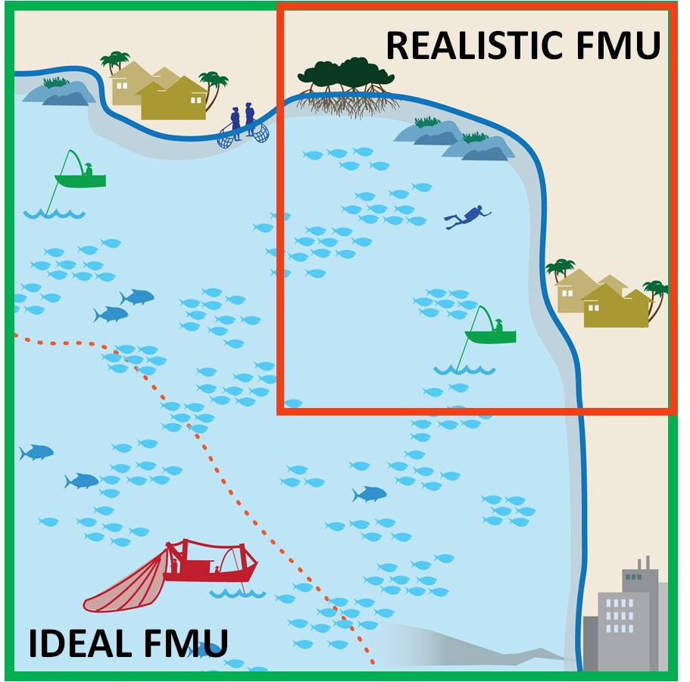

Activity: Map the FMU.

1.2 Agree on the FMU vision
It is now important to agree on the vision for the FMU. A vision is the top-level aspiration of what the future will look like if management is successful. This should reflect any known national or provincial policies and legislation. There is a set hierarchy of vision–goals–objectives–actions (see Figure 10.2 below).
Figure 10.2: The EAFM plan hierarchy
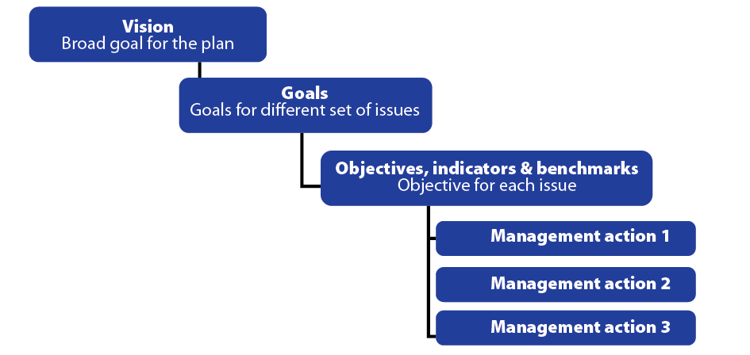

An example of a vision is:
Enhance the socio-economic benefits of the FMU through the sustainable and responsible use of the fishery resources and the broad ecosystem where they are found.
Goals, objectives indicators and benchmarks and management actions are discussed in detail later in the course.
Activity: Agree on the vision for the FMU.

1.3 Scope the FMU
Once the location and boundaries of the FMU have been defined and the vision has been agreed upon, the FMU needs to be scoped and profiled so to bring together all the relevant background information. This profile will serve as:
- a basis for all EAFM planning and management activities;
- a baseline for future monitoring and evaluation of performance.
The process of scoping and profiling the FMU is outlined in detail below but in some cases it may not be necessary to carry out all the steps in such depth; the actual FMU scoping document may be relatively brief because it is background information. It is also important to recognize that much of the information may have been collected already and is held by different agencies, organizations and stakeholders; the exercise can be basically one of compilation and collation.
The FMU profile addresses a broad range of information across different disciplines and technical fields, including social sciences, natural sciences and political sciences.
The EAFM team works with stakeholders and the key stakeholder group to profile the fishery. The broad range of interests and dimensions to the fishery should be captured in the profile. However, in practice the most important consideration for the team is a balance of expertise, so as to collect data which are relevant and useful. These data will then act as a baseline for assessing change over time and can be a starting point for monitoring performance.
The FMU profile should help to answer these key questions:
- what is the current condition of resources, patterns and problems of resource use?; and
- what are the patterns of power in resource access and use, i.e. between and within gender, ethnic groups and social hierarchies?
Information needs
Scoping is underpinned by data, information and knowledge derived through both the formal scientific process and through traditional knowledge, noting that the framework for EAFM is such that lack of data should not be an obstacle to getting started.
In the following section “research” is used very broadly to mean obtaining and verifying data and information, either from existing sources or from new activities. Depending upon the FMU vision, the research may only involve those stakeholders associated with particular activities. When it is not possible to research all stakeholders, it may be necessary to set priorities as to which stakeholders to focus on. This can be done by noting three main factors:
- proximity to resources;
- the impact that stakeholder activities on resources; and
- relative levels of dependence of stakeholders on resource-related activities.
The FMU information gathered needs to be a balance between scientific information and indigenous knowledge. “Indigenous or local knowledge” of resource users and other community members (from different genders, ethnic groups, social groups, etc.) is critical information for planning and management. Information collected will differ depending on research methods, as well as the profiles of those who are collecting the data. The key stakeholder group determines the profile scope/scale based on decision-making information needs and available resources or time. The collection of information may take several weeks to several months depending upon the scope and scale of information needs.

The three assessments needed for the FMU scoping and profiling process reflect the three EAFM components:
1. Resource and ecological assessment;
2. Socio-economic assessment; and
3. Legal and institutional assessment.
More detail on these assessments can be found in Tools n.20, 21 and 22.
There will likely be insufficient information to answer all questions regarding the impacts of policy choices, but there is usually enough to identify the interactions between species and sectors and the direction of particular human impacts on biota ☺ and their social and economic impacts.
Data can be either quantitative or qualitative. Quantitative data are a numerical measure, i.e. “who, what, when, where, how much, how many, how often,” and are obtained through standardised interviews, biophysical surveys and surveys using closed questions. Qualitative data often refer to “how and why” and can be obtained informally, e.g. through free and guided interviews (including focus group discussions); surveys using open-ended questions; participatory methods; observations; and interpretation of documents.
When data are poor, scoping can be carried out with a qualitative conceptual model via stakeholder engagement. In this case, the data come from synthesizing informal or disparate sources of information and from using the participants’ basic understanding of the ecosystem.
In data rich systems, i.e. when there are data describing major system drivers or threats, sophisticated ecosystem simulation models and sensitivity analyses can reveal which connections in the system are strongest and most affected by management. The species or processes associated with the strongest connections should be the focus of goals.
Statistical analysis can quantify the most critical connections in the system in data rich situations, but statistical analyses can be time consuming and require a certain skill set, so conceptual modelling can provide a good alternative. Either way, for socio-economic and governance issues, it is good practice to always include qualitative data as these can often be used to explain or elaborate upon numerical data. Statistical analyses can provide evidence to make inferences about the system, but generally more detailed information and interpretation will be required to explain the complex social, ecological and governance components of the fishery.
An EAFM is an information driven and guided process, it is therefore important to note that data and information is a cross-cutting consideration and is not only required for scoping. Included within an EAFM plan is a monitoring system (Module 12 Step 3.1 and 3.2; Module 17 Step 5). This monitoring system ensures that further data relevant to the impact of management on the fisheries system will be collected. This means that through time uncertainty can be reduced and the understanding of the coupled socio-ecological system will grow.
EAFM is also an adaptive management process where a lack of information should not preclude action, i.e. the precautionary approach (less information = more caution). Existing information and traditional knowledge can be utilized, as long as it is verified and validated.
As resources permit, a transition to more sophisticated information gathering can take place over time. A gap often exists between information required for fisheries management and the activities of fisheries research agencies. A direct advantage of the cooperative and participatory nature of EAFM is that it should prompt dialogue between the people tasked with management, namely fisheries and related research departments, and academic researchers from various sectors. This should help to align the research agenda more directly with the information requirements for EAFM.
Once key information, parameters and illustrations have been assembled, it is time to validate these findings by presenting them to the stakeholders for comment. Validation can take place in various forms:
- small discussion groups with key stakeholders;
- presentations to specific groups of stakeholders or interest groups;
- presentations to groups of selected representatives of different stakeholder groups; and
- community meetings involving a wider range of stakeholders.

Activity: Discuss what type of data and information is needed for scoping, what methods are used to obtain it and what sources will be used?
Sharing Information
It appears that unless there is a common need or cause, there is little incentive to share data and information (except in formal scientific publications). Fishery information sharing across boundaries occurs when there is a joint management regime. It also occurs as an obligation to regional fishery management organizations that inform the development of common management actions and decisions or need for action on the target stocks, bycatch species or sometimes habitat impacts.
Fishery information (often statistical) is also reported to regional bodies (e.g. SEAFDEC, APFIC, FAO) as part of an obligation or undertaking to support regional knowledge. However, countries and organizations are often reluctant to release raw data and regional data often ends up as summary information.
There are also challenges to sharing data between national agencies – a classic example is fishing vessel registers/vessel licenses that may be held by the maritime transport department and fishing licenses held by the fishery department. The two agencies often do not combine their data, preventing an effective tracking of vessels operating as fishing vessels, and fishing vessels entering the fishery and operating without licenses. It also prevents the effective constraint of increasing the numbers of fishing vessels.
Fishery research (which may be joint or coordinated) may result in some transboundary sharing of results or even of raw data. Regional or bilateral research programs encourage looking at an issue across countries. Alternatively, research on a similar topic across several countries, offers the opportunity for the researchers to compare notes and look at it in a broader context (e.g. role of mangroves as habitats; fishing gear selectivity; fish migrations), this can then advise regional norms on best practice or management.
NGOs typically work in an advocacy mode and the information that they gather may be communicated to influence policy or decision-making, or to support a particular stakeholder group and empower them in negotiations or to leverage (political/financial) support. The information is sometimes transboundary – especially if the NGO in question is an international NGO and may have projects or actions in several countries (e.g. live reef fish trade, shark fin trade, ornamental fish trade, coral trade, labour migration/human rights abuse).
Participatory EAFM should foster better sharing of information, a lot of which will now be recorded in the EAFM plan.

Filling out the EAFM plan
Finishing Step 1 allows sections 1 and 2 of the EAFM plan template to be filled. Suggested subheadings for the BACKGROUND are given as a guide.
- VISION

2. BACKGROUND
Description of the area and resources to be managed, including maps at different scales.
The fisheries management area
Area of operation of the fishery, jurisdictions and ecosystem "boundaries" (including national/province/district jurisdictions). Map of FMU.
History of fishing and management
Brief description of the past development of the fishery in terms of fleets, gear, people involved, etc.
Current status of the fishery
Description of the fishery resources and fleet/gears used.
Resource status.
Map of resource use patterns.
Socio-economic benefits, including postharvest
Description of stakeholders and their interests (including socio-economic status).
Description of other uses/users of the ecosystem, especially activities that could have major impacts and implications for coordination and consultation processes.
Social and economic benefits, both now and in the future.
Special environmental considerations
Details of critical environments, particularly sensitive areas and endangered species.
Institutional aspects
Legislative background.
Existing co-management arrangements – roles and responsibilities.
MCS arrangements.
Consultation process leading to the plan and ongoing dialogue.
Details of decision-making process, including recognized participants.
Nature of rights granted in the fishery and details of those holding the rights.
Maps of management interventions/user rights/jurisdiction boundaries.

Steps 2.1, 2.2 & 2.3
Identify and prioritize issues and goals
Module 11

Session objectives:
- Identify your FMU-specific issues;
- Develop goals for the EAFM plan;
- Prioritize issues through risk assessment.

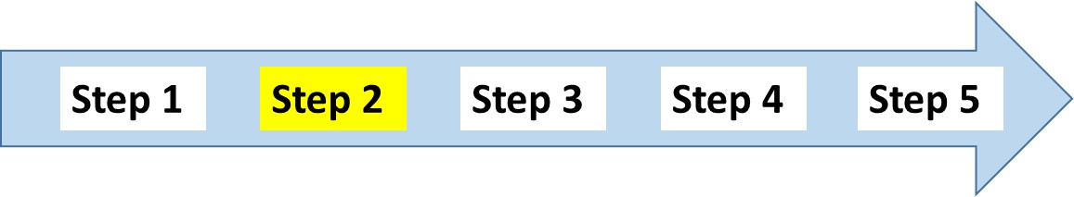
Overview
This module outlines how fisheries related issues can be identified and broken down into the three EAFM components, before being assessed for risk. It explains how to define goals for the EAFM plan.
Introduction
During the initial participatory workshops with stakeholders an important activity is to identify all issues relevant to the fishery, to help stakeholders decide where to focus the management system so as to generate the best outcomes for stakeholders.
To assist with this process, the issues can be separated into the three EAFM component groups:
- Ecosystem well-being – all ecological “assets” (e.g. stocks, habitats, ecosystems) relevant to the fishery and the issues/impacts being generated by the fishery that may be affecting them.
- Human well-being – the social and/or economic “outcomes” currently being generated by the fishery, both the good (those outcomes the community wants to have. e.g. food security and economic development) and the bad (those it wants to avoid, e.g. conflicts and injuries).
- Good governance – the management and institutional “systems” in place, or proposed, to deliver the wanted outcomes (e.g. access and tenure systems, compliance, democratic processes, conflict resolution and institutional arrangements) along with the external “drivers” (not controlled by the fishery) which may be affecting performance.
The identification process must cover all direct and indirect impacts of fishing activities on fish that are retained and those that are discarded; on the broader ecosystem; and the wanted and unwanted social and economic outcomes on both the fishers and the community. The process should also identify all the elements needed to enable the effective governance and administration of the fishery, including legislation, plans, consultation, compliance, etc. Finally, it also records any issues external to the management system that could affect the performance of the fishery, including natural (e.g. climatic) and human induced ecological (e.g. pollution), social (e.g. international attitudes) or economic (e.g. exchange rates) impacts.
Because a large number of issues can be identified, the key part of the whole EAFM process is to ensure only the most important are addressed by direct management intervention. This requires a determination of their relative priority using some form of risk assessment and/or prioritization procedure. Such procedures should be based upon the fishery trying to deliver the three components of EAFM, not just the ecological ones. A successful planning process relies, for the most part, on prioritization of the identified issues.
2.1 Identify the issues
An evaluation of issues associated with the fishery needs to be guided by the high-level policy goals set at the national or regional level; the broad management vision of the FMU; and, if possible the goals, should be consistent with existing or proposed new legislation. Fisheries policies and management plans often stop at broad goals, but because the issues and objectives are so broad, it is difficult to set management objectives that management can address. A number of tools are available to help develop and categorize the issues (Table 11.1).

Table 11.1: Tools for identifying and categorizing issues (see Toolkit for more details).
Name | Description | Implementation
Card storming (variation on brainstorming) | Discuss issues and write their key ideas on cards; the facilitator then organises these ideas into clusters. Fosters interdependence and collaboration. | Easy
Component trees | Have three EAFM components (human, governance and ecological) as headings, and categorise the various issues under each of these three headings and the possible sub-headings. Breaks each issue down until it becomes manageable. | Moderate
Problem tree | A diagram that traces the causes and effects of problems | Moderate
Asset/objective-impact/threat matrix | A matrix that helps to separate identified issues into their two different categories – an “issue” describes a threat to, or impact on, what is desired to achieve. | Moderate
Causal analysis | Issues are sorted into a hierarchy of cause and effect starting with the overarching driver, then the root cause and proximate cause that results in the issue | Moderate

Cause and effect
When threats and issues are identified through a participatory process it is usual for a wide variation in the sorts of issues to arise - some are very broad (e.g. pollution) and some are very specific (e.g. bombing reefs).

A tool called a “problem tree” is one way to sort the wide range of issues identified (Tool n.28). The problem tree can recognise four levels of issues:
- Drivers: these are the large-scale events that have a flow-on effect on many issues, e.g. growth in population and wealth, or climate change.
- Effect: The effect of that the core problem creates;
- Core problem: the actual problem; and
- Causes: the cause of the problem. These can be broken down further into main causes and causes underlying these.

Figure 11.1: Example of a problem tree for “declining fish stocks”.
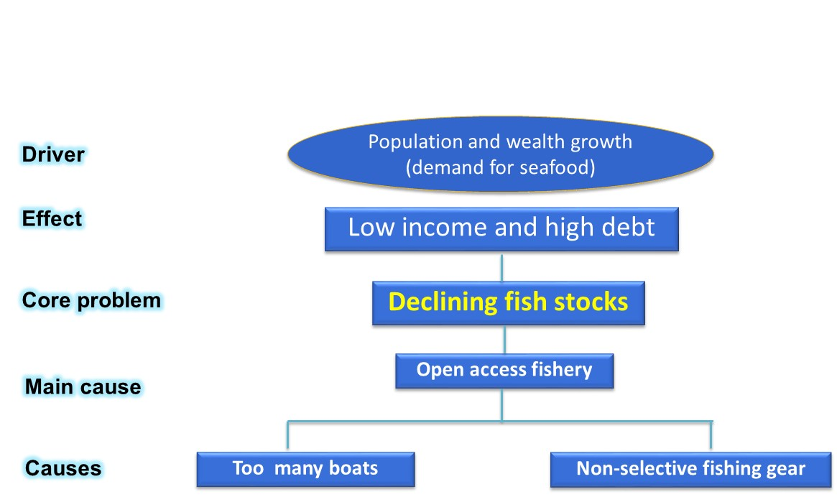

In Figure 11.1, the core problem is declining fish stocks. The overarching driver for this is growth in population and wealth that is leading to increased demand for seafood. The effect that declining fish catch has is low income and high debt of fishers. The main cause of the problem is an open access policy that opens the fishery to anyone who wants to fish (in comparison to a limited access policy that restricts fishing to only those with a right to fish). As a result of the open access system, there are too many boats and non-selective fishing gears in operation (causes).

Using the problem tree
The problem tree helps identify threats and issues at a level that can be addressed by a management. The effect is often linked to the goal (see later in this module) and the core problem often identifies the management objective (Module 13 Step 3.1). The causes can be addressed by management actions (Modlue 14 Step 3.3). This could be the main cause or the underlying causes. In this example, management actions could address the main cause by changing the policy from open access to limited access. Actions could also address the fact that there are too many boats and that non-selective gears are being used.

Issue check list
Regardless of the method used, it is important that all the issues in the FMU have been considered. Here is a checklist that outlines the categories that should be considered and some examples. Some of these will not be applicable to every FMU, but deciding which issues are included is an important step that stakeholders involved with the EAFM process have to take.

ECOLOGICAL WELL-BEING
FISHERY RESOURCES
Landed catch | e.g. sustainability of main commercial species
Bycatch/non-target species | e.g. discards; endangered and vulnerable species
FISHING EFFECTS
General ecosystem | e.g. food chain impacts
Habitat | e.g. loss of mangroves; damage to sea bed
Pollution from fisheries | e.g. oil discharge
ECOSYSTEM EFFECTS
Pollution from other users | e.g. human/industrial waste

HUMAN WELL-BEING
Income, employment and livelihoods | e.g. food security; gender-related access to/use of resources
Safety and health | e.g. product quality; safety at sea
Post-harvest | e.g. market supply
Interactions with other sectors | e.g. feed for aquaculture; competition for employment

GOOD GOVERNANCE
Institutions | e.g. lack of cooperation among relevant agencies; lack of management structures/mechanisms
Fishing communities/fishing industries | e.g. lack of awareness of existing rules and regulations
Consultation/dialogue | e.g. lack of participation
Information and knowledge | e.g. uncertainty about stock status
Global economy | e.g. changing market demand; fuel prices
Compliance and enforcement | e.g. lack of MCS capacity

Activity: Agree on the set of threats and issues that are applicable to the FMU. Use a proble tree analysis to sort them into (i) Drivers, (ii) Effects, (iii) Core problems, and (iv) Causes

2.2 Define goals for the EAFM
Remember the EAFM plan hierarchy:

As can be seen in the figure, goals is nested under the vision and should still be broad level and limited to three to five for any EAFM plan. A goal is the long term outcome that management is striving to achieve. It often refers to a group of inter-related issues. For example, the overall goal of a community-based management action may be to restore the health of coral reefs and fish stocks in the managed area. An objective is a formal statement detailing what you are trying to achieve for each issue (these are often referred to as managemant objectives) and are considered in the next step (Module 13 Step 3.1).

Example goals are:
- Restored and sustainably managed fisheries and other living marine resources and habitats;
- Improved livelihoods of communities that are dependent on the fisheries resources; and
- The FMU is well governed with good compliance and enforcement.

It may be appropriate to consider a goal for each of the three components of EAFM, it is recommended that two goals for “ecological well-being” are included as this component covers both the fishery resources and the general ecosystem issues. This will help expand fisheries-centric thinking to the ecosystem scale.
Activity: Using the results of the problem tree analysis, put the Drivers aside as they are out of our control. Develop a goal for each theme (e.g. the 3 components of EAFM), by looking at the effects within each theme.

2.3 Prioritize the issues through a risk assessment
Issue identification is likely to result in a long list of potential issues, but there is a practical limit to the number of issues that can be dealt with by a management system. Prioritization of specific issues is usually conducted using a risk assessment. The risk assessment can be either qualitative and opinion based, or highly quantitative and data based.

A risk analysis typically seeks answers to four questions:
- What can go wrong? (Risk)
- How likely is it to go wrong? (Likelihood)
- What would be the consequences of it going wrong? (Impact)
- What can be done to reduce either the likelihood or the consequences of it going wrong? (Action)
Remember: risk = likelihood x impact

High priority issues are those with a high likelihood of occurrence and high impact. These high priority issues are the ones that require direct management.

A number of tools are available to prioritize issues (Table 11.2).

Table 11.2: Tools for prioritizing issues

Name | Description | Implementation
Non formal risk categories/ Semi quantitative risk assessment | The risk associated with each identified issue is directly assigned by the participants to one of three categories – high, medium or low risk, with the descriptions incorporating both the consequence and the likelihood. | Easy
Qualitative risk analysis  (impact/  likelihood matrix) | Participants place issues on the 2x2 matrix with two variables of likelihood and impact with two to six categories of likelihood and two to six levels of consequence (impact). Each identified issue is rated accordingly and plotted onto matrix. | Moderate
Dot ranked informal vote ranking | Participants identify issues which they think are high priority. Final count shows which issues are of high priority to that group of stakeholders. | Easy
Pair-wise ranking | Participants list up to five issues on cards on both vertical and horizontal axes of a matrix, in the same sequence. Compare each pair and agree which is the higher risk. Repeat until all possible combinations have been filled. List the results in rank order by sorting the cards in order of priority. | Easy

A simple semi-quantitative risk assessment is to rate each issue as to whether it has (i) high, medium or low likelihood of occurring and (ii) high, medium or low impact when it does occur. These are then plotted on a 2x2 matrix diagram Figure 11.2). In this way, the high likelihood/high impact issues are identified. These are the high priority issues that need to be taken forward into the planning process. The medium risk issues might also be identified and mentioned in the EAFM plan in case their priority changes over time.
Figure 11.2: Semi-quantitative risk assessment. Likelihood is the probability of occurrence and impact is how change would occur.
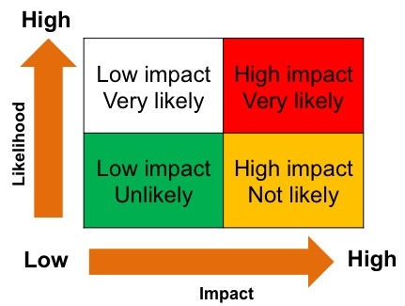
Activity: Prioritize the issues using a 2x2 risk assesment and select the high priority issues and group them into the 3 EAFM components of EAFM.

Finishing Step 2 allows the issues and goals to slot into the EAFM plan under the following headings:
3. MAJOR THREATS AND ISSUES
Ecological issues
Fisheries resources and general environmental issues, including both the impact of the fishery on the environment and vice versa.
Social and economic issues
Issues relating to the people involved in fishing, the general public and at the national level, including gender issues.
Governance issues
Issues affecting the ability to achieve the management objectives.
4. GOALS OF MANAGEMENT
Higher level goals concerning where you want management to lead the process.
Usually 3-4 goals covering main themes.

Reality Check I
Module 12

Session objectives:
- Identify the constraints and opportunities in meeting the FMU goals;
- Use facilitation skills with co-management partners in focus group discussions (FGDs);
- Use conflict management to resolve conflict in EAFM.

Overview
This module allows the EAFM key stakeholder group to step back and assess what may stand in the way of the EAFM plan and EAFM goals from being realized. This is the time to practice the facilitation skills discussed earlier in Module 9 Startup B. This module discusses how to assess conflict so as to move towards consensus and explains the stages of conflict management. It then outlines strategies and techniques for dealing with conflict, including how to achieve, where possible, “win-win” (mutually beneficial) solutions.

Introduction
At this stage of planning, the high priority issues that management can address have been identified and grouped under themes. Goals have been developed for each theme. It is now time to do a reality check to see if the goals are really achievable. This is called Reality Check 1. Further on in the process, after the EAFM plan has been implemented, another reality check – Reality Check II – will be carried out.
- Constraints on and opportunities for achieving the goals
Each goal needs to be reviewed to identify the constraints and opportunities for achieving it.
To evaluate whether the goals are achievable, the EAFM team could ask the following questions:

Relevant questions:
- Is funding available or achievable to reach these goals?
- Is there sufficient political support and stakeholder support?
- Is there institutional support?
- Is there sufficient human capacity?
- Are the time frames realistic?
- can the information/data needs be met at a level where the precautionary approach allows for adaptive management?

Some of these questions may have already arisen as governance issues. If the answer is a definite “no” to any of these questions, then there are two options: either reset the goal to be more realistic or work with stakeholders to remove the constraint, or at the least manage it. If possible, constraints should be turned into opportunities.
Activity: Consider the constraints and opportunities in meeting the goals.
Planning tools are also available to evaluate whether the goals are achievable (see Toolkit 25).

- Facilitation and focus group discussion
Many of the constraints can be overcome by involving the stakeholders in focus group discussions (FGDs). FGDs and the role of a facilitator were introduced in Module 9 Startup B.

Remember the key ways to sustain stakeholder engagement are:
- effective facilitating that can be achieved by:
  - guiding people in a discussion of their experiences, feelings and preferences about a specific topic;
  - raising issues identified in discussions; and
  - the use of probing techniques to animate discussion and promote in-depth reflection.
- participants can make their own questions, frames and concepts and develop their own priorities.
During this process, remember that interactions between participants provide opportunities to source data.

During any FGD, the facilitator is expected to:

- guide each session;
- not be too intrusive/structured in their approach;
- allow the discussion to flow freely;
- use a fairly small number of general questions to guide the focus group session;
- refocus the discussion as necessary;
- intervene to bring out important issues if participants do not; and
- build rapport (use active listening).

Activity: Hold a focus group discussion.

- Conflict and conflict management
Previous modules have demonstrated that an EAFM reflects ecological, socio-economic and governance needs, and a diverse range of sectors and stakeholders.
Given the extent and scope of the EAFM multi-stakeholder process, and the likely confrontations between different levels of resource users, conflicts are inevitable in EAFM. Conflict is not necessarily negative. It can facilitate the emergence of more equitable power relationships, correct bad fisheries management practice and improve EAFM policy.
Conflicts over fisheries and marine resources have many dimensions including, but not limited to, power, technology, politics, gender, age and ethnicity. Conflicts can take place at a variety of levels, from within the household to the community, regional, societal and global scales. The intensity of conflict may vary from confusion and frustration over the direction that fisheries management is taking, to violent clashes between groups over resource ownership rights and responsibilities. Conflict may result from power differences between individuals or groups or through actions that threaten livelihoods.
Conflict management is about helping people in conflict to develop an effective process for dealing with their differences. The generally accepted approach to conflict management recognizes that the parties in a dispute have different and frequently opposing views about the proper solution to a problem, but acknowledges that each group's views, from the group's perspective, may be both rational and legitimate. Thus, the goal of people working in conflict management is not to avoid conflict, but to develop the skills that can help people express their differences and solve their problems in a collaborative way.
Activity: On the FMU maps, mark the areas where conflict is likely and who the players will be.
Moving from conflict assessment to consensus
A first step in conflict management is to assess the specific conflict in question. An analysis of a particular conflict can provide insights into the nature, scope and stage of conflict, and possible approaches to its management. There are four main factors that should be analyzed when assessing conflict:
- Characterize conflict and stakeholders. Here the type and origin of the conflict encountered is analyzed, including the number of stakeholders involved, the balance of power among the parties and the relationships between them.
- Stage in the management cycle. Conflicts at the “beginnings” stage are likely to be different from conflicts at the implementation stage. New stakeholders may arise as the EAFM process proceeds. This requires a flexible process that adapts to changing circumstances.
- Stage in the conflict process. Determine whether conflict is at a point at which interventions may be accepted.
Legal and institutional context. The formal and informal institutions, the manner in which conflicts are resolved through these institutions and the formal legal doctrines may influence the appropriate approach.
Conflict can be ignored (hoping it will go away), confronted (with the risk of deepening the disagreement), or it can be managed positively. One approach to conflict management is to have multi-stakeholder analysis and consensus building meetings (Tool n.4). These meetings have the objective of fostering productive communication and collaboration prior to the outbreak of conflict by employing tools such as conflict anticipation and collaborative planning, together with the cultivation of alliances and mobilization of support. Adopting a participatory co-management approach to planning and implementing EAFM (as outlined in Module 9 Startup B and Module 16 Reality check II) will definitely support such a collaborative process.
Building consensus involves collaborative decision-making techniques, where a facilitator/ mediator assists diverse or competing interest groups to agree on contentious issues, objectives or other matters where consensus is needed, as opposed to taking a majority vote. This usually involves respectfully sharing perspectives and working together to seek mutual benefit. Ideally, it can be used before conflicts actually emerge (thus reducing the need for conflict management). In EAFM, conflict management is useful at the stage of setting overall management goals and EAFM plan objectives, where reaching agreement on big issues paves the way for agreements on smaller technical or institutional issues, as well as in resolving conflicts during the implementation of the plan.
How to use conflict management in EAFM
The goal of conflict management is to apply skills that help people express their differences and resolve their problems in a win-win outcome. Conflict management is basically a form of facilitated negotiation that works best in these conditions:

- all disputing parties are known;
- willingness to resolve issues;
- reaching a solution is important for all;
- parties trust conflict management method;
- mutually beneficial solution is possible;
- parties have authority to make deals;
- funds, time and resources are available; and
- resolution is desirable in a wider context.
It is necessary to get past the symptoms and understand the root causes of the conflict (often from multiple sources) to be able to manage it. In the EAFM process, potential sources of conflict include:

- relationships: values, beliefs, prejudices, past injustices, past miscommunications;
- information: poor quality, misinformation, different interpretations;
- interests: perceived or actual, physical or intangible; and
- structures: resource flows, authority, institutions, time constraints, finances.

The stages in conflict management are:
- Initiation: a stakeholder or outsider may invite help to manage the conflict;
- Preparation: conflict assessment, information sharing, rules, participant selection;
- Negotiation: articulating interests and win-win options, packaging desired options;
- Agreement: concluding jointly on best option package, recording decision making; and
- Implementation: publicising outcomes, signed agreement (optional), monitoring.

Conflict as part of the change process
Conflict should be viewed as an opportunity for change. Responses to change often follow the following stages: (i) denial, (ii) resistance, (iii) acceptance and (iv) commitment (Figure 12.1).
Figure 12.1: Conflict is a process of change that can have four stages.
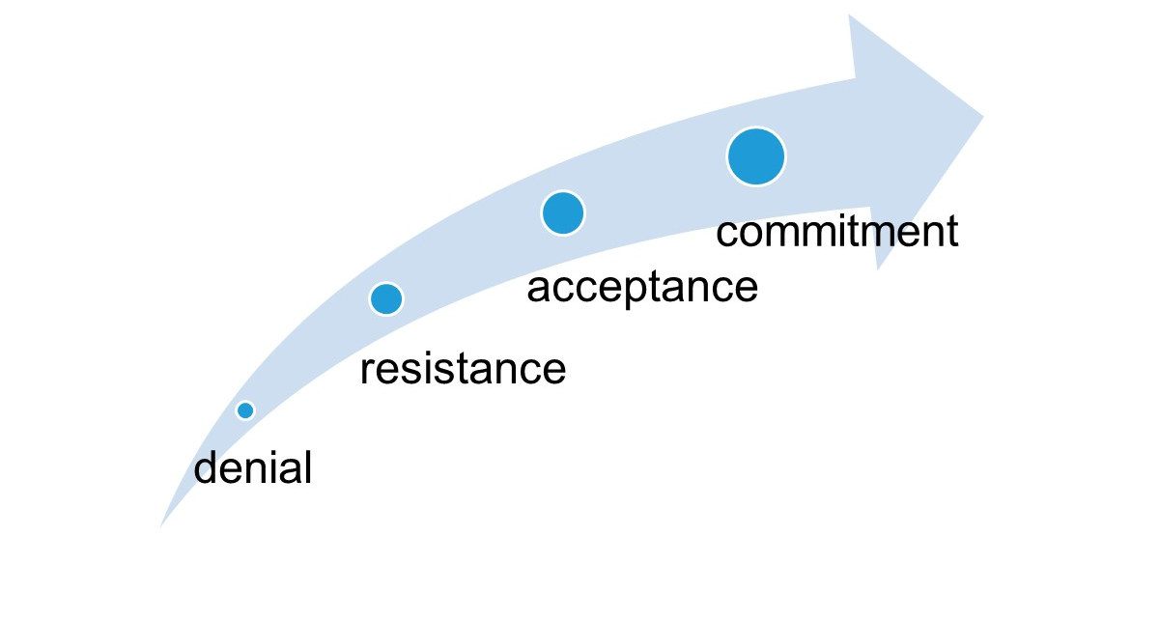

Conflict can be expected as part of the EAFM process of change. If the process is well managed, working through the conflict may lead to greater commitment towards the change.
Use the strategies outlined below and conflict management tools (Tool n. 8) to assist with working through conflicts that might be encountered.
Strategies for dealing with conflict
Strategies for dealing with conflict can be categorized according to the strength of the desire to reach objectives and/or maintain good relationships (Figure 12.2). If someone has a high concern for the relationship and a low concern for the objective, that person is likely to accommodate. If someone has a low concern for the relationship and a low concern for the objective, that person will likely go for an avoidance strategy. If someone values the objective more than the relationship, they will compete. Compromise occurs when someone “gives up” some of what they wanted in order to reach an agreement that suits all parties. If someone values the relationship and objective equally, they will go for collaboration, which is the win-win solution.
Figure 12.2: Conflict strategies

 | High concern for relationship |  | Accommodation |  |  |  | Collaboration
 |  |  |  |  |  | Compromise
Low concern for relationship |  |  |  | Avoidance |  |  | Competition
 |  |  |  |  | Low concern for objective |  | High concern for objective

Table 12.1 below explains these five strategies for dealing with conflict in more detail.

Table 12.1: The five strategies in dealing with conflict
APPROACH | BEHAVIOUR | JUSTIFICATION
Avoidance | Non-confrontational. Ignore issues. Deny they are a problem. | Afraid of damaging relationships or creating even greater problems.
Accommodate | Agreeable, non-assertive behaviour. Cooperative, even at expense of personal goals. | Afraid of damaging relationships and creating disharmony.
Compete  (win/lose) | Confrontational, aggressive. Must win at any cost. | Survival of fittest.  Must prove superiority.
Compromise | Settle for middle ground. Satisfies no one completely, but everybody gets a part of what they wanted. | No one wins everything they want, but everyone wins something.
Problem-solving  collaboration  (win-win) | Needs of both parties are important. High respect. Mutual support. Assertive/cooperative. | Mutually beneficial solution can be found.

Achieving win-win solutions
When trying to achieve a solution(s) to a conflict situation that will work for all parties, it is a good strategy to think of potential opponents as problem-solving partners. Here is a process that can be used when mediating between stakeholders in conflict.
- Set the scene: "Let's find a way to solve this that works for everyone".
- Define problem in terms of needs/outcomes. Define the original problem and individual needs, as well as expected outcomes. Identify the shared (relationship) needs.
- Brainstorm possible solutions.
- Evaluate the solutions.
- Choose solutions.
- Plan what action will be taken.
- Evaluate results.
Conflict management techniques
- The use of suggestions rather than proposals encourages flexibility and movement, and encourages building on ideas in order to reach agreement.
(Not “We need to do it this way!” but “What if we try to use this approach?”)
- Be assertive, not aggressive or passive, to take emotions out of the situation; assertive behaviour can be especially useful for dealing with anger or aggression by slowing down perceptions so that you “respond” rather than “react”.
(Not “I'm the manager here!” but “We need to think this through from the start.”)
- Avoid “you” statements. “I” or “we” (not “you”) statements are less likely to be seen as personally critical; avoiding “you” statements can assist this through a more sensitive approach based on mutual interests. (Not “You’re wrong!” but “I think we should try to use another approach.”)
- Anticipate reactions proactively to plan and prepare your approach to conflict;
(“I know you're very busy, but we could really use your help on this.”) Anticipation of the other person's feelings and awareness of their reactions helps to create a more positive climate in which to respond and encourage responses rather than reactions.
- Consider the other person's interests to make your comments more relevant;
(“I realise this is our problem not yours, but a good solution can help you too.”)
- Acknowledge reactions detected through body language or expressions;
(“I can see that you don't think much of this approach, so let's talk about it.”)
- Apply limit setting to clarify responsibilities and create limits for decisions; limit setting is useful to clarify priorities, particularly when organizational authority applies (i.e. the decision is not your own). (“Please get it to me by Monday” or “the department needs the figures for the year end.”)

The first six conflict management techniques concentrate on this critical area of converting emotional reactions into more flexible responses. Everyone has personal views, feelings and emotions that influence the way they respond to others in conflict situations. Those managing the EAFM process need to be sensitive to personal factors in both themselves and the other stakeholders’ interests. This may sound difficult now, but it will certainly increase management effectiveness.
Characteristics of assertive communication
Being assertive is very culturally dependent. What is acceptable in certain countries may be considered rude or inappropriate in parts of the region. The characteristics listed below therefore need to be adapted to the region and culture in which the EAFM process takes place:
- speaking in short, direct sentences;
- using phrases such as “I think,” “I believe,” and “in my opinion” to demonstrate taking responsibility for thoughts;
- asking others to clarify their statements when there is uncertainty around their meaning;
- describing events objectively rather than exaggerating, embellishing or distorting;
- maintaining direct and extended eye contact (in certain cultures only, e.g. western culture).

Tips for EAFM managers
- Agree objectives through consultation with the stakeholders. Ensure all concerned share the FMU’s vision (broad goal).
- Divide responsibilities and resource entitlements carefully to minimize conflict. People with identical objectives who share resources are likely to compete against each other. Enable and encourage stakeholders with complementary objectives to work in co-operation with each other.
- Create opportunities for relationship building and make interdependencies between different departments or agencies explicit. This will encourage tolerance and collaboration when difficulties arise.
- Recognize staff and partners who demonstrate that they value supportive working relationships.
Activity: Win-win solutions role play
Consultation Tools: http://www.fao.org/fishery/eaf-net/topic/166247/en

Steps 3.1 & 3.2
Develop objectives, indicators and benchmarks
Module 13

Session objectives:
- Develop management objectives;
- Develop indicators and benchmarks related to the objectives.

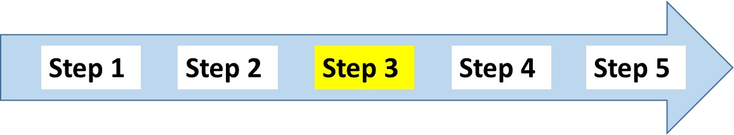
Overview
This module outlines how to develop management objectives, and from this how to develop indicators and benchmarks. It also briefly discusses data and information needed for indicators, and reiterates the importance of stakeholder participation in these key activities.
Introduction
After identifying the FMU goals for each EAFM component, and the issues that require direct intervention, the next step is to develop a management system that will deliver successful outcomes. This requires clearly determining what is to be achieved for each issue in the fishery – the objective – what can be measured to assess whether the objective is being achieved, and which management actions are going to be used.
The first thing to do is to develop objectives for the high-risk issues (high likelihood/high impact) that are clear, measurable and directly linked to one or more of the higher level goals. These are the management objectives that are at the core of the EAFM plan. Some medium-risk issues might require identification of a mechanism in the plan for ongoing review and some form of contingency plan. Low-risk issues might be noted in the plan, explaining why they are considered low risk.
3.1 Management objectives
Using the high priority issues identified in Step 2.2, it should not be difficult to create an objective directly from the issue. The objective needs to state what will be achieved, e.g. “minimize the impact on turtles and improve the status of the turtle population”. Stakeholders will also need to decide on how to assess whether the objective is being achieved. This is done through setting indicators and benchmarks (also called reference points, for example in stock assessments). In practice, it should be possible to estimate the indicators from data that have or could be collected, but this should not exclude an indicator for which new data are required. Indicators and benchmarks are developed only after an objective has been agreed to (Tool n.30 for examples).
Relevant questions:
For each issue that is to be directly managed the following relevant questions apply:
- What are the management objectives relevant to this issue and what specifically should the fishery be trying to achieve for this issue?
- Are any of the objectives for the issue in conflict with each other, if so what is the order of priority?
- Is there stakeholder agreement on the objectives?
- Are the agreed set of management objectives and outcomes for the issue still consistent with the high level goals, other policies, treaties, legislation, etc.?

Key actions
- For each issue requiring direct management, identify possible management objectives.
- If there is more than one management objective for an issue, determine their hierarchy or relative priority.
- Obtain stakeholder input or advice on their appropriateness and practicality.
- Review management objectives to ensure they are consistent with high level objectives, legislation or policies.
- Confirm the set of management objectives that will be used for developing the management system.

For an EAFM plan, if issues are specific it will be easier to introduce management actions and interventions. For example, within the broad objective:
“Manage the main commercial species within ecologically viable stock levels by avoiding overfishing and maintaining and optimizing long-term yields”
There may be two related management objectives:
“Prevent spawning stocks declining to a level that impairs recruitment”; and
“Minimize the number of juvenile fish being taken”.
As it is sometimes difficult to develop management objectives without also identifying the relevant indicator and benchmark, it is better to think of these elements as a package. So, objectives and their relevant indicators and benchmarks need to be worked out together.
3.2 Indicators and benchmarks
Stakeholders also decide on how to assess whether the objectives are being achieved. This is done through setting indicators and benchmarks to measure management performance to determine whether management is meeting the objectives.
What is an indicator?
An indicator measures the current status at one point in time (e.g. temperature, areas of mangroves etc).
An indicator can be a quantitative or qualitative measure of some attribute of the fishery that is directly measured (e.g. percentage of habitat trawled area using GPS tracks); estimated using a model (e.g. biomass estimated using a stock assessment model); measured indirectly (surrogate measures of biomass such as catch rates); or even just inferred (e.g. number of collaborative meetings as an indicator of cooperation and coordination across agencies).
More than one indicator may be used to monitor performance of the same management objective (e.g. both fishery-based and fishery-independent biomass estimates). This can provide greater confidence where none are considered accurate by themselves, but requires determination of how they will be collectively interpreted to track performance when they show differing trends.
Participatory, community-based monitoring can be used to develop and monitor suitable indicators that are based on locally collected data. This can provide a practical and cost effective method to measure progress towards meeting the management objectives developed for EAFM. For more details on how participatory community-based monitoring can be integrated into the EAFM process see EAF-net website (Activity 3.2 and Tool n.38).
Where the risks are low, crude indicators may be adequate. When selecting indicators, the level of complexity and the precautionary nature of the management action must also be considered. Where the inherent risks are higher, or the management approach is more aggressive, more robust and precise indicators will be needed. The alternative is for management to be more precautionary with appropriate adjustments made to the acceptable performance limits.

Relevant questions:
- Is there already an indicator being used?
- What levels of the indicator define acceptable performance for the objective and why?
- How precise or robust does the indicator and associated benchmark need to be to match the risk profile of the fishery?
- What resources are available for indicator measurement?
- Would the cost of moving to a more robust indicator be worth the additional expense?
- Are the resources sufficient to maintain the indicator system as long as needed - are the proposed indicators compatible with the monitoring and evaluation capacity available?
- To what degree should the indicator–benchmark–management systems be formalized?
- Is it appropriate to generate control rules?

Key actions
- Identify possible indicators to measure performance for each management objective.
- Agree on the level of precision and accuracy required.
- Review what data/information are available and the relative costs for each possible indicator given their relative uncertainty.
- Determine the most cost effective options.
- Given the levels of uncertainty in the indicator, determine what will signify acceptable and unacceptable performance.
- If more than one indicator is to be used for the objective, determine how they will work together to determine the assessment outcome.
- In practice it should be possible to estimate the indicators from data that have been or could be collected.
What is a benchmark?
Put simply, the benchmark describes where you want to go (target), where you came from (baseline) and where you do not want to be (limit).
Benchmarks are often targets that specify the desired state of the indicator (e.g. 20 percent of area under an MPA) or limits that specify a boundary within which to operate, or that should not be exceeded (e.g. 50 percent of existing fishing effort). In fisheries jargon, these are often referred to as target and limit reference points.
It is always desirable to set benchmarks using a precautionary approach which involves setting reasonable levels and taking firm actions when these are approached or exceeded.
Measuring management performance
Comparing the indicator with an agreed benchmark (a target, baseline or limit), provides a measure of how well management is performing (Module 17 Step 5; (Figure 13.1).

Figure 13.1: Measuring management performance: trend of an indicator shown against two benchmarks (target and limit).
Green is the desirable outcome (above the target), orange is less desirable (below the target but above the limit, and (iii) red is undesirable.

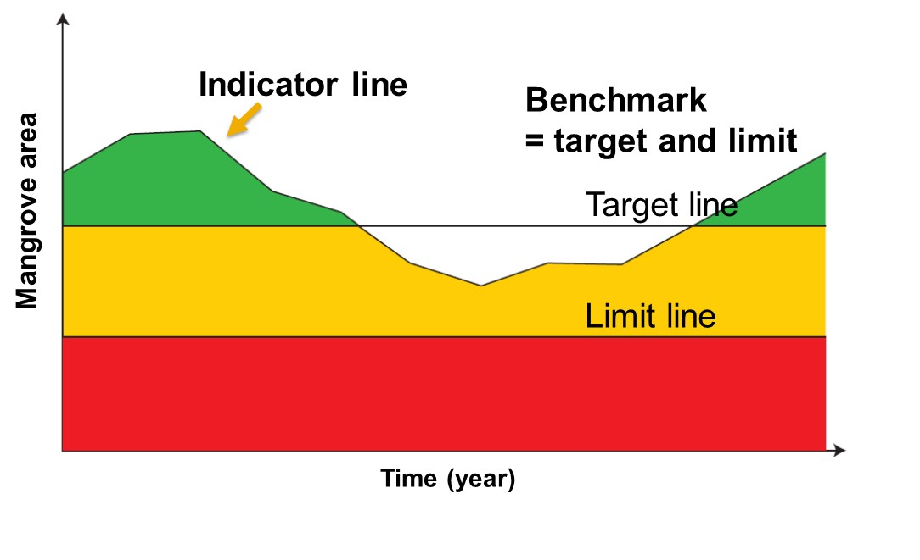
Data and information needs for indicators

Indicators and benchmarks need to be SMART:
- Specific (in terms of quantity, quality and time);
- Measurable (objectively verifiable at acceptable cost);
- Available (from existing sources or with reasonable extra effort);
- Relevant (to objectives and sensitive to change); and
- Timely (to ensure usefulness to managers).
Data and information needs were discussed in Module 10 Step 1.3 Scope the FMU. The same considerations apply to data and information for indicators and monitoring. Data needs are guided directly by the indicators selected, therefore data related to the three components will be required. The collection of new data will likely be necessary and participatory approach to data collection should be encouraged.

Relevant questions:
- Who is responsible for measuring the indicator(s)?
- Where do the data come from (new or existing)?
- If new, what method will be used?

It is also good practice to carry out data validation. Specifically, a combination of different types of qualitative and quantitative data collection methods and sources should be used. This will provide a more complete analysis of the subject matter – can enhance credibility of evaluation conclusions and confidence in the recommendations.

Participatory Monitoring and Evaluation
Where possible, participatory monitoring and evaluation (M&E) should be used to collect data and monitor indicators. Participatory M&E focuses on who measures change, who benefits and how concerns are negotiated, specifying what to measure as indicators and setting the benchmark targets and limits. The composition and skills of the assessment/M&E team are very important. Note that the assessment/M&E team may be the same or different from the EAFM team.

Activity: Develop management objectives, indicators and benchmarks for a selected number of high priority issues.
As part of the overall EAFM plan, the objectives, indicators and benchmarks slot into Section 5 of the EAFM plan under the following headings:

5. OBJECTIVES, INDICATORS AND BENCHMARKS
Priority issues, objectives, and benchmarks for the fishery, covering:
- fishery resources
- environment (including bycatch, habitats, prey protection, biodiversity, etc.)
- social
- economic
- governance (ability to achieve the plan).

Steps 3.3, 3.4 & 3.5
Management actions, compliance, finance and finalize EAFM plan
Module 14

Session objectives:
- Identify management actions and how stakeholders will comply with these;
- Include financing mechanisms in the plan;
- Bring it all together – finalize the EAFM plan.

Overview
This module completes Step 3. It explains how to agree to management actions and focuses in particular on how to ensure compliance with these agreed actions. The module also discusses financing issues and concludes with how to finalize the EAFM plan.
Introduction
Having determined the set of management objectives, indicators and performance measures for the fishery, the next step is to produce an agreed and coherent set of management actions that address the issues and meet the objectives.
3.3a Management actions
The manager’s toolbox
In existing fisheries management, the focus is often on managing people to promote sustainable use of the fish resource. For example, technical actions may control the type of fishing gear used and impose closed seasons to protect spawning stocks. In EAFM, because the issues and objectives being considered are broader, an expanded suite of management actions is required.
Thus, the suite of management actions in EAFM will include: (i) conventional fisheries management actions to address target species concerns; (ii) actions to maintain, restore, and conserve the structure and function of the ecosystem; (iii) actions that address human social/economic dimensions; and (iv) actions to address the governance issues.
EAFM management actions may include activities such as:
- technical measures to regulate fishing mortality (e.g. control gear type);
  - catch and effort controls:
    - input controls (e.g. limited entry, capacity limits, fishing location limits, territorial use rights)
    - output controls (e.g. total allowable catch (TAC))
  - spatial controls (e.g. area closures, marine protected areas (MPAs) and no-take areas);
  - temporal controls (e.g. seasonal closures; protecting spawning aggregations);
- ecosystem manipulation (e.g. habitat modification and population manipulation, such as restocking, planting mangroves, stock enhancement and culling);
- community-based development:
  - income diversification (e.g. alternative livelihood skills);
- human capacity development:
  - fishery management skills; and
  - working with others:
  - Integrated Coastal Zone Management (ICM), Marine Spatial Planning (MSP), Environmental Agency, etc.
See Manager’s Toolbox Tool n.33 for a “work- in-progress” template of management actions as well as Tool n. 35 for management actions specifically for alternative livelihoods.
Some of the EAFM issues and objectives will fall outside the mandate of the fishery agency. In these cases, EAFM needs to link to additional management sectors, such as coastal management, disaster risk reduction and climate change adaptation . EAFM management actions can include management plans and actions undertaken through other management strategies (e.g. ICM, MPAs, marine spatial planning) when they meet the EAFM management objectives.

Overlapping actions
In most cases, there will be several management actions that could address a particular objective and a list of these could be assembled through brainstorming sessions with members of the target community, assisted by the key stakeholder group and relevant government agencies. Community engagement tools such as the problem-objectives tree (Tool n.28) can be used to encourage community members to propose management actions that would solve particular problems. For each objective, it is useful to prepare a list of all possible management actions with particular attention given to their ease of application, likelihood of success, feasibility and cost.
As a result, unlike many fishery management processes that simply introduce interventions without first setting objectives, it will be clear to all stakeholders why a particular management action is being introduced. All management actions must include reference to those responsible and the time frame required for their implementation. Different management actions will be the responsibility of the community, the promoting agency, or other agencies.
Decision or control rules
Where possible, the use of specific management actions should be accompanied by decision rules on how they are to be applied. In practice, this is often developed later in the process. The decision rules state what action should be taken under different conditions, as determined by its performance. In a small-scale fishery context these actions need to be pragmatic (e.g. relating to stricter enforcement if a particular action is not working). The key is to try and agree on what might happen and how to react to the change in the indicator value. This provides some certainty for all stakeholders and the rules should be widely known and understood. In certain cases, decision rules can be quantitative (e.g. changing the TAC for the species under consideration as pre-specified fractions of abundance determined by surveys) or, more commonly, qualitative where, for example, a certain value of an indicator triggers a decision to conduct a review of management.
Management actions and the Rules and regulations
Good practice is develop a set of rules and regulations as a companion document to the EAFM plan. Because the EAFM plan is intended as long-term reference (albeit with regular adaptations and changes) management actions in the EAFM plan should be generic e.g. limit the mesh size of the cod end. The exact specifications of this action are best set out in the rules and regulations (e.g. minimum mesh size = 2.5cm. This is because it is often easier to change rules and regulations rather than the EAFM plan itself (although this depends on how the EAFM plan is formalized Module 15 Step 4). Rules and regulations can be formal or informal, indeed those made by communities based on their EAFM plan may prove to be more effective than top-down laws and rules, if there is good community buy-in.
3.3b Compliance and enforcement
There is no point in developing management actions unless there is some way to ensure compliance with these actions.
Compliance and enforcement are different but complementary concepts. Compliance is achieved when fishers’ actions conform to the relevant regulations and legislation, whereas enforcement is the act of enforcing or ensuring observance of and/or obedience of rules and regulations. Compliance is the outcome of voluntarily acceptance of, and action in accord with, the management rules and regulations.
When the rules and regulations are broken, enforcement is the action taken against those responsible for non-compliance. The task of balancing compliance with enforcement requires that resource managers must make compliance a preferred outcome compared to enforcement actions. Any compliance and enforcement system should be accountable, legitimate, equitable and flexible. Compliance is best achieved when fishers perceive management as being legitimate and fair, the science as being reliable and trustworthy, where there is effective monitoring, control, and surveillance activities, and effective penalties to decrease economic incentives for violating.
Enforcement systems attempt to increase compliance with rules governing resource use by monitoring user behaviour and punishing those engaged in prohibited activities. By increasing the severity and likelihood of sanctions and, thus, raising the opportunity cost of non-compliance, enforcement systems act directly upon resource users to foster adherence with established rules. Enforcement systems also shape compliance indirectly. By shaping perceptions of overall compliance rates, enforcement systems affect rates of “contingent compliance,” where individuals base their decision to obey rules upon the (perceived) rate of compliance by others. Through both the design of sanction mechanisms and the perceived “fairness” of enforcers, enforcement systems also shape perceptions of legitimacy.
Monitoring, control and surveillance (MCS)
In fisheries jargon, the enforcement of, and compliance with, management actions is known as “Monitoring, Control and Surveillance (MCS).” MCS is the mechanism for implementing agreed management actions. The components of MCS comprise:
- Monitoring (M) – the collection and analysis of information relevant to compliance;
- Control (C) – the rules by which the fishery is governed; and
- Surveillance (S) – observing and policing to ensure compliance with the fishing rules.

Note that this use of the word “Monitoring” has a different scope to that used in the term “Monitoring and Evaluation (M&E)”. Monitoring for compliance can be thought of as a specialized subset of the larger monitoring for M&E. Monitoring for compliance includes collecting information on what is happening in the fishery. Control is the rules under which fishery resources can be harvested, as stipulated in national fisheries legislation, EAFM plans and other arrangements (i.e. traditional law). This provides the basis on which fisheries management (via MCS) is implemented. Surveillance involves the regulation and supervision of fishing activity to ensure that fishing rules and management actions are observed. This activity is critical to ensure that the fishery is not over exploited, poaching is minimized and management actions are implemented. MCS needs:

- Cooperation and coordination across several agencies;
- Stakeholder “buy-in”;
- Training and resourcing;
- Education and awareness raising; and
- Policing, prosecuting and sentencing.
Top-down and bottom-up compliance and enforcement
Enforcement can be “top-down” (i.e. fishery patrol enforcement) and/or “bottom-up” (i.e. local fish wardens and co-management). While the national and local governments have responsibility for law enforcement, enforcement of regulations by fishers is increasingly common when governments are short of enforcement resources. In some cases, fishers are deputized to undertake enforcement, while in other cases they are provided a telephone number “hotline” to call and report illegal activities. Resource users may also decide to self-enforce regulations when they believe that they benefit from compliance with regulations. Ideally, self-enforcement should be formally empowered by agreement with responsible government agencies so that it is legitimate, otherwise there is the danger self-enforcement takes on a form of vigilantism.
Enforcement is more than the presence of armed police having the authority to arrest people; it involves the application of a broad range of approaches by different institutions and stakeholders to change or modify behaviour. Enforcement interventions can be 'soft' preventive measures or 'hard' sanctions. Soft enforcement approaches promote voluntary compliance with the requirements of the law without going to the courts. Soft enforcement focuses on the social and cultural dynamics of compliance that can be used to: (a) sustain widespread compliance, (b) encourage voluntary compliance, and (c) achieve general deterrence.
Soft or positive approaches include:
- Social marketing;
- Social mobilization;
- Coastal resource management best practices;
- Legislation and regulation;
- Information management and dissemination;
- Education and outreach; and
- Monitoring and evaluation.
Negative or 'hard' enforcement uses legal sanctions imposed by a court or regulatory authority for deterrence. Hard enforcement approaches have one objective, which is to identify, locate and suppress the violator using all possible instruments of law. Negative or hard approaches include:
- Continuous presence of law enforcers;
- Consistent activities to detect, apprehend and prosecute violators and impose appropriate sanctions;
- Sophisticated strategies developed to apprehend repeat violators; and
- Negation of all economic benefits from illegal activities.

Enforcement requires consultation and coordination among the various agencies and organizations with responsibility for enforcement of regulations, monitoring, surveillance, apprehension and sanctions. This may include the Police, Navy, Coast Guard and any community-based enforcement units.
Actions to foster compliance with management rules and regulations will change over time. In the initial phase of management, there will need to be an emphasis on general public education and outreach and visible enforcement processes to help stakeholders become familiar with boundaries and regulations. As benefits of management become understood, stakeholders should develop a sense of “ownership” of—and a commitment to—the success of the management. At this point self-enforcement should emerge (wilful compliance) from social sanctions and peer pressure.
See Tool n. 34 for ways to improve MCS.
3.4 Financing
As for any other plan, developing the EAFM process will require consideration of the required budget and other sources of funding to support the process. Module 8 Startup A explained that secured funding to embark on the EAFM process was needed. Funds must be available to support the various activities related to planning, implementation, coordination, MCS and M&E of the plan. It is good practice to plan yearly budget lines for each of these activities as part the EAFM plan and implementation work plan (see Module 15 Step 4.1). Funding, especially sufficient, timely and sustained funding, is critical to the sustainability of the EAFM process. In the early stages of implementation, funding may have been obtained from an external donor organization or a large development project. This source of funding may or may not continue in the long run. Programmes often fail when this outside source of funding stops; it is therefore essential to put in place alternate sustainable financing mechanisms. Funds also need to be made available on a timely basis to maintain cash flow for such things as staff salaries and activities. The EAFM process must be supported and accepted by the community so that stakeholders will be confident enough to invest their own time and funds.
Relevant questions:
- Is funding available from existing budget or are new sources required?
- What is the existing budget and budget cycle?
- Who will/can pay?
- What are the equity issues and the impacts on stakeholders?

The choice of which financing mechanism(s) to utilize in a particular case should be based on analysing several feasibility factors:
- financial (funding needed, revenue generation, revenue flow, year-on-year needs);
- legal (legal support for financing mechanism, new legislation needed);
- administrative (level of difficulty to collect and enforce, complications and costs; potential for corruption, staff requirements);
- social (who will pay, willingness to pay, equity, impacts);
- political (government support, monitored by external sources); and
- environmental (impact).

Depending upon the situation, and the support from government, several sources may be available:
Government revenue allocations | - Direct allocations from government budget;  - Government bonds and taxes earmarked for conservation; and  - Debt relief.
Grants and donations | - Bilateral and multilateral donors’ grants;  - Foundations;  - Non-government organizations;  - Private sector; and  - Trust funds.
Tourism revenues | - Fees (entry, diving, yachting, fishing);  - Tourism-related operations of management authorities;  - Hotel taxes;  - Visitor fees and taxes; and  - Voluntary contributions by tourists and tourism operators.
Real estate and development rights | - Purchases or donations of land and/or underwater property;  - Tradable development rights and wetland banking; and  - Conservation concessions.
Fishing industry revenues | - Fish catch and services levies/cost recovery mechanisms;  - Eco-labelling and product certification;  - Fishing access payments;  - Fishing license fees and excise taxes;  - Aquaculture license fees and taxes; and  - Fines for illegal fishing.
Energy and mining revenues | - Oil spill fines and funds;  - Royalties and fees for offshore mining and oil and gas;  - Right-of-way fees for oil and gas pipelines and telecommunications infrastructure;  - Hydroelectric power revenues; and  - Voluntary contributions by energy companies.
For-profit investments linked to marine conservation | - Private sector investments promoting conservation; and  - Biodiversity prospecting.
Other sources | - Loans; and  - Income derived from local enterprises such as handicrafts, aquatic products, and visitor gifts.

Activity: Agree management actions, and relevant compliance and enforcement actions.
Activity: Agree financing mechanisms to support the above.

3.5 Finalize the EAFM plan
Steps 1-3 of the EAFM process culminate in the material needed to develop the EAFM plan. This plan specifies in ONE document all the elements needed for the implementation of EAFM.
The template below shows the main elements of a typical EAFM plan. Most of the information for the plan should have been collected through the stakeholder consultations, research (scoping) and through secondary data.
The act of going through the consultative process to develop the EAFM plan is just as important as the output itself. It fosters ownership of the plan, trust of other stakeholders and starts to build a sound working relationship between stakeholders. It also allows roles and responsibilities to be clarified and can form the link between major players such as research institutes, fishery agencies and fishers, thereby making the work of each more aligned to the needs of the end-users.

EAFM template
EAFM plan for FMU XXXX
- VISION
The broad goal of management.
- BACKGROUND
Description of the area and resources to be managed, including maps at different scales.
The fisheries management area
Area of operation of the fishery, jurisdictions and ecosystem "boundaries" (including national/province/district jurisdictions). Map of FMU.
History of fishing and management
Brief description of the past development of the fishery in terms of fleets, gear, people involved, etc.
Current status of the fishery
Description of the fishery resources and fleet/gears used;
Resource status;
Map of resource use patterns.
Socio-economic benefits, including postharvest
Description of stakeholders and their interests (including socio-economic status);
Description of other uses/users of the ecosystem, especially activities that could have major impacts, and arrangements for coordination and consultation processes;
Social and economic benefits, both now and in the future.
Special environmental considerations
Details of critical environments, particularly sensitive areas and endangered species.
Institutional aspects
Legislative background;
Existing co-management arrangements – roles and responsibilities;
MCS arrangements;
Consultation process leading to the plan and ongoing activities;
Details of decision-making process, including recognized participants;
Nature of rights granted in the fishery and details of those holding the rights;
Maps of management interventions/user rights/jurisdiction boundaries.
- MAJOR THREATS AND ISSUES
Ecological issues
Fisheries resources and general environmental issues, including both the impact of the fishery on the environment and vice versa.
Social and economic issues
Issues relating to the people involved in fishing, the general public and at the national level, including gender issues.
Governance issues
Issues affecting the ability to achieve the management objectives.
- GOALS OF MANAGEMENT
Higher level goals, i.e. the ultimate goal of management.
- OBJECTIVES, INDICATORS AND BENCHMARKS
Priority issues, objectives, benchmarks for the fishery, covering:
- fishery resources;
- environment (including bycatch, habitats, prey protection, biodiversity, etc.);
- social;
- economic;
- governance (ability to achieve the plan).
- MANAGEMENT ACTIONS
Agreed actions for the plan to meet all objectives within an agreed time frame, including bycatch, habitat protection, socio-economic benefits, good governance, etc.
- COMPLIANCE
For actions that require rules/regulations - arrangements for ensuring that the management actions are effective.
- DATA AND INFORMATION NEEDS¹
Data and information needs to monitor implementation of the plan. Clarify where the data are to be found and who collects, analyses and uses the information.
- FINANCING
Major sources of funding.
- REVIEW OF THE PLAN²
Date and nature of next review(s) and audit of performance of management.
The EAFM plan should refer to how the data and information required to monitor the indicators will be collected or collated and who is responsible.
2 Review of the plan will be covered in Module 17 Step 5.2, but a mention is needed here on the M&E process and frequency.

References
FAO. 2001. Fisheries enforcement. Related legal and institutional issues. FAO Legislative Study 74. Rome, Italy. FAO. Available at http://www.fao.org/fishery/eaf-net/

Step 4.1 Formalize, communicate and engage
Module 15

Session objectives:
- Develop an implementation work plan;
- Summarize what is meant by formal adoption of the EAFM plan;
- Develop a communication strategy.

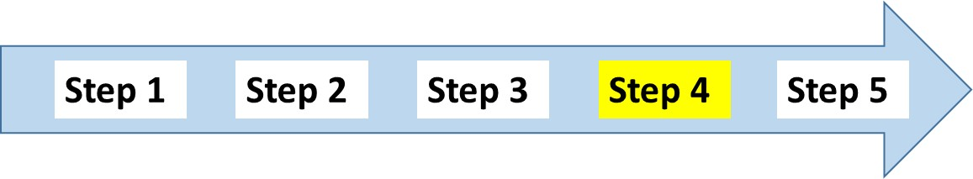

Overview

This module explains how to formally adopt the EAFM plan and how to develop a work plan for the effective implementation of the EAFM plan. It also discusses the related communication strategy that should be developed.

Introduction
Once the EAFM plan has been approved and agreed, implementation should start as soon as possible in order to capitalize on the good will and excitement generated by the negotiations amongst stakeholders. Time scales for implementation can be a problem because, if the planning process takes too long, it may result in loss of momentum, particularly if staff or governments change. Implementation comprises the activities through which the EAFM plan is carried out. The implementation process will involve numerous decision-making points and a different process from the one used to create the plan and the agreements. All the activities in the EAFM plan must be implemented correctly and in a timely manner if the goal and objectives are to be achieved.
Many of the problems facing fishery management (water pollution, introduction of exotic species, destruction of fish habitat due to coastal development, climate change), fall outside the direct control of fisheries managers. Therefore, implementing the EAFM plan will require fisheries managers to reach out, coordinate and integrate themselves within broader processes of integrated coastal management (ICM), integrated watershed management (IWM), conservation management and integrated ocean governance (as started during the Startup tasks). If these processes do not exist, coordination with at least the environmental agency will be required.
In practice and because the world is structured along sectoral lines (e.g. agriculture, forestry and fisheries; mining and petroleum; environment; shipping and maritime affairs), sectoral management will likely be the entry point for more the more integrated management approach of EAFM. Thus, while planning, monitoring and evaluation are carried out at the ecosystem level, implementation will require working with other sectoral agencies, including the environment protection and conservation agency (see Figure 15.1 below).

Figure 15.1: Implementing EAFM: integrating sectoral management within ecosystem planning, monitoring and evaluation
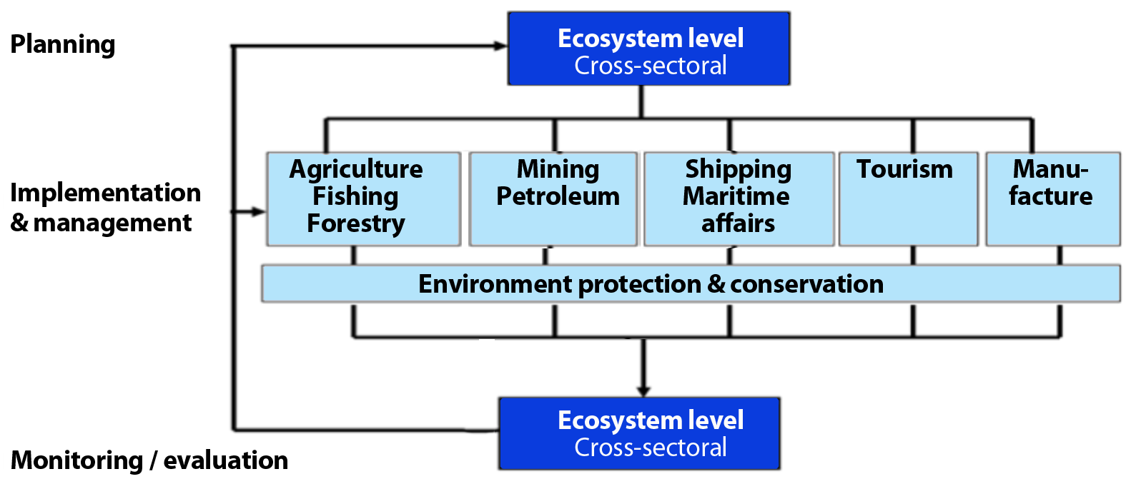

Implementation will, therefore, require trusting the plan and trusting the partners and staff of the fisheries and other agencies. No plan is perfect. There will be successes and failures. This is why continual monitoring and learning-by-doing (adaptive management) has been emphasized. There will likely be failures early on in implementing EAFM as everyone learns to work together and do their job, but it is important that everyone learns from these failures and moves forward.

Given the importance of a high degree of stakeholder participation and cross-sectoral coordination, the implementation of the EAFM plan should include specific measures and mechanisms to continue engaging all parties throughout the management process. This can include such things as: participatory research; co-management; management councils and committees involving stakeholders in management decisions on a regular basis; and the use of traditional and local knowledge (as explained in Module 9 Startup B and further detailed in Module 16 Reality Check II).
- Formalizing the EAFM plan
To implement the agreed set of management arrangements it is often necessary to have them formalized. Depending upon the jurisdiction and fishery, this may need to be a formal, legal document and in some cases may require parliamentary approval. In other cases, legislation may be needed to recognize and implement the EAFM plans. At the other end of the spectrum it may be as simple as a list of activities agreed to, and maintained by, the local community leadership group.
It is necessary to determine what level of formalization is required for the EAFM plan to ensure that the specific arrangements are both legally and socially enforceable by the relevant authority or groups. This may involve a “central” management authority, local or regional authorities or local community leaders, or some combination of these. There is little chance of success if the plan is not endorsed by those who influence the implementation of the plan.
More details on legal and policy support are provided in Module 16 Reality Check II which focuses on governance. Once a new or revised EAFM plan has been formally approved it is vital that this is communicated to all the stakeholders who could be affected by any changes to their previous activities.

The work plan to implement the EAFM plan

Managers will benefit from using an implementation work plan that outlines what would need to be done to implement the EAFM plan, by whom, by when, and where. To generate such a work plan requires going through the full set of EAFM actions developed in Module 14 Step 3.3 and determining (i) what are the specific tasks that need to be undertaken? (ii) who are the actual persons/institutions that will be responsible for completing these tasks? and (iii) by what date will the tasks be complete?

Headings that could be used for such a work plan include (i) information/knowledge management; (ii) management actions and MCS; (iii) legal/institutional strengthening; and (iv) human capacity development.

In order to develop a realistic work plan it is important to ask: are there really enough resources (both people and financial) to complete each of the tasks?
This work plan needs to be developed by the fishery management agency because it is their staff and resources that will be most involved in starting the process. If specific actions are to be undertaken by other groups, they need to be involved in planning for these aspects. The work plan should include a schedule of activities and responsibilities with clear milestones.

Basic work plan format
- For all the management actions identified in the EAFM plan, determine what needs to be done, by whom and when. A matrix with column headings of What, Who, When and Where is a good tool for this.
- It may also be necessary to have some separation of activities based on whether they are dealing with different functional components of the fishery – inshore, offshore, inside EEZ, high seas, etc. Undertaking consultation may be very different for the various groups and separate activities may therefore need to be generated.
- The process should clearly identify where changes are needed, such as by the implementation or modification of legislation, regulations, licence conditions or policies. If so, these need to be scheduled.
- The process should also identify the activities that may be outside the scope or jurisdiction of the fisheries agency. In these circumstances it may be necessary to advise other government departments of the issues they should be dealing with. Such interdepartmental governance issues are often a high-risk area and such should be tackled with due caution and tack and with the support of Agency leads.
- Once all the activities have been identified, the assignment of priorities and timelines should be undertaken by the relevant fisheries/management agency.
- Communication strategy
Communication includes sharing the results of the EAFM plan with the identified target audiences and identifying ways to adapt management practices to improve EAFM. A communication strategy provides a clear process for sharing results in a logical and strategic way.
Startup B discussed ways of initially engaging and consulting with stakeholders. Once the implementation of the EAFM process is underway, keeping stakeholders informed at a community level is very important to maintain the momentum and legitimacy of the management system and its functionality (e.g. its capacity to adapt to change). This is especially important in the case of a community-based fishery. Keeping the government committed to controversial actions will generally require direct discussions with key political leaders and not merely submission of reports.

Relevant questions:
- Who needs to know about the fishery and why? Are they interested in all aspects or just some aspects of the fishery?
- What communication format is appropriate for different target audience types: formal report, newsletter, website, etc.?
- What should the frequency of the communication products be for each audience?
- What should the report contain: information on successes and failures; progress and blockages; problems and solutions; present as well as future perspectives?
- What action is expected from the audience in return?
- What impact are the reports expected to have: the raising of awareness; institutional response?
- How to get feed-back from the reports?
A communication strategy will include:
- an analysis of the range of possible internal and external audiences, their characteristics and a set of priority target audiences;
- a plan for how and where results will be delivered by identifying which media and formats will be used with each audience group, and the approach and style of delivery to be taken;
- a set of key messages which illustrate examples and stories that explain the results and help focus the attention of particular target audiences; and
- the timeline of when messages and presentation formats are to be released and delivered to target audiences.
Possible headings for a communication strategy:
- Communication objectives
- Stakeholder audience
- Messages
- Media and format
- Personnel/human resources
- Relationship strategy
Media and format could include: meetings, workshops, news articles, web pages, emails, newsletters, status reports, social media and PR materials. Give due consideration not only to levels of literacy, but also to what is socially or culturally acceptable. Remember how some audiences are more accessible than others; ensure ALL audiences are catered for (including the less powerful, less literate, the ones with a lesser voice). Refer to Tool n.36 for more methods.
Once these pieces of the strategy are pulled together, it will be possible to estimate the time, and human and financial resources needed to complete the communication strategy (Table 15.1).

Table 15.1: Basic communication strategy template
Target audience | Communication method  (how & where) | Key messages | Timing

Reality Check II
Module 16

Session objectives:
- Check on the status of the EAFM plan implementation;
- Consider whether implementation is in line with the principles of EAFM;
- Check on the practicalities – is the supporting environment in place?;
- Revisit the constraints and opportunities in meeting your FMU goals.

Overview
This module outlines the second reality check. This check takes into account the main principles of EAFM introduced earlier, as well as some important practicalities in terms of a supporting environment. It stresses the need for an effective legal framework; effective compliance and enforcement; nested institutions and coordination mechanisms; appropriate scale; capable fisheries management institutions and human capacity; as well as adequate human and financial resources. If these are not in place, either the EAFM plan will need to be modified or the weaknesses rectified.
Introduction
While implementation is based on the plan and agreed activities, the quality and effectiveness of implementation are shaped by a number of governance issues or the “ability to achieve”. As part of the EAFM process, seven principles were considered and the elements of good governance were described. In Startup A, coordination with other agencies and levels of government were highlighted, and the legal basis for the FMU was discussed in Reality Check I. Startup B focused on participation and co-management. Governance issues were also identified when prioritizing the EAFM issues during Module 11 Step 2.2. In this module, a reality check is undertaken to firstly, determine whether all the important building blocks that will enable EAFM implementation are in place, and secondly, whether the necessary supporting environment is in place.
- Reality check against the seven principles of EAFM

A number of questions can be asked to check how well the implementation of the EAFM Plan aligns with the seven principles of EAFM (Table 16.1) and then a subset of questions relating to each principle needs to be examined (see below).
Table 16.1: EAFM principles in practice
- Good governance | NO | PARTLY | YES
Is there an adequate legal framework?
Are rules and regulations in place and agreed to by stakeholders?
Are effective compliance and enforcement arrangements in place?
Are effective governance arrangements in place?
- Appropriate scale
Is management at the appropriate ecological, human and governance scales?
- Increased participation
Is co-management with relevant stakeholders working?
- Multiple objectives
Have the different objectives for management been considered and trade-offs made?
- Coordination and cooperation
Are nested institutions and resource user groups working?
Is cooperation, coordination and communication taking place?
- Adaptive management
Can the management system learn by doing and adapt accordingly?
Are the results of Monitoring and Evaluation (M&E) being communicated and acted on by adapting the plan and subsequent management?

- Precautionary approach
Has management commenced despite a lack of data and information?
Are management actions more conservative when there is greater uncertainty?

- Good governance

An adequate legal framework
Internationally, the instruments for an EAFM are mainly contained in voluntary agreements including:
- Rio Declaration on Environment and Development, Rio de Janeiro, 1992
- Agenda 21 of the UN Conference on Environment and Development, Rio de Janeiro, 1992
- FAO Code of Conduct for Responsible Fisheries, Rome, 1995
- Jakarta Mandate on Marine and Coastal Biodiversity, Jakarta, 1995
- Reykjavik Declaration on Responsible Fisheries in the Marine Ecosystems, Reykjavik, 2001
As a result, few fisheries organizations or national policies and legislation actually make explicit reference to EAFM, although this is now changing. Many countries of the region have a legislative framework that does not constrain EAFM or co-management. On the contrary, in many countries decentralization policies and legislation to support these policies support EAFM development and co-management.
In the longer term, EAFM may require that existing legal instruments, and practices that interact with or impact fisheries, be reconsidered and that adjustments are made where necessary. In the future, it may be necessary to regulate the inter-sectoral interactions through primary legislation, e.g. laws controlling coastline development.
Reviewing and confirming the legal basis for all plans, agreements, and proposed activities is an important activity for the implementation team to conduct, with a focus within and across the local/municipal, provincial, national and international levels. The team should identify the relevant legislation and associated decrees/bylaws, ordinances and subsidiary acts for their particular country/region (noting that in many cases, the fishery and environment departments may not have a consolidated set). Refer to end of this module for FAO legal database web links.
The process of making laws and fisheries management plans is also reliant on the underlying legislation that provides the basis for rights and legitimizes the decision-making process. The initiation of planning by communities can lead to effective local management plans. However, it is important that these are legitimized or placed within broader planning frameworks. If not, there is a risk that these local planning actions will be undermined by outside forces that lie beyond the power of communities and local management systems to address.
Because the implementation of the EAFM plan is often applied across a number of sectors, each with its own responsible agency (for example, the fishery agency and the tourism agency), a number of laws may be relevant to the FMU, not just the fisheries law (Figure 16.1). The environment agency is often the only agency with cross-sectoral responsibilities.

Figure 16.1: Sectors that might have legislation relevant to EAFM. Note that the environmental agency and environmental laws cut across all sectors.
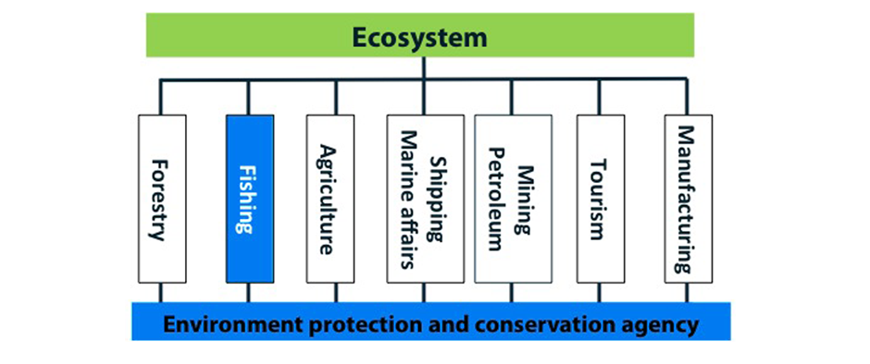
In cases where new or modified regulations are required, or where changes to the legal framework (e.g. the Fisheries Act) are needed, the drafting process could be assisted by viewing good examples from elsewhere, and having access to legal experts. When drafted, these revisions usually involve formal approval by Parliament or government, which may require specific consultation with politicians and their advisors. Having stakeholder support for the proposed changes will clearly assist in securing government approval.
Inadequacies in current legislation should not act as a deterrent to getting started with the EAFM process. As issues and management actions are identified, the need for changes in policy and legislation will become apparent and the EAFM process should guide those processes and make the management systems more responsive and effective.
As a reality check following questions could be asked:
The chief question is: can EAFM be implemented within the current legal framework? In other words, are the current laws a constraint?
Other questions may be:
- Are international commitments included?
- Are there coherent multiple legal instruments – e.g. environment and fishery, national and provincial?
- Are specific laws required to implement EAFM?

Rules and regulations in place and agreed to by stakeholders
One of the keys to implementation of an EAFM plan is have rules and regulations in place that are agreed to (or at least acknowledged) by stakeholders. This leads to greater buy in and a higher probability of compliance. Through the EAFM planning steps, by linking management actions with objectives and core problems, the need for, and rationale for having the appropriate rules and regulations should have become apparent.

As a reality check following questions could be asked
1. Where the rules and regulations decided through a participatory process?
2. Are all stakeholders aware of the rules and regulations and how they were formed?
3. Is the M&E in place to evaluate whether the rules and regulations are achieving the objectives?

Effective compliance and enforcement (refer also to Module 14 Step 3.3)
EAFM is underpinned by effective compliance. Effective compliance involves:
- participatory compliance and enforcement by stakeholders through co-management;
- enforceable legislation and control mechanisms (licences, vessel registration);
- extension work (i.e. working with fishers to improve awareness and compliance);
- data collection systems (dockside monitoring, catch certification);
- communication systems (radios, mobile phones);
- land-based monitoring (i.e. coast watch schemes);
- port inspections;
- sea patrol vessels (state and community-based patrols); and
- international cooperation (e.g. regional fishery commissions).
As with all other components of the EAFM process, participation is the key. By being part of the planning process, stakeholders are more likely to take ownership of the proposed management actions and should be more compliant. In some cases, these stakeholders can also be part of the enforcement team, although care is needed in terms of their roles and responsibilities.
It is important to establish a collaborative inter-agency mechanism to manage and facilitate compliance. Partnerships provide the authority for compliance and also the inter-agency mechanism to develop and coordinate compliance plans. Partnerships provide the necessary conditions for good communications and transparency and can address issues of corruption. Partner agencies can readily share knowledge and information on the fishery and its users. It will be important to initiate the partnership process with a meeting of the heads of all the key institutions involved in fisheries to assess their commitment. Partnerships composed of 10 people or less are manageable in size.
The lead agency will likely be the fisheries agency. The long-term goal of compliance should be to encourage voluntary compliance by the fishing communities/industry with the rules and regulations that govern the fishery (both formal and traditional). To achieve this, it is recommended that the partnership established for the FMU provides the strategic overview for compliance issues and helps to identify and use more effectively the compliance assets that exist at other levels (i.e. inspectors, surveillance data, traditional coast watch, etc.). The nested system of partnerships is established at the district level, around the main ports or landing sites. The key institutions to be engaged in compliance partnerships might include:
- national/provincial/district fisheries and environmental agencies;
- community leaders;
- NGOs;
- navy;
- coast guard;
- private sector (fishers, traders and processors);
- maritime police; and
- marine transport.
Each of the partners brings with them important compliance assets (boats, staff, sea safety experience, Information Technology) that can be combined to provide a strong compliance network. The sharing of assets should be stipulated in the partnership agreement. The partnership would require support from secondary partners - other government institutions (national/ provincial/district), or donors.
As a reality check following questions could be asked:
- What are the existing fisheries and environmental enforcement and compliance arrangements – can they be strengthened?
- Are the fisheries and environmental compliance systems aligned?
- Are the stakeholders moving towards self-compliance through participatory planning, implementation and monitoring?

Effective governance arrangements
Cooperation and coordination, both vertically across different jurisdictional levels (e.g. Communities to National) and horizontally across relevant agencies involved in EAFM (e.g. across fisheries, environment and tourism) will need structural arrangements in place that formalize the coordination and facilitate participation. A hypothetical governance arrangement is shown in Figure 16.2. At the Community level, villages have “Village Committees” (VCs) (often two committees – one for men and one for women). Selected individuals of these VCs would be then be represented on “Management Advisory Committees” (MACs) at the District level. In turn, selected individuals would be represented at the Provincial level. This could also be the area designated as a FMU, and in that case it could be a FMU MAC. At the national level there could be a National EAFM committee with representatives of fisheries, environment, Navy/coast guard, tourism etc. At the highest political level, an overarching Council made up of politicians from relevant Ministries could be providing policy guidance and direction.

Figure 16.2: An example of a governance arrangement that coordinates across jurisdictions and agencies involved in EAFM.
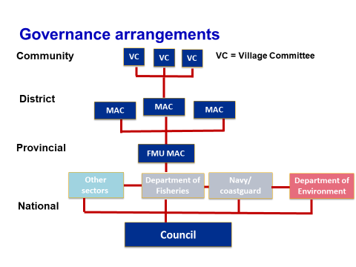
As a reality check following questions could be asked:
- Are there effective governance arrangements in place?
- Do the arrangements cover both vertical (across jurisdictions) and horizontal (across agencies/sectors) dimensions?

- Appropriate scale
Appropriate ecological, human and governance scale
In Step 1 of EAFM, the spatial scale and boundaries of the FMU was agreed. However, EAFM must be implemented within the context of the multiple spatial and temporal scales that reflect the natural hierarchical organization of ecosystems (e.g. from Large Marine Ecosystems (LMEs) such as the Central America Coast to small bays such as Balandra Bay in the Gulf of California). Early on in this course scaling issues were introduced in Module 4 Principles and benefits of an EAFM). Scaling up and scaling down are very real issues that need to be taken into account.
Since ecosystems are nested, part of one or other ecosystem may lie outside the FMU and EAFM often involves ‘‘scaling up’’, or at least considering these externalities. If the FMU does not include impacts of other components of the fishery e.g. commercial large-scale fishing, then management of the small-scale fishing activities could easily be undermined. Often it is practical to start EAFM on a relatively small pilot scale (e.g. a small coastal community) and a next logical step would be to scale up to include alliances or clusters, for example a number of communities covering an entire bay. An example is given in the example on the FISH project in the Philippines (Module 4 Principles and benefits of an EAFM, section 2).
One of the challenges of EAFM is to fashion ways to ensure that the actions of coastal and fisheries institutions at each level of government are harmonized with one another and are consistent with agreed EAFM goals and policies. There is often a gap between national planning and policy goals on one hand, and the practical goals and implementation through local government on the other. This calls for a consistent approach across national and local levels and reinforces the importance of having an inclusive framework that allows for this harmonization of policy and management objectives. Management decisions that are matched to the spatial scale of the ecosystem, to the programs for monitoring all desired ecosystem attributes and to the relevant management authorities are likely to be more successful in achieving ecosystem objectives.
Cross-scale alignment for ecosystem management will take time and may not be achieved during the first iteration of the EAFM cycle. In some cases, the impact of unaligned scales on the FMU may only become apparent during the implementation and monitoring and evaluation phase (Steps 3 and 4). This can be improved when the plan is adapted from the next iteration (Step 5).

As a reality check following questions could be asked:
With the goals and objectives that have been set for the FMU in mind;
- How do the boundaries of the FMU relate to the wider ecosystem boundaries?
- If the FMU only covers part of the ecosystem, are arrangements in place to align management across boundaries?

- Increased participation
Co-management
Remember: co-management is a “Partnership arrangement in which a community of local resource users, government, other stakeholders and external agents share responsibility and authority for the management of the fishery, with various degrees of power sharing”.
As a reality check following questions could be asked:
- Is co-management at the appropriate scale relative to the FMU?
- Are communities empowered?
- Is there an effective co-management structure?
- Is there equitable participation?
- Are effective conflict management mechanisms in place?

Of special importance when working with fishing communities and stakeholders is whether or not they are empowered. This involves increasing awareness, knowledge, skills and institutional capacity so that stakeholders have the power to act and make decisions. Stakeholders need to be in a position where they can take ownership of decisions and outcomes and act responsibly. Empowerment also involves promoting and sustaining motivation.
Community development is an internal process of growth and development that can be fostered by: (i) information dissemination, (ii) training, (iii) facilitation and mentoring by external agent, and (iv) networking. During the initial steps of EAFM, some or all of these five methods to promote participation and community development should have taken place.
Community mobilization
EAFM requires the sustained, motivated participation of communities. Have communities associated/relevant to the FMU been mobilized? The following types of activities can initiate community mobilization and/or strengthen existing groups for their participation in the EAFM process:
- environmental education;
- social communication;
- building alliances and networks;
- organizational sustainability; and
- human capacity development.
Refer to Tools n.9, 10 & 19 for more detail.

- Multiple objectives
Different objectives and trade-offs
Because EAFM covers the ecological, human and governance dimensions of sustainable development, conflicting objectives of management often arise. For example:
- ecological objective: reduce the fishing effort and the number of fishing boats;
- economic objective: make the fishers and supporting industries more economically viable;
- human objective: increase employment; and
- governance objective: increase subsidies.

The first two objectives should be compatible – reducing fishing effort should result in increased catches, especially of higher value species. However, it probably will not result in increased employment. In such a case, another intervention may be necessary such as alternative livelihoods for those displaced by the management actions. In reducing fishing effort and the number of boats, there are also going to be “winners” and “losers”, although this is not always the case. Where the “losers” lose their right to fish, some sort of compensation or promotion of alternate employment opportunities and training becomes more important.
As stressed throughout this EAFM course, nothing acts in isolation and it is important to develop packages of management actions that will achieve a trade-off of all the desirable objectives. With a limited natural resource such as a fishery, it is not always possible to have: (i) healthy fish stocks, (ii) a healthy environment, (iii) vibrant economies and (iv) full employment, all at the same time, despite over-arching policies that often try to suggest otherwise.

As a reality check following questions could be asked:
- Does the EAFM plan cover objectives that address all the high priority issues identified for the FMU?
- Have the trade-offs between competing objectives been considered and agreed?

5. Coordination and cooperation
Nested institutions and resources
Throughout this course it has been emphasized that in EAFM there is a need for fisheries and environmental institutions to ensure coordination, consultation and cooperation, including joint decision-making with other interacting sectors. Such an understanding will assist in highlighting negative interrelationships, as well as the interrelations that contribute positively to governance. Institutions operate at multiple levels of jurisdiction and they work at different levels of society. They are often linked to each other and thus form networks of relationships that improve governance through increasing coordination, cooperation and communication. An understanding of these institutional interrelationships is important when considering institutional adaptation to EAFM, because any successful change requires understanding of how the institutional system really works and which factors need to be considered.
Globally, there are many examples of how fisheries management fits within a government system. In many countries and regions, fisheries management is a national responsibility and is located within a ministry of fisheries, or as a component of a ministry of agriculture. In other countries, fisheries management is a provincial or state level responsibility. And in some countries, such as the Philippines, responsibility for fisheries and coastal habitat conservation is devolved to the local, municipal level. Whether or not fishery management – or at least some management functions – have been partly or largely devolved to industry or community entities, government will be involved in a coordinating or policy-level role. In particular, within EAFM, there is an important role for interdepartmental and/or intergovernmental linkages – from aquaculture and shipping to tourism and agriculture.
A high degree of interconnectedness between institutions can produce dynamic change patterns – changes in one part of the system may have effects on other parts of the system and a new balance may be established. Likewise, a small change in one part of the system may lead to cumulative effects on the system as a whole. For example, by allowing an increased range of stakeholders to participate in the decision-making procedures, changes to the system of management institutions may be required in order for the increased stakeholder participation to be viewed as legitimate.
Ideally, a nested structure for fisheries management should be set up to include fairly large-scale regional seas or Large Marine Ecosystems (e.g. the Bay of Bengal Large Marine Ecosystem), for which integrated management plans would be developed by a regional advisory council and serve as the basis for centralized decision-making. These large regions could be subdivided into high seas and national EEZs and, if appropriate, more locally e.g. where local districts could serve as the basis for devolved management. The existing LMEs form a natural boundary for such a nested system and LME projects could be more orientated towards meeting this ideal and forming the necessary linkages between the region as a whole and the local stakeholders.
Cooperation, coordination and communication
Increased coordination, cooperation and communication within and between relevant institutions and resource user groups are required, both in the planning process (Steps 1-3) and in implementation (Step 4). This requires a clarification of roles and responsibilities, improved coordination and integration across government and other users, and more accountability across stakeholder groups. There are implied benefits from such policy and operational coordination, although it is important to assess the costs involved in this as well.

Further questions when checking whether institutions are coordinated:
- Has any conflict over management responsibility been resolved and are institutions working together in an integrated fashion?

- Adaptive management
Learning and adapting
As stressed earlier, it is critical to adopt an adaptive management approach. One of the keys to this is to have a good M&E system in place. Developing effective indicators and benchmarks that link to the objectives of management was considered in Module 13 Steps 3.1 and 3.2. When these are included in the M&E system (as discussed in the next module Module 17 Step 5.1), the performance of management can be tracked and adapted based on lessons learnt in its application. No management system is going to get it right all the time. Human behaviour dictates that whatever rules and regulations are put in place, fishers and other stakeholders will find ways to circumvent them. There may also be unexpected consequences that were not envisaged in the planning phase. As long as these are recognised and acted on, no harm will be done in the long-term.

7. Precautionary approach
Management initiated despite lack of data and information
The precautionary approach stipulates that lack of information is not an excuse for delaying management actions. Very often, when considering the initiation of an activity, the exact target of the management action will not be known. For example, the management action might be to reduce the number of boats where the optimal number is not known. However, what is known is that there are too many boats chasing too few fish. Reducing boat numbers takes years, so that while the reduction is taking place a lot more data and information can be collected and, as numbers decrease, the optimal number will become clearer.
Risk averse management actions
The precautionary approach also stipulates that management should be more conservative (i.e. more risk averse) where there is more uncertainty. For example, if the impact of a particular fishing gear on a critical habitat is not really known, a conservative approach would be to limit the impact of the fishing gear to the extent possible in the event that the gear type does indeed damage habitat. It would then be necessary to prove that the gear does not damage the habitat before the management action is revoked.

B. Supporting environment
In the implementation phase of an EAFM plan, there must be a supporting environment that will foster success. Important questions are:
- Is the adequate political will and support?
- Are there adequate resources (personnel, equipment and training) for EAFM?
- Is there effective financing mechanisms?
- Is there an appropriate institutional structure?
In this reality check phase, these need to be tested to see if the plan can really be implemented.

- Adequate political will and support
The adoption of an EAFM management approach assumes that there is political will to address the three areas of human well-being, ecological well-being and good governance. However, the reality of a rapid turnover of high-level policy staff in government and short political terms does limit the long-term strategic implementation of the ecosystem approach to management. EAFM emphasizes the need for longer-term commitment, which spans short-term appointments and three-year planning and budget horizons.
Successful implementation of an EAFM plan will often depend on have political backing. This can be difficult to secure if the politician and senior policy makers perceives that the plan will cause some unrest and criticism from stakeholders. This in turn will affect his/her popularity and future votes. However, given good participation and communication, strengthened political will can often be gained. In the first instance, it is important to engage the politician in the planning stage of EAFM and they should be included as stakeholders. The communication strategy should also include politicians and senior policy makers (Module 15 Step4.1). As a special target audience, they need clear messages as to the importance of the fisheries sector, especially in terms of food security, poverty alleviation, nutrition and health, not just the GDP, which is often small. They also need clear messages as to why implementing EAFM is good for their constituencies, especially in terms of improved livelihoods and political stability.
In many, cases the EAFM team may not have direct access to the politician/senior policy makers. However, they probably have access to someone who is in contact. These people are often key to changing mind sets and perceptions, and need to be advocates for EAFM and change. As with all stakeholders, the more they are involved in the process, the more likely they are to advocate the benefits, especially when they see positive outcomes. The formation of a Council made up of politicians from relevant Ministries will also facilitate dialog and buy in (see 4. Effective governance arrangements below).
Key questions when checking on political will could include:
1. Have the politician/senior policy makers been engaged in the EAFM planning process?
2. Have clear messages for politician/senior policy makers been communicated and understood?

- Adequate human and other resources
Human resources are a critical factor in the successful implementation of EAFM. Human resource problems include lack of capacity, as well as the difficulty of retaining good staff in the government sector. Capacity development provides skills and institutional capacity for all relevant stakeholders – fishers, resource user organizations, government officials and staff, and others that take an active role in co-management. Capacity building often implies that activities are carefully planned and executed, following a clear plan. In reality, capacity building often involves more experimentation and learning. For this reason, the term capacity development, which implies an organic process of growth and development, is more appropriate than capacity building.
Human capacity development can be defined as:
“The process by which individuals, groups, organizations, institutions and societies increase their abilities to: (1) perform core functions, solve problems, define and achieve desired objectives over time; and (2) understand and deal with their development needs in a broad context and in a sustainable manner.”
This definition highlights two important points: (i) that capacity development is largely an internal process of growth and development; and (ii) that capacity development efforts should be results-oriented. Within EAFM, these efforts should focus on results linked to the EAFM plan.
The objective of capacity development is not to supply a product or service, but to foster the development of specific individuals and organizations. Capacity development is often needed to raise an organization's performance level, which is reflected in its efficiency (minimizes costs), effectiveness (achievement of its goals) and sustainability (relevance and acquiring resources for operations).
Obviously the content of capacity development will be different for the different target groups but during the planning phase “science skills” (both formal and traditional knowledge) will be required for resource assessments, fishing operations, ecology, etc., and “people skills” will be required to facilitate stakeholder involvement, including conflict resolution, negotiation skills and participatory engagement. Developing the EAFM plan will also involve drafting and understanding legislation and how to develop the plan with stakeholders. During the implementation phase, presentation skills, communication skills (especially with fishers and fishing communities, policy decision-makers and the media) will be required. Scientists will need to improve the way they communicate their results so that they become useful to policy makers and other stakeholders. MCS skills will also have to be developed. In the M&E phase, competencies in data collection and analysis, for assessing the plan’s performance, will be required.
The core capacities of an organization or community, therefore, consist of:

- defining and analysing the environment or overall system;
- identifying needs and/or key issues;
- formulating strategies to respond to or meet needs;
- devising or implementing actions;
- assembling and using resources effectively and sustainably;
- monitoring performance, ensuring feedback and adjusting courses of action to meet objectives; and
- acquiring new knowledge and skills to meet evolving challenges.

In the context of participatory planning and management, local capacity will be required in order to:
- ensure local resource users, groups and organizations, fishing communities and the local government unit charged with fisheries management are more capable;
- ensure local resource users, their organization’s leaders, local government officials and staff and other stakeholders are able to undertake their roles and responsibilities in co-management; and
- improve the quality of fisheries management taking place at the community level.
Capacity development includes understanding what EAFM and co-management is and how to organize and participate in it; communicating with other stakeholders; dealing with administrative and business matters; and participating in negotiations. Capacity development is an ongoing process and is the power of an individual or organization to engage with management.
It needs to be stressed that not every individual needs to have the same knowledge and capacity. This is why the participatory approach is so powerful, the necessary capacity exists across the range of stakeholders. Determining which stakeholder is involved in the different steps of the process is an important part of making the best use of combined capacity. It is not necessary for all stakeholders to be involved in all activities. Forming small, specialized working groups is one way of controlling this.
A key concept in capacity development is what is referred to as “social capital”. It is important to recognize that the whole social community is more than the sum of its individual parts. People form relationships that fulfil a number of social needs, such as communities of common interests, mutual obligation, care, concern, interest and access to information. These can be considered as networks of norms and trust that facilitate cooperation for mutual benefit. Social capital facilitates a process of learning through interaction. This social capital is critical to achieve collective action and to prosper and sustain a social, economic and institutional environment that is ready to adapt and change. The social networks can be horizontal (across the community) to give communities a sense of identity and common purpose, and/or vertical (government to community to individuals) to broaden capacity and support (see community mobilization (alliances and networking) in Module 9 Startup B and Tool n.9 and n.10).
Capacity development cannot be “done” by outsiders. An external agent can promote or stimulate capacity development and provide information, training and other types of support, but an external agent should not attempt to lead an organization's capacity development effort or take responsibility for it. The organization's managers and members must set their own goals and make decisions. Leadership must emerge from within the organization and its members must do most of the required work.
Capacity development involves the acquisition of new knowledge and its application in the pursuit of individual and organizational goals. This is the reason learning by doing, or experimental learning, lies at the heart of capacity development.
The main tools for capacity development include one or more of the following approaches:
- information dissemination (Module 9 Startup B, section 6 and awareness raising);
- training to develop knowledge, skills and attitudes (see Tool n.9); and
- facilitation and mentoring by an external agent (Module 9 Startup B, section 2).
Networking, with the exchange of information and experiences from other people working on similar tasks, as well as through workshops, meetings and communities of practice. This should promote:
- feedback, in order to promote learning from experience within an organization (see participatory M&E Tool n.38).
The type and amount of capacity development will depend upon the organizations' goals and the budget available for these activities. The provision of information or one-time training, while able to reach more individuals and organizations, seldom produces lasting changes in the participants' behaviour. Facilitation by an external agent is generally more effective, although it is more costly.
Enabling factors for capacity development include:
- an external environment that is conducive to change;
- top managers who are committed to provide leadership for change;
- a clear set of objectives and priorities;
- a critical mass of members involved in, and committed to, the change process;
- awareness and understanding of the initiative;
- open and transparent processes and decision-making;
- adequate resources for developing capacities and implementing change; and
- adequate management of the capacity development process.

Key questions when checking on the human capacity could include:
1. Do the staff responsible for implementing EAFM have appropriate experience and training in assessment and management of multispecies fisheries, whether under data-poor or data rich conditions?
2. Is the implementing EAFM team trained and equipped with the skills and knowledge required to identify and reconcile management objectives in an ecosystem, both ecological and social?
3. Is the implementing team equipped with “people skills” to facilitate a process that maximizes the benefits of a having a truly participatory process?

Obviously a range of other resources such as facilities and equipment are also required. These resources link closely to having sufficient funding (see below).

- Effective financing mechanism
In discussing financing earlier, it was pointed out that having an EAFM plan can unlock financial resources. Early in the implementation phase, it is important that the EAFM plan be streamlined into the main activities of the fishery and other agencies and be included in the annual budgets. This requires knowledge of the timing of the budget cycle and links to planners who formulate the annual budget.
In many more developed countries, the cost of management (either fully or in part) is paid for by the beneficiaries of the management, i.e. the fishers and others in the value chain. The logic of this policy is that if the income and well-being of fishers and associated buyers and sellers is being increased by management, it is those who benefit that should be paying, not the public at large. This payment can be in the form of a levy or through some sort of license fee that includes part or all of the management costs. A similar “user pays” principle is also often applied to research. In this case, those who pay have a greater say in what research is carried out. One successful model is to have 50% of research funded by fishers, which is matched by government. Allocation of the research fund is made through a board that consists of fishers, government and researchers. Not only does this pay for more research, it also assists in the prioritization of the research effort so that it becomes more relevant and useful to fishers.
Introducing a “user pays” policy, however, will not be popular with the beneficiaries and can be opposed through advocacy with politicians and other senior officials who want keep favour with the voters. As with implementing other EAFM components, moving to a “user pays” system takes time but is possible if a good co-management system is being adopted.
Key questions when checking on financing could include:
- Has the implementation of the EAFM plan been mainstreamed into the activities and tasks of the relevant agencies, and has an annual budget been allocated?
- Have other sources and models for funding (e.g. “user pays”) been adequately investigated?

- Effective management institutions and arrangements
The capacity and structure of the fisheries management agency, and the fisheries science infrastructure, must be taken into account when considering EAFM implementation. In many developing countries, fisheries agencies do not have a fisheries management division/section/group and it should not be assumed that one exists. Fisheries management units are more likely to be found in more developed countries. A quick institutional analysis (see Tool n.22) can be used to look at the structure and function of the existing arrangements. In many cases, it may be necessary to develop the human capacity and infrastructure needed to manage fisheries.
The FAO approach to EAFM implementation is to build on existing management structures and processes as these are already based in the local context and can be adapted but not simply replaced. The nature of these existing structures and processes will affect the benefits and costs, and the time frame, of EAFM implementation.
One of the main institutional changes required for EAFM is a clearer definition of the roles and responsibilities of the different players in the integrated process that is being introduced. This will require a commitment to change and a passion to lead others through this change. Although in many political contexts this will mean taking risks, the risks will likely be outweighed by the benefits.
Fisheries agencies are often nested within a larger ministry that includes agriculture, forestry and as well as fisheries (see Figure 16.3 for an example).

Figure 16. 3: An example of a fisheries agency structure

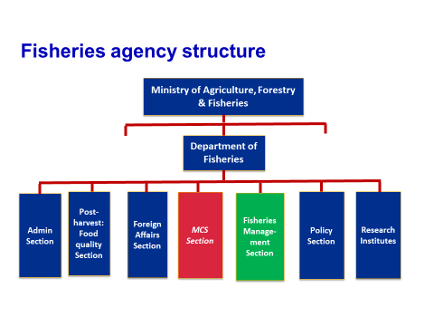
In this example, the fisheries agency is called a “Department of Fisheries” and has a number of “Sections”. These sections usually cover different functions such as research, administration (especially registration/licensing), policy formulation and planning, foreign affairs and post-harvest (including food quality and processing). Some ‘Department of Fisheries” may have a MCS Section, responsible for coordinating all the other agencies that are involved in MCS for fisheries. In developed countries, there is often a “Fisheries Management Section” that houses the fisheries managers (see Module 2 for a discussion and fisheries management and what makes a fisheries manager. This section is often missing in the structure in developing countries, making implementation of an EAFM plan more difficult.

Key questions on effective management institutions and arrangements could include:
- Who or what is responsible for fisheries management? This could be an individual mandated to manage as part of his/her job, or a team that works cooperatively to manage the fishery.
- Does the lead fishery agency have a structure in place (e.g. management unit) whose staff are responsible for fisheries management?

Activity: Revisit your constraints and opportunities developed earlier and discuss how valid these still are for achieving your FMU goals. Amend as appropriate.

Note FAO has a legal database that covers some, but not all, aspects:
http://faolex.fao.org/
FAOLEX is a comprehensive and up-to-date computerized legislative database, one of the world's largest electronic collection of national laws and regulations on food, agriculture and renewable natural resources. Users of FAOLEX have direct access to the abstracts and indexing information about each text, as well as to the full text of most legislation contained in the database.
http://faolex.fao.org/fishery/index.htm
Legislation on Coastal State Requirements for Foreign Fishing was published in 1981. An electronic edition of Coastal State Requirements which consists of a series of tables summarizing the provisions of national legislation and of bilateral and multilateral agreements governing foreign fishing in waters under national jurisdiction only. Revised versions were published in 1983, 1985, 1988, 1993 and 1996.
http://www.fao.org/docrep/012/ak471e/ak471e.pdf
1984 FAO Regional Compendium REGIONAL COMPENDIUM OF FISHERIES LEGISLATION (WESTERN PACIFIC REGION) VOLUME I.
This has been updated by FFA into a CD rom. “FFA compendium of Pacific islands fishery legislation.”
No e-version
Regional compendium of fisheries legislation (Indian Ocean Region)/prepared by Legislation Branch, FAO Legal Office with the assistance of the International Centre for Ocean Development
ICSF – Indian legal documents
http://indianlegal.icsf.net/
ICSF's Database on Indian Legal Instruments Relevant to Fisheries, is a compilation of Indian national and State-level laws relevant to marine fisheries and fishworkers.

Step 5.1 & 5.2 Monitor, evaluate and adapt the plan
Module 17

Session objectives:
- Monitor how well management actions are meeting goals and objectives;
- Plan what has to be monitored, why, when, how and by whom;
- Evaluate monitoring information and report on performance;
- Review and adapt the plan.

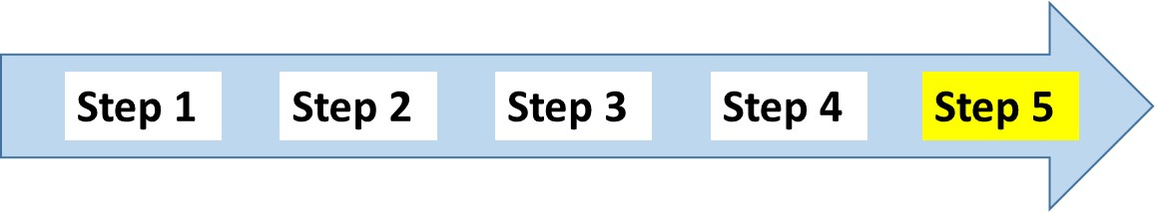
Overview
This module explains the importance of monitoring and evaluation (M&E) for effective EAFM. Section 5.1 outlines how to monitor and evaluate performance, essentially by collecting and analysing data related to indicators, as well as by collating these data and evaluating progress. Section 5.2 outlines the need for periodical review of the plan based on the M&E results and making changes to it if necessary.
Introduction
The final step in the EAFM process is to monitor how the EAFM plan management actions are meeting the objectives and to feed this information back into the EAFM process so that the learning can be adapted and used. Thus, M&E and reporting of performance is a critical step in the adaptive management process. It is essential not only to ensure that adequate performance is being generated against current objectives, but if the results are favourable, it can also be an incentive for further involvement.
To facilitate learning-by-doing, a constructive attitude to both success and failure is required. If failures are regarded as an opportunity for learning, and if people are rewarded for identifying problems and promoting innovative solutions, learning-by-doing will be strongly encouraged. The challenge can be to recognize that adaptation and refinement of plans is a normal activity that occurs through experience and acquisition of new information (see adaptive management in Module 4 Principles of EAFM).
As explained in Module 10 Step 1.3 Scope the FMU and Module 13 Developing indicators, in data-rich situations managers can use a well-directed research program, with the support of appropriate technical expertise where needed. However, in the case of data-poor situations, they will need to make increasing use of adaptive management and the precautionary approach, as well as fishers’ traditional knowledge, to overcome the constraint of insufficient knowledge. In both cases, using participatory approaches for data collection and analysis will enhance understanding and ownership.
5.1 Monitor and evaluate performance
Monitoring should be done during the whole of the plan’s implementation. The frequency of monitoring activities will be indicator dependent i.e. some indicators will need to be monitored monthly, some seasonally and some annually.
Monitoring allows for an assessment of the EAFM plan's activities in order to determine whether goals are being achieved and what needs to be done to make improvements (adaptive management). The indicators and benchmarks developed (Module 13 Step 3.2) and the FMU background information generated in the scoping phase (Module 10 Step 1.3) acts as the baseline, against which to measure progress. This is gradually built on over time.
At the simplest level, because specific objectives and indicators (Module 13 Steps 3.1 and 3.2) have been chosen to cover the important ecological, social, economic and governance issues, assessing the status of each indicator against its benchmark should provide a snapshot of how well management is performing at the ecosystem level. A common mistake is to collect too much data, data that is irrelevant to the EAFM plan or which never gets used (i.e. a waste of time and resources.) Only collect that is relevant and useful.
When planning for monitoring the main questions are: WHAT data is collected for WHAT purposes, HOW OFTEN and BY WHOM? These responsibilities are outlined in the implementation work plan developed in Module 15 Step 4.1 (see Tool n. 38 for more participatory M&E approaches). The EAFM team (who initiated and “holds” the EAFM process) might need to set up an assessment team (M&E team) composed of representatives from key stakeholder groups or they can use the key stakeholders group itself, established in Startup A. This M&E team coordinates data collection and analysis of management performance. Different stakeholders should be involved in this process and it is essential to have feedback loops in place to foster learning and to enable adaptive management. The assessment team regularly feeds back the results of monitoring to the EAFM team (or other agreed overarching committee). The collated results are also communicated to the wider stakeholder group (often as periodic evaluations).

Communicating and reporting

Different evaluation results will be required by different stakeholders and there should be upward and downward information flows between the different levels, ranging from the national level to the community level, as well as across sectors (Figure 17.1).
Figure 17.1: Monitoring information flows
The communication strategy developed earlier as part of EAFM Implementation (Module 15 Step 4.1) should outline who needs what M&E information, how (what format) and by when? Line managers and certain fisher stakeholders will need frequent, detailed data such as monthly or quarterly monitoring data to assess performance and be able to take immediate remedial action and/or redirect activities, if needed, to ensure that agreed objectives can be met. For example, if some of the agreed management actions include setting up an MPA, and reduced take of key species, the EAFM team and the key stakeholder group will need regular data on how the MPA is established and the extent to which it is being complied with, including changes in key resource user attitudes and perceptions. They will also require collated figures of recent monthly catches.
Other stakeholders will need less frequent feedback and less detailed information. For example, in the case above, national or regional fishery and environmental agencies will need the monthly figures compiled into quarterly or six-monthly reports so that they can see if these impact on other species, trade or commercial aspects. Eventually, when the MPA is set up and possibly generates tourism revenue, the same agencies would be interested in seeing a regeneration or rehabilitation of the ecosystem and key species. The tourism or social affairs departments would want to see not only revenue but also social impacts.
The idea is to share data and information between as many relevant sectors and agencies as possible in order to maximize knowledge and achieve EAFM objectives. In some countries, sharing data between different departments in the same ministry can be a challenge, let alone sharing between different sectors. However, the EAFM approach of co-management, cooperation and inclusiveness established from the outset of the process (Module 8 Startup A Task v.) should continually strive to foster this sharing of information and communication.
The communication strategy should also outline the format of reporting back by means of written documents (with or without templates, verbal workshops or other media).
A useful communication tool for summarizing the results of monitoring is the indicator “traffic lights” system. Data are entered into a computer program (basic Excel can do this) with pre-defined criteria/variables. The figures are then transformed into a visual image, whereby green = performance is satisfactory; amber (orange) = things are not progressing very well and caution is needed; red = performance is not satisfactory (Figure 17.2).
Figure 17.2: “Traffic light” reporting
In this way, the table or visual of activities immediately shows which actions are on track and which require management review or decisions. Such a visual can tell managers at a glance which activities are not performing according to plan and therefore require more information, checking, analysis or more remedial action. Remember that visuals cannot tell the whole story; before taking any action managers would also have to read the relevant feedback report. Figure 17.3 shows the traffic light system used by India in the Bay of Bengal Large Marine Ecosystem to show whether ecosystems are healthy (green); impacted (amber) or degraded (red) in terms of pollution level.

Figure 17.3: Bay of Bengal traffic light system used for monitoring ecosystems

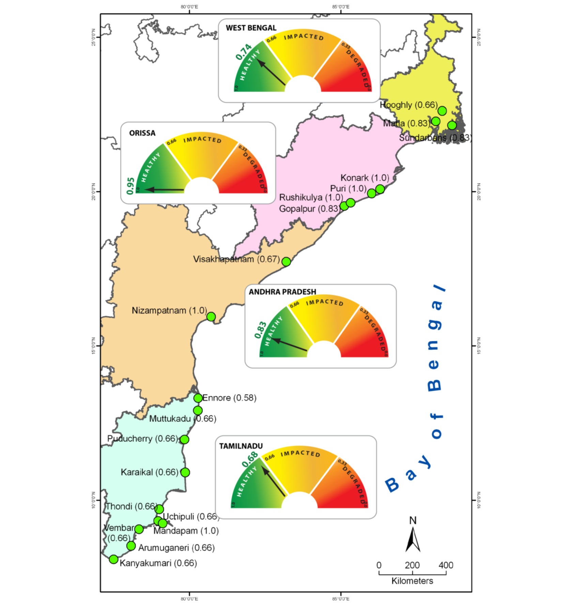

5.2 Review and adapt the EAFM plan
The EAFM plan finalized in Module 14 Step 3.5 should be adapted periodically, based on the M&E results. This involves using the results of the monitoring and periodic evaluations to improve the plan and is usually carried out during regular reviews of the plan based on the evaluation and reports. These take place with the purpose of assessing the performance of the management actions in achieving the objectives (EAFM plan template 11. Review of the plan). These reviews are the time to consider whether the EAFM plan should be changed or not. The assessment/M&E team will be involved in this process, though the review could be facilitated by outsiders. Such reviews should be carried out under guidance from, and while making regular reports to, the EAFM team.
Short-term reviews, for example as part of an annual cycle. The results should be summarized in an annual report that is easy to understand and that links with the fishery co-management process. In general the report will contain:
- performance assessments; and
- fishery management responses.
Data can be aggregated and displayed using the traffic light diagrams explained above, or via other graphs, tables or visuals. Remember that because such visuals cannot tell the whole story, some text that interprets and explains the key findings (or case studies in boxes) is also required.
If the plan is working, there is reason to celebrate! Determine which aspects of the plan are working; if some aspects are not, it is necessary to establish why. It may then be necessary to adapt the plan, specifically looking at:
- management actions;
- compliance; and
- governance arrangements.
It may be that activities are going as planned and little change is needed. However, it may also be found that things are not going as expected and substantial changes are necessary. To do this, will require going back over the plan and its components to make modifications and move forward. Regular reviews are an important element of the EAFM process; they support the flexible and iterative approach by formalizing continuous assessment.
All stakeholders need to understand what actions will be taken if management is not meeting its objectives. The EAFM team must be prepared to modify any part of the plan if it isn’t working. This could be as serious as modifying the objectives, indicators and benchmarks, or less serious in the case of modifying the management actions and compliance arrangements i.e. if they are stipulated in rules and regulations which are separate to the formalized plan. As with all decisions, the basic process consists of first identifying what the problem is and why it is occurring. In many developing countries, the problem might be weak governance and inadequate compliance. This will obviously not require a change to the EAFM plan, but a change to the implementation work plan (developed in Module 15 Step 4.1), so as to strengthen compliance.
In some data-rich cases it might be possible to set up formal decision rules based on how well an indicator is doing against its benchmarks, e.g. if the level of a target stock falls below a reference limit point, fishing will be stopped until the stock has recovered. These are known as “decision rules” and can be built into operating models of the fishery. Operating models can be divided into biological operating models that describe the biological characteristics of the system that is modelled, and economic operating models that describe the behavioural responses of fishers to the imposed regulations and other conditions that affect their behaviour. They provide the background against which alternative management regimes can be compared.
Longer-term reviews should also be conducted on a regular basis (three to five years), preferably by an independent third party audit. Ideally these reviews should be planned to feed into broader strategic processes (Module 6 EAFM plans – the link between policy and action).
These reviews should include consideration of the full management arrangements including the high priority issues. Longer-term reviews may provide evidence that high priority issues set earlier are no longer appropriate.
Data collection, monitoring, evaluation and reviews all need to be budgeted for. During Module 14 Step 3.4 when financing options for EAFM are explored, it is essential to earmark part of the budget for M&E activities, especially for evaluation and reviews, otherwise these are unlikely to happen.
To summarize, evaluations should be made at least annually. The yearly evaluations may trigger a review and adaptive responses in the management (if they are not working very well) and in the compliance and enforcement (MCS) activities. Once every five years or so a major evaluation and review of the plan should take place, and if appropriate, the issues, goals and objectives should be examined (Figure 17.4).

Figure 17.4: The M&E process, including short-term and longer term reviews of the plan
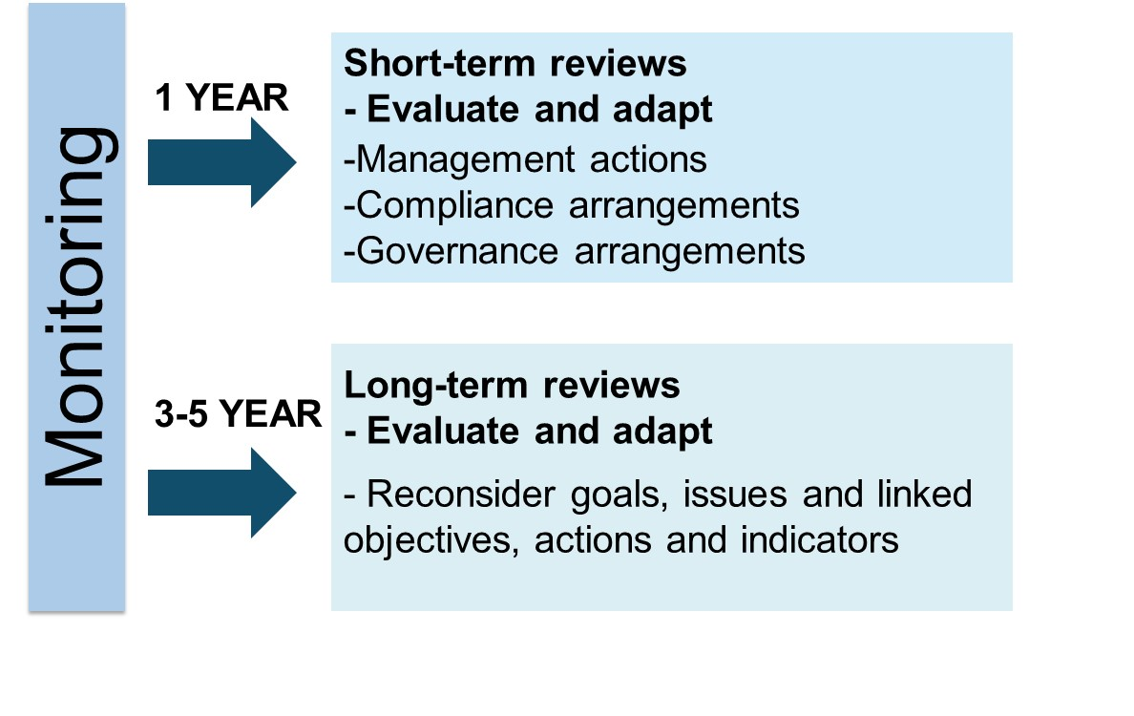
Activity: EAFM Quiz

Homework: Review the group outputs of the EAFM process steps and start considering how these fit into the EAFM plan template. Start planning how you are going to present the EAFM plan on day 5. NB: the format is no PowerPoints.

Websites
Australian National Fisheries ESD website: http://www.eafm.com.au
Bay of Bengal Large Marine Ecosystem Project: http://www.boblme.org
Coral Triangle Initiative: http://www.coraltriangleinitiative.org/
EAFnet: http://www.fao.org/fishery/eaf-net/en
EBM Tools Network: http://www.ebmtools.org/
International Institute for Sustainable Development: http://www.iisd.org
Knowledge Management Toolkit: http://www.kstoolkit.org
NOAA Fisheries Tools Website: http://nft.nefsc.noaa.gov/index.html
NOAA Coral Reef Conservation Program: http://coralreef.noaa.gov/aboutcrcp/international/ctr/
Other web-based resources and literature
Agardy, T. 2010. Ocean zoning: making marine management more effective. Earthscan, Rutledge. 240pp
APFIC. 2009. APFIC/FAO Regional consultative workshop “Practical implementation of the ecosystem approach to fisheries and aquaculture”, 18-22 May 2009, Colombo, Sri Lanka. RAP Publication 2009/10. Bangkok, Thailand. FAO Regional Office for Asia and the Pacific. 96pp
AusAID. 2000. Good governance – guiding principles for implementation. Canberra, Australia. The Australian Agency for International Development.
Bell, J.D.; Johnson, J.E. & Hobday, A.J., eds. 2011. Vulnerability of tropical Pacific fisheries and aquaculture to climate change. Secretariat of the Pacific Community, Noumea, New Caledonia. 925p
Christie, P.; Fluharty, D.L.; White, A.T.; Eisma-Osorio, L. & Jatulan, W. 2007. Assessing the feasibility of Ecosystem-Based Fisheries Management in tropical contexts. Marine Policy 31: 239-250
Chua, T-E. 2006. The dynamics of integrated coastal management (practical applications in the sustainable coastal development in East Asia). In: Regional programme on building partnerships in environmental management for the seas of East Asia (PEMSEA). Quezon City, Philippines.
Clarke, P & Jupiter, S. 2010. Principles and practice of Ecosystem-Based Management: a guide for conservation practitioners in the tropical Western Pacific. Suva, Fiji.Wildlife Conservation Society.
Coffey, C. Undated. Good governance and the Common Fisheries Policy: an environmental perspective. London, UK. Institute for European Environmental Policy.
Daw, T.; Adger, W.; Brown, K. & Badjeck, M-C. 2009. Climate change and capture fisheries: potential impacts, adaptation and mitigation. In: K. Cochrane, C. De Young & T. Bahri, eds. Climate change implications for fisheries and aquaculture: overview of current scientific knowledge. FAO Fisheries and Aquaculture Technical Paper No. 530. Rome, Italy. FAO.
De Young, C.; Charles, A. & Hjort, A. 2008. Human dimensions of the ecosystem approach to fisheries: an overview of context, concepts, tools and methods. FAO Fisheries Technical Paper No. 489. Rome, Italy. FAO. 152pp
Ehler, C. & Douvere, F. 2009. Marine Spatial Planning: a step-by-step approach toward Ecosystem-Based Management. UNESCO Intergovernmental Oceanographic Commission and Man and the Biosphere Programme. IOC Manuals and Guides No. 53, ICAM Dossier No. 6. 99pp
FAO. 2003. The Ecosystem Approach to Fisheries No. 4 Suppl. 2. Rome, Italy. FAO. 112pp
FAO. 2005. Putting into practice the ecosystem approach to fisheries. Rome, Italy. FAO. 76pp
FAO. 2008. The Ecosystem Approach to Fisheries. G. Bianchi & H.R. Skjoldal, eds. CABI Publishing and FAO. 363pp
FAO. 2009. Fisheries management. 2. The ecosystem approach to fisheries. 2.2 Human dimensions of the ecosystem approach to fisheries. FAO Technical Guidelines for Responsible Fisheries. No. 4, Suppl. 2, Add. 2. Rome, Italy. FAO. 88pp
FAO. 2011. Technical Guidelines for Responsible Fisheries. No.4, Suppl. 4. Marine Protected Areas and Fisheries. Rome, Italy. FAO. 198pp
FAO. 2012. EAF Toolbox: the ecosystem approach to fisheries. Rome, Italy. FAO. 172pp
Fernandes, L.; Green, A.; Tanzer, J.; White, A.; Alino, P.M.; Jompa, J.; Lokani, P.; Soemodinoto, A.; Knight, M.; Pomeroy, B.; Possingham, H. & Pressey, B. 2012. Biophysical principles for designing resilient networks of marine protected areas to integrate fisheries, biodiversity and climate change objectives in the Coral Triangle. Report prepared by The Nature Conservancy for the Coral Triangle Support Partnership. 152pp
Fletcher W.J. 2008. A guide to implementing an ecosystem approach to fisheries management (EAFM) within the western and central Pacific Region - version 5 (March 2008). Honiara, Solomon Islands. Pacific Islands Forum Fisheries Agency. Available at: http://www.fisheries-esd.com/a/pdf/EAFM%20GUIDE%20Version%205.pdf
Fulton, E.A.; Smith, A.D.M. & Johnson C.R. 2003. Effect of complexity on marine ecosystem models. Marine Ecology Progress Series 253: 1-16
Fulton E.A.; Smith, A.D.M.; & Punt, A.E. 2005. Which ecological indicators can robustly detect effects of fishing? ICES Journal of Marine Science 62: 540-551
Fulton, E.A.; Smith A.D.M.; Smith D.C. & van Putten, I.E. 2010. Human behaviour - the neglected source of uncertainty in fisheries management. Fish and Fisheries. DOI: 10.1111/j.1467-2979. 2010.00371.
Fulton, E.A. 2010. Approaches to end-to-end ecosystem models. Journal of Marine Systems 81 (1-2). doi:10.1016/j.jmarsys.2009.12.012
Garcia, S.M.; Zerbi, A.; Aliaume, C.; Do Chi, T. & Lasserre, G. 2003. The ecosystem approach to fisheries. Issues, terminology, principles, institutional foundations, implementation and outlook. FAO Fisheries Technical Paper. No. 443. Rome, Italy. FAO. 71pp
Green, S.J.; White, A. & Kilarski, S., eds. 2013. Designing marine protected area networks to achieve fisheries, biodiversity, and climate change objectives in tropical ecosystems: a practitioners guide. Cebu City, Philippines. The Nature Conservancy and the Coral Triangle Support Partnership. viii + 35p
ICSFW
Katsanevakis, S.; Stelzenmüller, V.; South, A.; Sørensen, T.K.; Jones, P.J.S.; Kerr, S.; Badalamenti, F.; Anagnostou, C.; Breen, P.; Chust, G.; D'Anna, G.; Duijn, M.; Filatova, T.; Fiorentino, F.; Hulsman, H.; Johnson, K.; Karageorgis, A.P.; Kröncke, I.; Mirto, S.; Pipitone, C.; Portelli, S.; Qiu, W.; Reiss, H.; Sakellariou, D.; Salomidi, M.; van Hoof, L.; Vassilopoulou, V.; Fernández, T.V.; Vöge, S.; Weber, A.; Zenetos, A. & ter Hofstede, R. 2011. Ecosystem-based marine spatial management: review of concepts, policies, tools, and critical issues. Ocean and Coastal Management 54 (11): 807–820
McLeod, K. & Leslie, H., eds. 2009. Ecosystem-Based Management for the oceans. Island Press. 392pp
Mengerink, K.; Schempp, A. & Austin, J. 2009. Ocean and coastal Ecosystem-Based Management: Implementation Handbook. Environmental Law Institute. 158pp
OECD. 2007. Principle elements of good governance. Paris, France. Organisation for Economic Cooperation and Development. Available at: http://www.oecd.org/
Plagányi, É.E. 2007. Models for an ecosystem approach to fisheries. FAO Fisheries Technical Paper. No. 477. Rome, Italy. FAO. 108p.
Pomeroy, R & Rivera-Guieb, R. 2006. Fisheries co-management: a practical handbook. Ottawa, Canada. CABI Publishing and International Development Research Centre. 264pp
Pomeroy, R.; Garces, L.; Pido, M. & Silvestre, G. 2010. Ecosystem-based fisheries management in small-scale tropical fisheries: emerging models of governance arrangements in the Philippines. Marine Policy. 34: 298-308
Rice J. 2007. Investigating the roots of confusion. Marine Ecosystems and Management.1:1
SEAFDEC. 2003. Regional guidelines for responsible fisheries in Southeast Asia: fisheries management. Southeast Asian Fisheries Development Center MFRDMD/SP/3. 69pp
Sen, A., Stiglitz, J. E., & Fitoussi, J-P. (2009). Report by the Commission on the Measurement of Economic Performance and Social Progress. Paris, France: The Commission on the Measurement of Economic Performance and Social Progress. 292pp.
SPC. 2010. A community-based ecosystem approach to fisheries management: guidelines for Pacific Island Countries. Compiled by the Secretariat of the Pacific Community. 65pp
Staples, D. & Funge-Smith, S. 2009. Ecosystem approach to fisheries and aquaculture: implementing the FAO Code of Conduct for Responsible Fisheries. RAP Publication 2009/11. Bangkok, Thailand. FAO Regional Office for Asia and the Pacific. 48pp
UNESCAP. 2007. What is good governance? United Nations Economic and Social Commission for Asia and the Pacific. Available at: http://www.unescap.org/pdd/prs/ProjectActivities/Ongoing/gg/governance.pdf

